FAIINVE – Invoice/Credit Memo Query

Use Banner form FAIINVE to query completed and approved invoices as well as invoices that are still in process. To query using this form you need the “I” document number found on your Banner reports. If you want to query by vendor name, you would use form FAIVNDH.

Go to Banner 9 Admin and enter form name FAIINVE then hit enter.

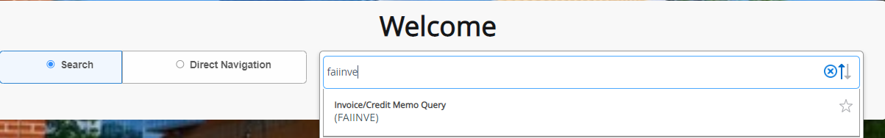

In this example I am using a paid Borden Dairy invoice with document number I0547810.

In the document field type the document number.

Click on Go

You can scroll through pages using the Next Section button at the bottom left of your screen.

If you have WebXtender you can go to Retrieve (top right portion of the toolbar) to obtain copies of the invoice and all other documents sent to Accounts Payable for payment processing.

