Ph.D. Plan of Study
Higher Education Administration
Kent State University

Student Name: _____________________________________________________________________
Id#: ________________________________________________________________________________
Address: ____________________________________________________________________________
KSU Email: __________________________________________________________________________
Telephone (Preferred Contact Number): _____________________________________________
Semester/Year of Admission: ________________________________________________________

ADVISORY COMMITTEE
Major Advisor: ______________________________________________________________________
Second HIED Member: ______________________________________________________________
Other members (if applicable): ______________________________________________________
Minor, Cognate, or Concentration Advisor: ___________________________________________

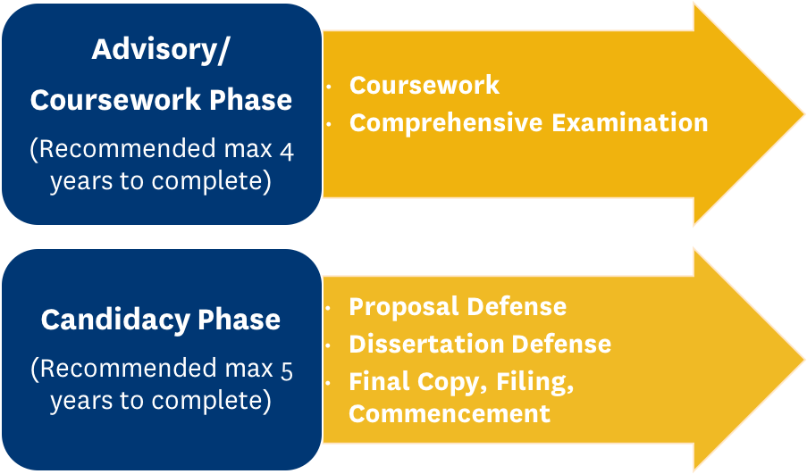

Maximum 10 years total to complete
Coursework | Required Credits | Term Planned | Term Completed | Grade
PREREQUISITE COURSES*
Law and Higher Education (HIED 76652) | 3
College Student Development: Theory to Practice (HIED 76653) | 3
Leadership in Educational Organizations (HIED 76657) | 3
Administration of Multiculturalism and Diversity (HIED 76671) | 3
REQUIRED COURSES (24 credits)
Employment Law (HIED 76521) | 3
Higher Education Curriculum (HIED 76656) | 3
Politics & Power (HIED 76662) | 3
Business Administration in Higher Education (HIED 76667) | 3
Internationalization of Higher Education (HIED 76670) | 3
Advanced Educational Leadership (HIED 86558) | 3
Research in HIED (HIED 76598) (available summer only) | 3
Dissertation Preparation Seminar (HIED 80080)** | 3
RESEARCH COURSES (15 credits) (See p. 3 for electives)
Statistics I for Educational Services (RMS 75510) | 3
Quantitative Research Design & Analysis (RMS 85515) | 3
Qualitative Research Design (RMS 85516) | 3
Research Elective | 3
Research Elective | 3
ELECTIVE COURSES (15 credits) (See p. 3 for electives)
Elective | 3
Elective | 3
Elective | 3
Elective | 3
Elective | 3
Total Coursework Credits | 54

DISSERTATION CREDITS
Dissertation I (HIED 80199) | 30 minimum required for I & II
Dissertation II (HIED 80299)
Total Coursework Credits | 84 (Minimum)
Courses used to complete requirements must be taken at the 70000 or 80000 level. Courses taken as part of a Master’s degree program do not need to be repeated. Students will be permitted to substitute a doctoral level elective course for each.

*PREREQUISITE COURSES: If these courses or their equivalents were not part of previous coursework, they will need to be completed in addition to other required courses. The total number of prerequisite courses will be determined by the Advisory Committee based upon the student’s prior coursework and degrees.
**Dissertation Preparation Seminar (HIED 80080) is not required prior to Comprehensive Exams.
***Dissertation II (HIED 80299) is 15 additional credits per semester if needed.

OTHER APPROVED ELECTIVE COURSES (15 credit hours)
Five (5) HIED courses are to be determined by the Advisory Committee:

HIED 76492: Internship in Higher Education Administration
HIED 76594: Internship in College Teaching
HIED 76595: Special Topics in Educational Administration
HIED 76596: Individual Investigation in Higher Educational Administration
HIED 76600: History of Higher Education
HIED 76601: Private Liberal Arts Colleges
HIED 76651: Student Affairs Functions in Higher Education
HIED 76654: Students and the College Environment
HIED 76658: Community College
HIED 76660: Faculty Roles & Responsibilities
HIED 76663: Status of Women in Higher Education
HIED 76664: Service Learning in Higher Education
HIED 76665: Technology, Systems, & Data in Higher Education
HIED 76666: Financial Management in Higher Education
HIED 76669: Administration of Student Disability Services
HIED 76672: International Students & American Colleges
HIED 76674: Comparative Higher Education Administration
HIED 76675: Design and Delivery of Education Abroad Programs
HIED 76676: Intercultural Communication for International Educators
HIED 76677: Workforce, Economic, & Community Development in Community Colleges
HIED 76678: Issues and Trends in Community Colleges
HIED 76679: Career Advising: Theory & Practice
HIED 76681: Administration of Advising Services
HIED 76733: Interpersonal & Group Dynamics in Educational Organizations
HIED 76745: Equity, Justice, & U.S. Higher Education
HIED 76749: Assessment & Evaluation in Higher Education
HIED 76771: Planning Study Abroad while Abroad
HIED 86559: Advanced Student & Adult Development
RMS 78806: Higher Education Data & Institutional Research

RESEARCH ELECTIVES (MINIMUM of 6 credit hours)
RMS 78710: Introduction to Measurement
RMS 78711: Modern Test Theory: Item Response Theory
RMS 78713: Multivariate Analysis in Educational Research
RMS 78714: Factor Analysis in Educational Research
RMS 78716: Statistics II: Anova & Nonparametric Tests
RMS 78728: Multiple Regression
RMS 78735: Structural Equation Modeling
RMS 78745: Hierarchical Linear Modeling
RMS 78898: Comparative Research Design
RMS 85517: Advanced Quantitative Research in Educational Services
RMS 85518: Advanced Qualitative Research in Educational Services
RMS 85520: Mixed Methods Research
RMS 85540: Grounded Theory & Phenomenological Research
RMS 85550: Ethnography & Case Study Research
RMS 85560: Critical Social Research

Elective Courses not listed above must be approved by the Advisory Committee. Research in HIED, Assessment, and Program Evaluation may not be used as Research Electives.

COMPREHENSIVE EXAMINATIONS
Anticipated Semester/Year of Comprehensive Exams ______/______

MINOR, COGNATE, or CONCENTRATION (optional)
Minor (15 additional credit hours), cognate (10 additional hours), concentration (13-15 additional hours)
Name of Minor, Cognate, or Concentration_______________________________________________________

Course Name and Number | Required Credits | Term Planned | Term Completed | Grade

Note: Completing a minor requires an additional comprehensive examination.

TENTATIVE FULFILLMENT DATES
Step 1. Coursework completed __________________Date
Internship experience completed __________________Date
Step 2. Completion of Comp. Exams __________________Date
Step 3. Approval of Dissertation Proposal __________________Date
Step 4. Defense of dissertation __________________Date
Step 5. Anticipated graduation date __________________Date

Submit the form through KSU’s DocuSign. Signatures will be obtained at that time.

Approval Page
Student Name and Approval
________________________________________________________________________(Print Name)
/s/ __________________________________________________________________________________
Committee Names and Approval
Print ___________________________________________ I.D. #______________________________
/s/__________________________________________________________________________________
Major Advisor/Co-advisor (circle one) Date __________________________________________
Print ________________________________________I.D. # __________________________________
/s/__________________________________________________________________________________
Co-Advisor/Member if applicable (circle one) Date _________________________________
Print _________________________________I.D. #_________________________________________
/s/ _________________________________________________________________________________
Optional Member if applicable Date ______________________________________________

Print __________________________________I.D. #________________________________________
/s/ ________________________________________________________________________________
Minor Advisor if applicable Date __________________________________________________
Print ________________________________________I.D. # __________________________________
/s/__________________________________________________________________________________
Program Area Coordinator Date ____________________________________________________
Print _________________________________I.D. #_________________________________________
/s/ _________________________________________________________________________________
Associate Dean Date _____________________________________________________________
Note 1: Up-to-date lists of full and associate members of the College of Education, Health, and Human Services are maintained in the Office of Administrative Affairs and Graduate Education, 408 White Hall.
Note 2: Any change in committee structure requires the filing of a revised form.
Note 3: If the major adviser has associate graduate faculty rank, the co-adviser or second major adviser must hold full graduate faculty rank.

