United Way Pledge online link

- Log in to FlashLine.
- In the left navigation panel select “University Resources”.
- Select “Giving Back”.
- Select the “United Way Pledge” tile.

If you are an employee:
- who has a current active United Way deduction, click here or go to page 2.
- who has never had a deduction to United Way through Kent State, click here or go to page 4.
- who has had a deduction in the past but not an active deduction, click here or go to page 5.

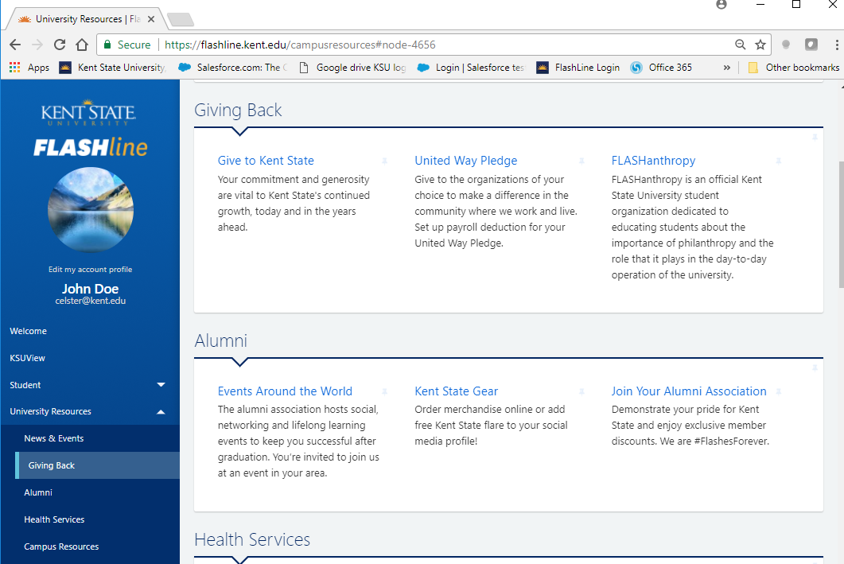

I. Employees with a current United Way deduction:

If you currently have a United Way deduction and would like to continue that deduction in 2021 -2022 with no changes in the amount of allocation, select ”Roll Over United Way Deductions” to roll your current deduction forward to the next year.

If you would like to change your deduction in any way, select ” Change United Way Deduction” and then click here or go to page 6 for further instructions.

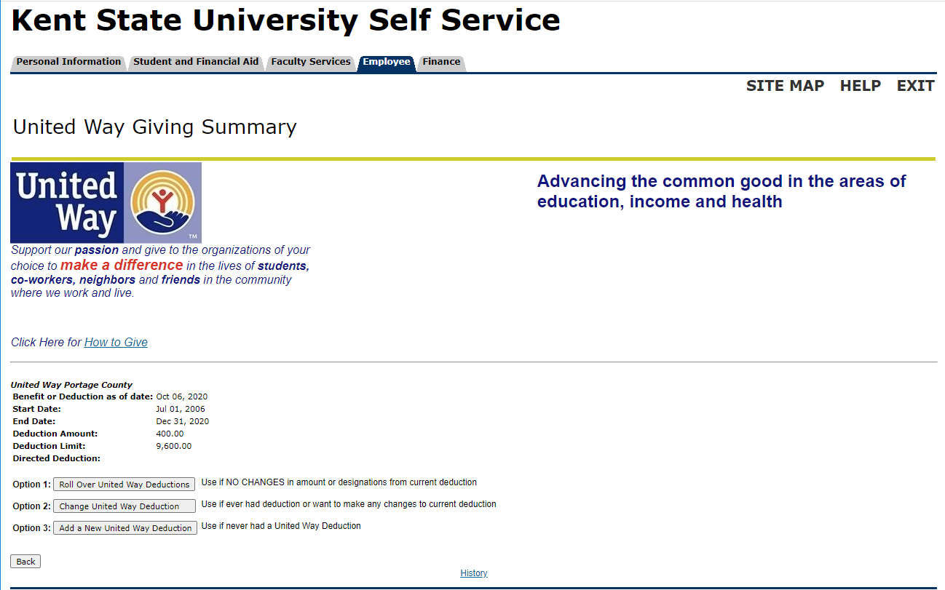

I. Employees with a current United Way deduction…continued.

The screen shown below will display. Select “Yes – Roll Contribution” to complete the election process.

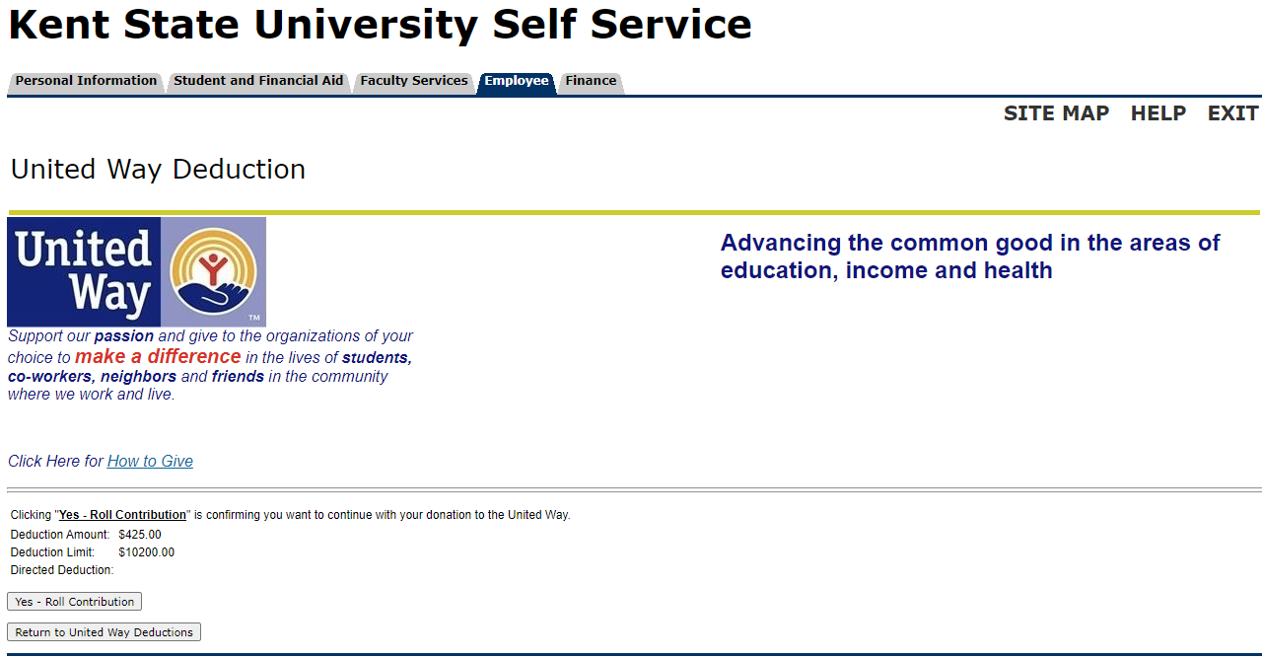

You are finished! A message telling you that you have successfully rolled over your contribution will display. To view the message, click here or go to page 9.

II. Employees who have never had a deduction to United Way through Kent State

If you have never had a deduction to United Way through Kent State, select “Add a New United Way Deduction” at the bottom of the screen.

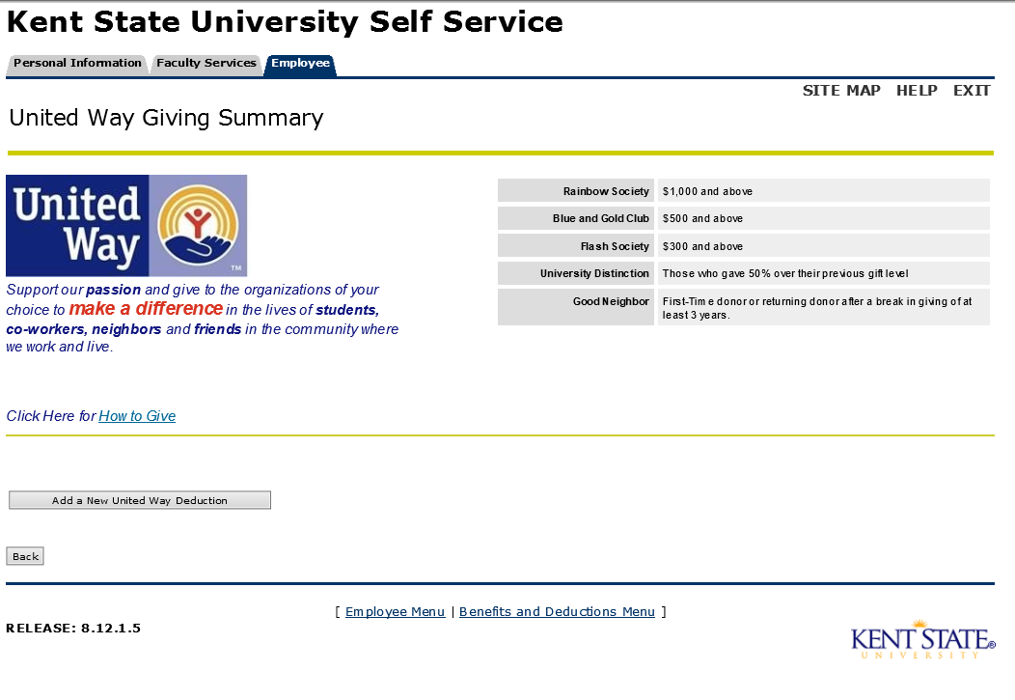

Select the United Way County of your choice by clicking on the Radio Button and then clicking “Select Benefit”.
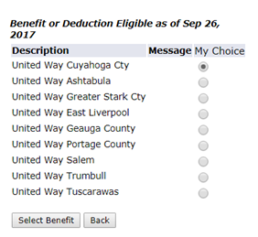
Click here or continue to page 6 for the next steps.
III. Employee who have had a deduction in the past but do not currently have an active deduction

If you have had a deduction in the past, but do not have an active deduction currently, you will need to click on the “Add a New United Way Deduction” button. You are not able to update a prior United Way deduction which is no longer active.

A list of counties will be displayed, including the county you gave to previously.
Select the United Way County of your choice by clicking on the Radio Button and then clicking “Select Benefit”.
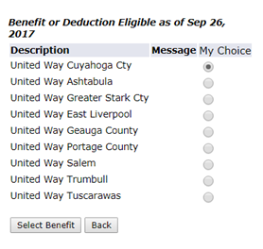

IV. Selecting a Contribution

Once you have chosen to either continue your current deduction or elect a new deduction, the screen shown below will display.
- You may choose to:
  - Enter a “Deduction Limit per Year” and click “Calculate Per Pay Amount” or
  - Click “One Time Donation”.

To be excluded from recognition, check the box shown below with a

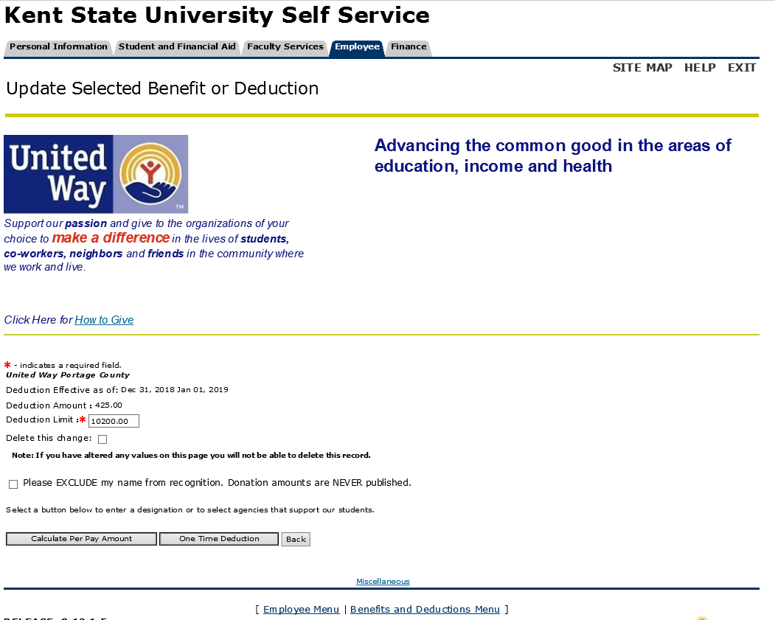

IV.1. Deduction Per Each Pay Period - Limit

If you choose to make deductions throughout the year the screen below will be displayed to show what the calculated per pay amount. You are unable to change the per pay amounts.

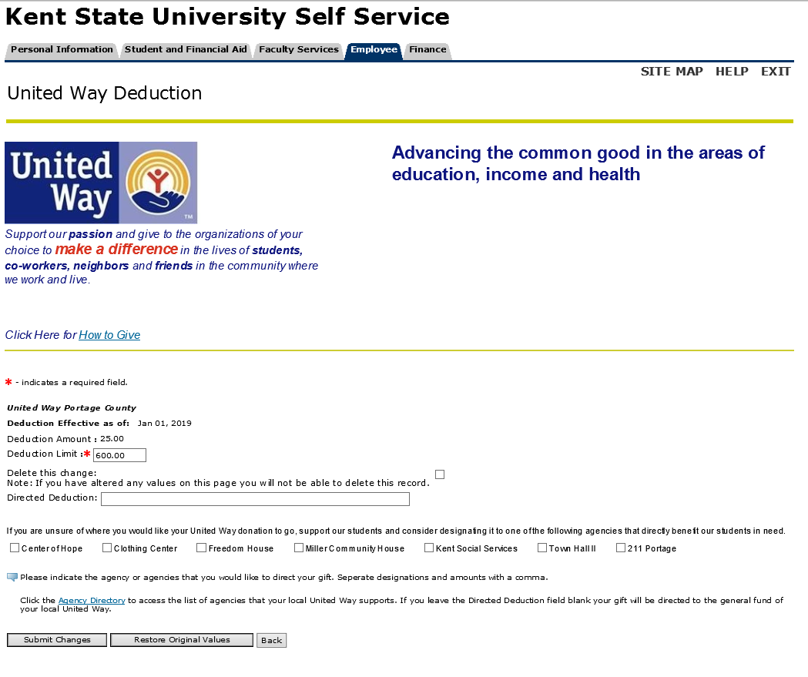

You may indicate the agency the you would like to direct your gift to in the Direct Deduction box. You may select multiple agencies by separating the designations and dollar amounts with commas. NOTE: Each agency designation must be at least $48.00. For example: Boy Scouts $50, Girl Scouts $50, Clothing Center $50. Make sure that the amounts add up to your deduction limit.

If the field is left blank, your gift will be directed to the general fund of the United Way you selected.

IV.2 One Time Pay Contribution

If you choose to enter a “One Time Deduction”, the screen seen below will display:

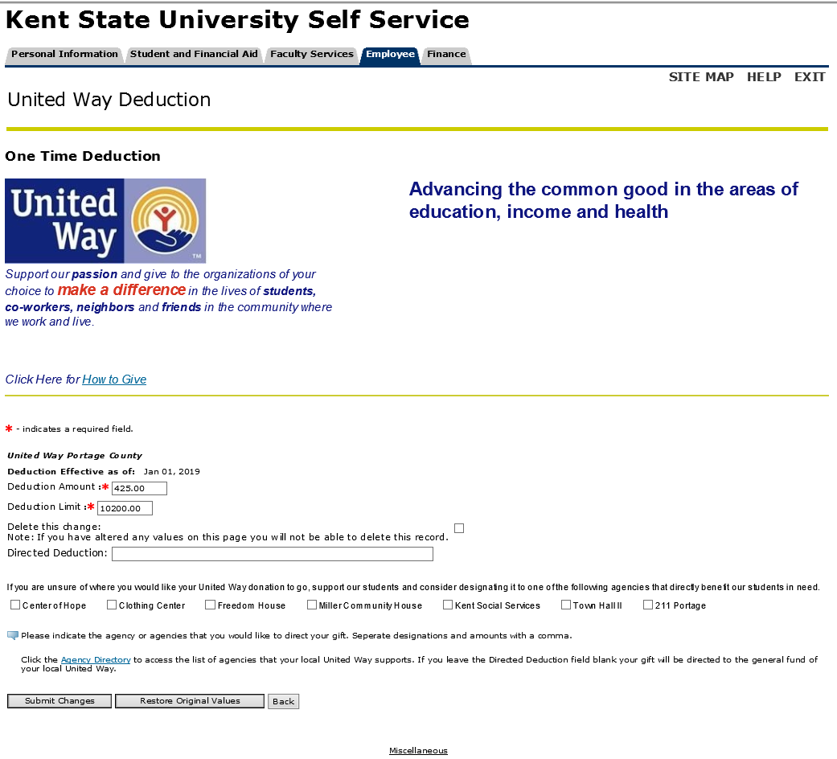

You may indicate the agency that you would like to direct your gift to in the Direct Deduction box. You may select multiple agencies, by separating the designations and dollar amounts with commas. NOTE: Each agency designation must be at least $48.00. For example: Boy Scouts, $25, Girl Scouts $25, Clothing Center $50. Make sure that the amounts add up to your deduction limit. If the field is left blank, you gift will be directed to the general fund of the United Way you selected.

NOTE: The valued entered in both the * Deduction Amount and *Deduction Limit boxes must match exactly. These are both required fields.
V. Completing the Contribution

You will complete the transaction by clicking the “Submit Changes” button. A confirmation screen will display once the Submit Changes button is selected.

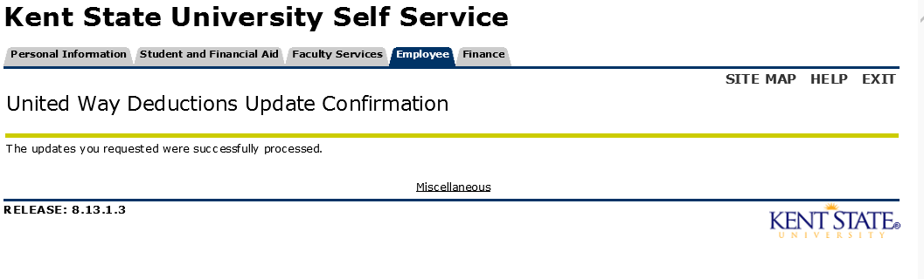

You will also receive the following confirmation email.

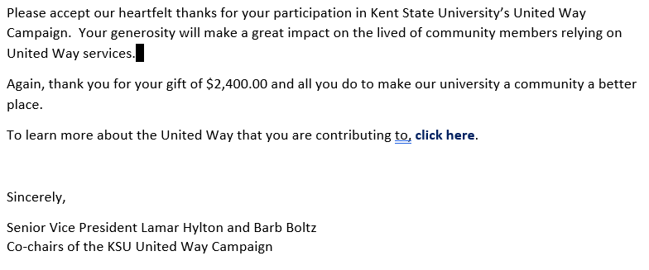

VI. Viewing your deduction history

Once you have made your election, you can view your deduction history by selecting the History link near the bottom of the United Way Giving Summary page. You can also review your elections on this page.

