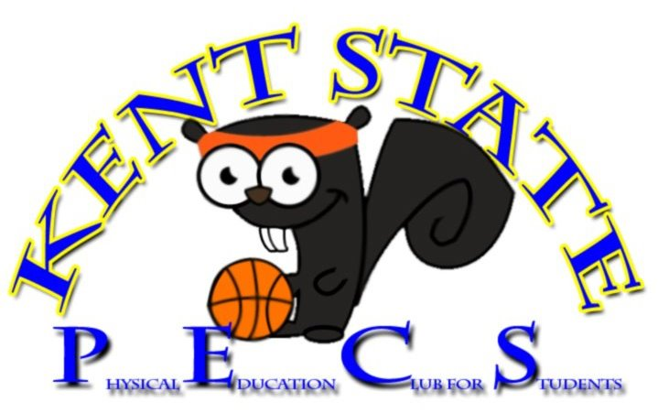

Hello & Welcome to the webpage for Kent State’s Physical Education Club for Students (PECS)! We are dedicated to learning, advocating, and growing as professional physical educators. We promote our purpose through monthly meetings, fund-raising events, and attending our state and nationally associated organizations, OAHPERD & AAHPERD. Specific dates and times will be announced and distributed as such information unfolds. Please check here regularly for more information and updates for our organization!

President: Kathryn Damicone…………………………………………………e-mail: kdamicon@kent.edu

President Elect: Caitie Kilbane……………………………………………….…e-mail: ckilban3@kent.edu

Secretary: Karli Scaffide………………………………………………………….…e-mail: kscaffid@kent.edu

Treasurer: Arielle Brafman……………………………………………………..e-mail: abrafman@kent.edu

Events Coordinator: Kyle Maricle……………………………………………..e-mail: kmaricle@kent.edu

Public Relations: David Gentry…………………………………………………e-mail: dgentry4@kent.edu

