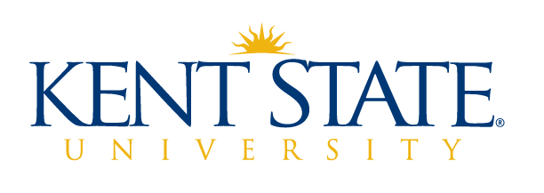

Advisory Committee for Academic Assessment (ACAA)
University Accreditation Accountability Committee (UAAC)
Accreditation, Assessment and Learning
Office of the Provost
Kent State University

May 12, 2022 Joint Meeting

AGENDA

- Welcome

- AY 2021-2022 Accomplishments

- ACAA Co-Chair election results

- Fall meeting ideas

- Updates/Announcements

- Upcoming meetings
  - ACAA - Fall calendar invitations will go out in August
  - UAAC – May 19 to review final HLC Quality Initiative

Meeting adjourned

