FAIVNDH – Vendor Detail History
Use this screen to view vendor payment history by fiscal year or by time period based on invoice dates.

- Login to Banner and type FAIVNDH in the search box and then hit Enter.

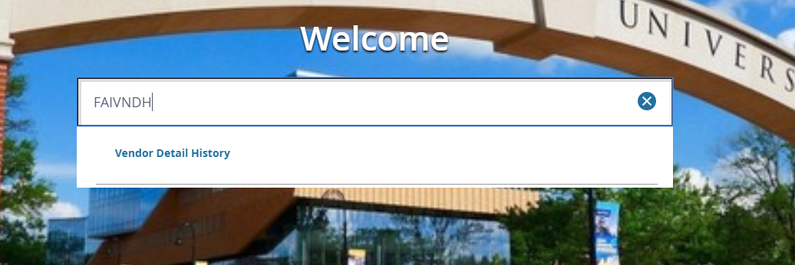

- You will be taken to the Vendor Detail History form, which can be used to search and view the payment history for a specific vendor.
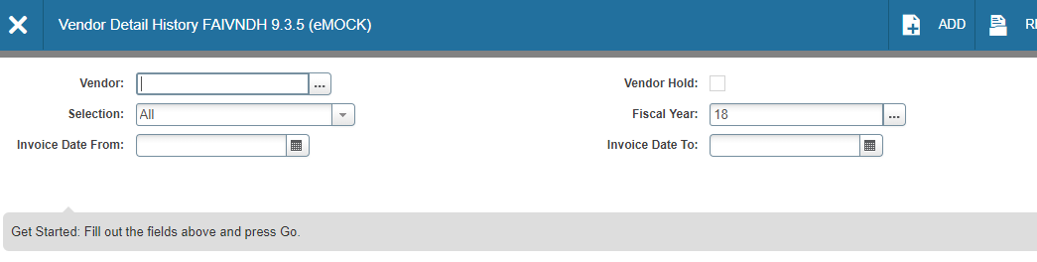
- On the vendor history screen, enter the vendor’s Banner ID number in the Vendor box. If you do not know the vendor number, click on the three dots that are on the right side of the Vendor box that is located to the right of the Vendor box and then click on Entity Name/ID Search.
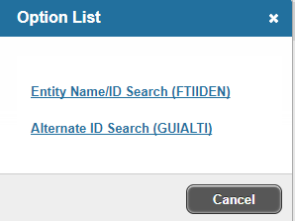

- You will be taken to FTIIDEN. Click on the Add Another Field button and choose Last Name (even if you are searching for a company and not an individual.)
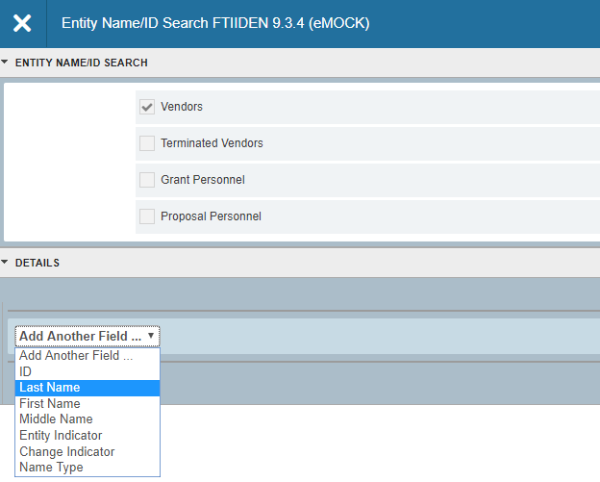
- Choose the limiter (e.g., Contains, Starts With, etc.) and enter your first search term, keeping in mind that this form is case sensitive. Next, consider adding another field in order to narrow the search. Search tips:
  - If you know that certain letters in the name are capitalized, enter them that way.
  - If you use the wildcard (%) do not use the Equals limiter.
  - If you do not know if letters are capitalized, use the wildcard (%) in their place.
  - If you know that the vendor has the word “Incorporated” or “Company” in its name, add at least part of those words.
  - Add additional fields to help narrow your search. For example, if you are searching for an individual, enter a partial or full first or middle name.
  - Add a search field with the parameters Name Type, Equals, VEND for all non-employee payees (both individuals and companies.)
  - See Search Examples on following page

FTIIDEN – Search Examples
Do you know the official name for the company commonly referred to as “Pepsi”?  Enter wildcards both before and after “Pepsi” in order to find the company no matter which of the above are correct. Add a Name Type of VEND in order to narrow the search to vendors that have been paid through Accounts Payable. | 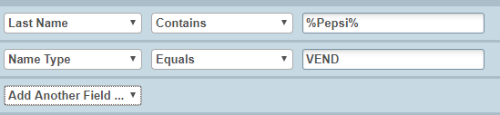  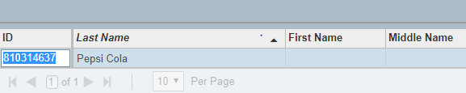
Can’t remember if the company is Collegenet or CollegeNET but you do remember that it has an “Inc” at the end?  Enter wildcards and the name type VEND to help narrow the search. | 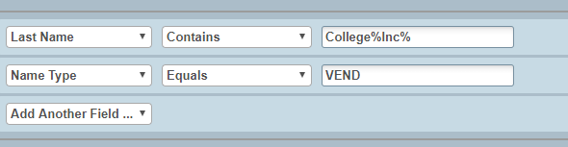  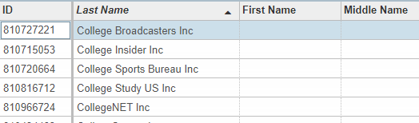
Use the First Name field for individuals.  If you know exactly what the name is, use Equals, if you need to use a wildcard for part of it, use Contains.  Do not use the VEND name type for employees. | 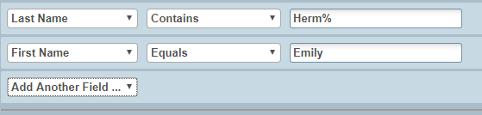  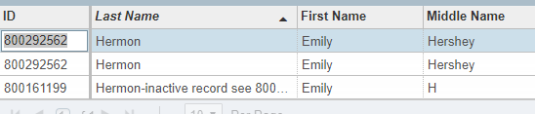

- Once you have entered your search terms, click F8 or GO in order to execute the search. A list of vendor names matching your query will appear. Double click on the vendor name that is correct and has VEND in the Type column. This will take you back to the FAIVNDH screen, where that vendor’s Banner ID will now be in the Vendor box.
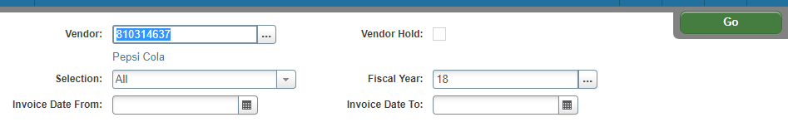
- The FAIVNDH screen will default to showing all payments during the current fiscal year. The following details may be limited if you so choose:
  - Selection – can be set to All, Credit Memo, Open (the invoice has been keyed but no payment has been processed), or Paid
  - Fiscal Year – can be changed to a different fiscal year or can be left blank. Leaving it blank and not entering anything in the Invoice Date fields will return results from FY08 through the present
  - Invoice Date – allows searches based on the vendor’s invoice date
- In order to view the payments, click Alt-PageDown or click on the GO button. This will return a full list of payments based on the parameters you chose.
  - Vendor Invoice = vendor’s invoice number
  - Invoice = Banner document number
  - Approval = has the payment finished being keyed (Y/N)
  - VIC = is more than one vendor invoice is associated with the Banner invoice (Y/N)
  - Credit Memo = is a credit memo (Y/N)
  - Open/Paid = an O indicates that the invoice is in the queue to be paid, P indicates that it has been paid
  - Cancel = indicates whether the payment was canceled (Y/N)
  - Vendor Invoice Amt = amount paid
  - Due Date = date on which the check run that includes this payment will occur/did occur
  - Check Date = date on the face of the check; usually the same as the due date
  - Check Number = starts with a 7 is a paper check; ! is an ACH direct deposit processed by AP; C is an AP credit card payment; U is a single use payment and W is a wire or ACH processed through the Treasury dept.
NOTE: Check runs occur at 8 p.m. Checks are printed on the morning of the next business day.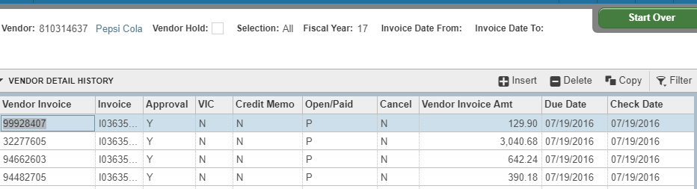

- To roll back in order to change the vendor, fiscal year, etc., click F5.

- Once you have a full list of invoices, you can filter the results:
  - Click F7 or hit the Filter button in the upper right corner of the results.
  - Choose the field to filter and enter your search the same as you did in Step 5
  - Click F8 or Go to run the filter and view results
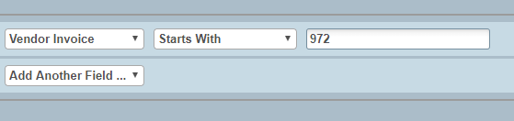
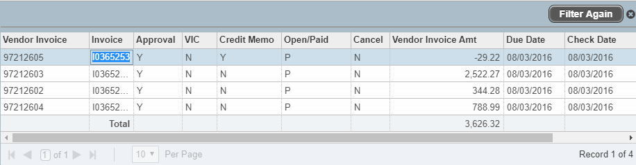

- To view the scanned documents related to the invoice, put your cursor on the invoice number and then click on the Retrieve button in the upper right corner.

- To view the information that was keyed for an invoice, click on the Related button and then choose View Invoice Information [FAIINVE]
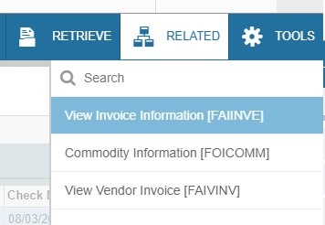

- This takes you to FAIINVE, which is the inquiry version of the form that Accounts Payable uses when keying invoices. Click Alt-PageDown or hit the down arrow in order to scroll through the different sections of this form.
  - Invoice/Credit Memo Header – lists the vendor invoice date, vendor invoice date, address on the payment, direct deposit status
  - Commodity Information – lists commodity codes entered for the payment
  - Accounting Amounts – lists accounting breakdown entered for the payment
  - Balancing/Completion – shows that the payment was in balance—commodity total equals accounting total

- Click the X in the upper left corner next to the screen name in order to go back to FAIVNDH.

