FGAJVCQ – Journal Voucher Quick

Type form name FGAJVCQ and then Enter
You can also use the search feature and type “journal” to search for journal entry forms

If you are entering a new journal entry you will need to make sure that the document number box is cleared. A number will be assigned to your entry after the FOATEXT has been added.
You can click on the down arrow icon located at the bottom left of the screen, click on the green GO button or Alt+Page Down to go to the next section.
The transaction date will automatically populate.

Input your hash total (absolute value of all debits and credits) then tab to next section.
Go to RELATED and select Document Text (FOATEXT)

You should see the following screen. Put your cursor in the text box and at the minimum type your name and telephone extension. Characters per line are limited to 50 but you can use the arrow down on your keyboard or the Insert button in the General Text Entry line to add additional lines. This information can be viewed in Banner and when utilized will provide detailed information regarding the journal entry.
After you have entered the FOATEXT click on the “X” to the left of the form name. Banner will ask you if you want to save the changes that you have made, click on YES. You will be back on the previous screen.
Note that a check mark now appears in the Document Text Exists box and a journal number is assigned.
Click the arrow down icon located at the bottom left of the page and you will be taken to the transaction section of the journal entry.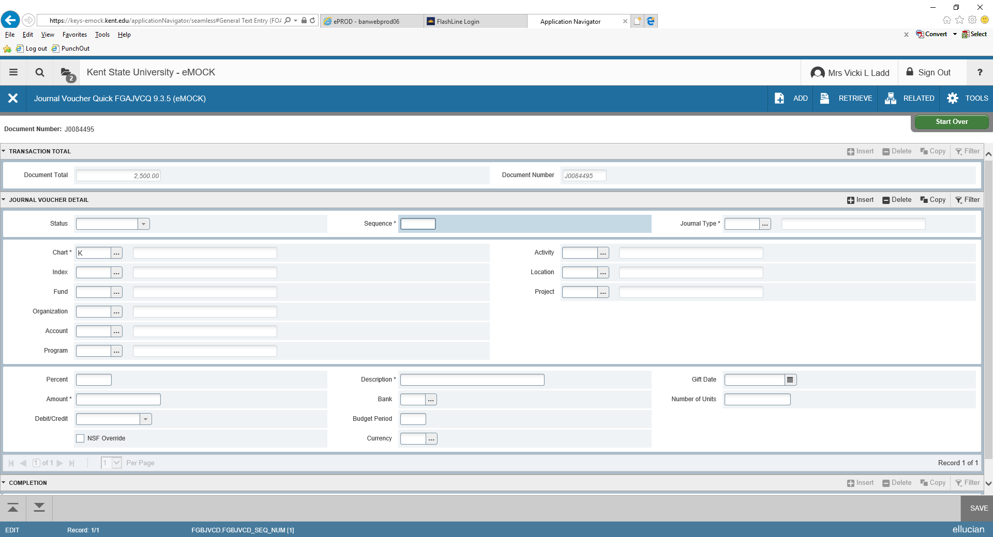
In the JOURNAL VOUCHER DETAIL section tab over to the Journal Type box and input IDC, COR, etc. or you can use the … which is a drop down feature.
Click in the Index box and either input the index or use the drop down feature (…) to locate the index number you wish to use. Note that when you input an index number the name of the index as well as the fund, org and program will autofill. (This can be used to verify department information)
Tab down to Account and input account code or use the drop down feature (…) to locate the account number you wish to use. The name of the account code will appear and can be used to verify that you have input the desired account code.
Tab down to amount and input amount
Tab down to Debit/Credit and select either debit or credit from the drop down or type in C or D then select credit or debit when it appears then tab
Tab over to the Description box and type the description to appear in the description field in Banner (this is different from the FOATEXT). Space is limited so be brief but make the description meaningful.
Tab through remaining fields (it is likely you won’t input anything in the remaining fields)
To input the next record, click on +Insert in the Journal Voucher Detail line
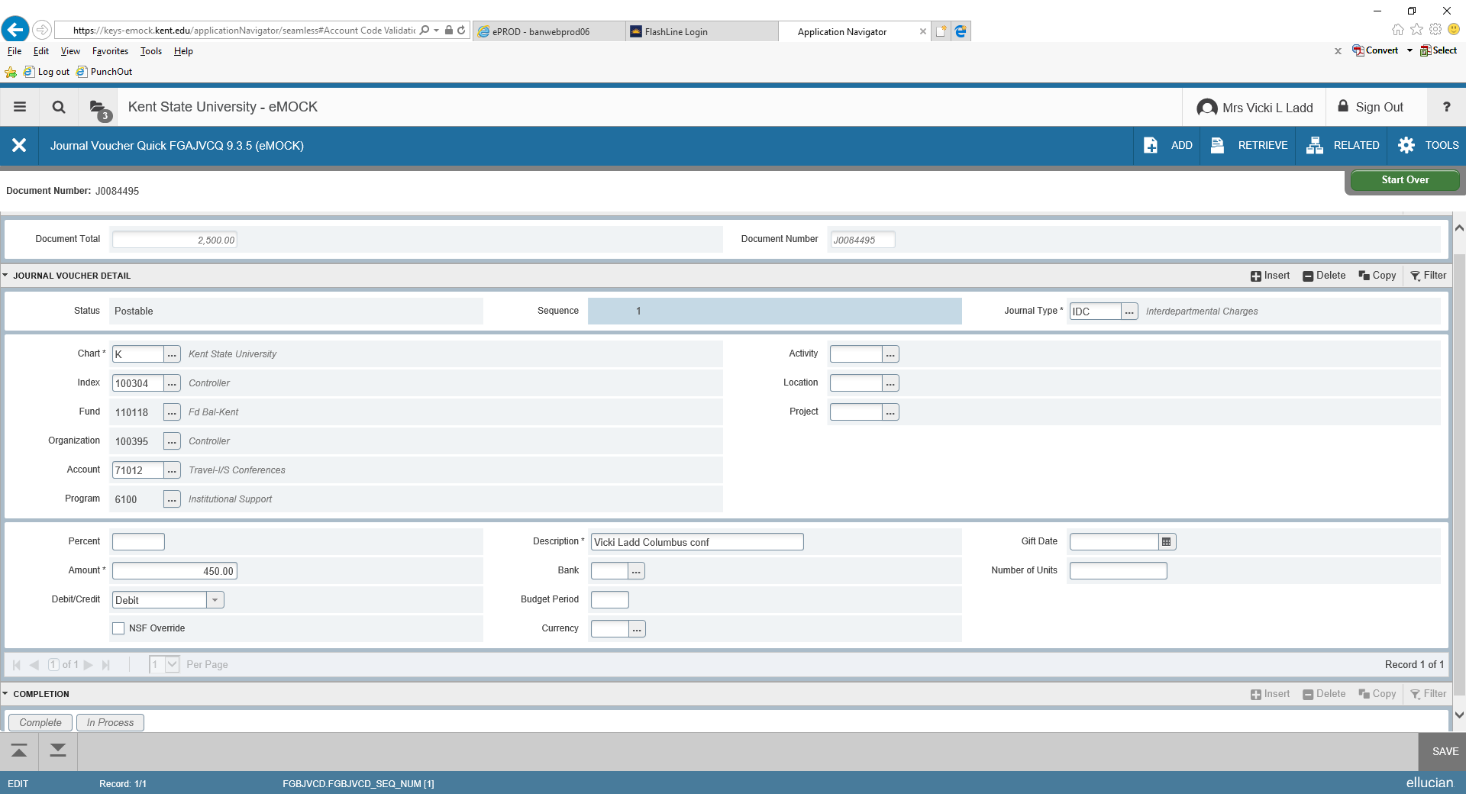
Continue with the next transaction using the steps above. Remember that your debits must equal your credits or the journal will not balance.
You can click on F4 and the next record will be duplicated. You will need to remember to update applicable fields such as index, account, debit or credit.
If you do not use the F4 duplicate function you will need to enter the index, account and other fields that are *asterisked. (Asterisked fields are required fields.)
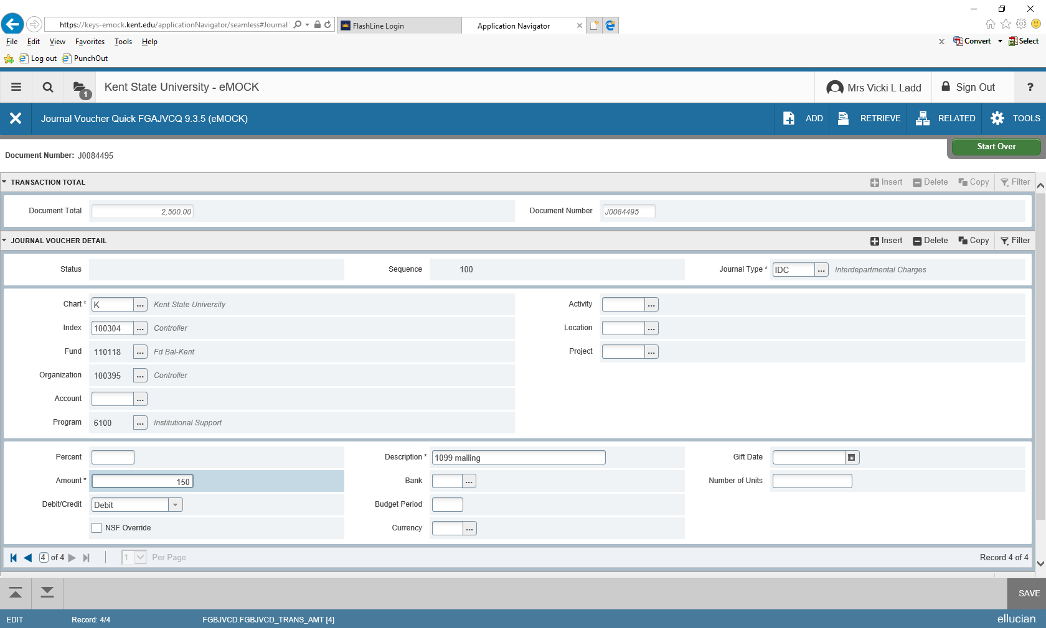
In this example I have 4 records to make up the Hash total. At the bottom left of the screen and above the previous and next section icons you will see the number of records that have been input and the record number that is currently appearing on your screen. Use the arrows next to the number of records to go to previous or next record.
Once you are done inputting all of the transactions that make up the hash total, click on “Related” and select Access Transaction Summary Info FGIJSUM for a summary of your transactions.
You should see something similar to the screen below. If status does not show “Postable” then there is a problem with that record and it will need to be corrected before the file can be completed.
To go back to the journal entry page, click on the “X” to the left of the form name. You should be back on the last record of the entry. If the file is postable make sure you are on the last record then click on Next Section.
If you have an “error” under status you will need to go into that record and correct it. To do this, in the line that shows the number of records (as noted above), go to the record, determine error and make the correction.
After all records are corrected and the status shows “Postable” in the FGIJSUM report you are ready to complete the transaction.
Due to the screen sizes, you may need to use the scroll bar located at the right of the screen to scroll down to the bottom of the page to the COMPLETION section. You will need to Click on the Next Section (arrow down) button to get into that section of the form.
Click on “Complete”.
If everything is ok, you should receive the following message: Document J00xxxxx completed and forwarded to the approval process.
The transaction will be reviewed by the Controller’s office and will either be approved or disapproved. If the document is disapproved, then you will be notified and will need to go into the transaction and make the needed change(s). Once the change(s) are made you will need to “Complete” the process again and it will be resubmitted to the Controller’s office.
Any journal entries not in a postable status at month end are deleted and cannot be retrieved.

VIEWING THE STATUS OF A JOURNAL ENTRY
In Banner go to form FGAJVCM and enter.

If you know the journal entry number, you can input the number in the Document number box then click Go.
If you do not know the journal entry number click on the “…” next to the document number box.
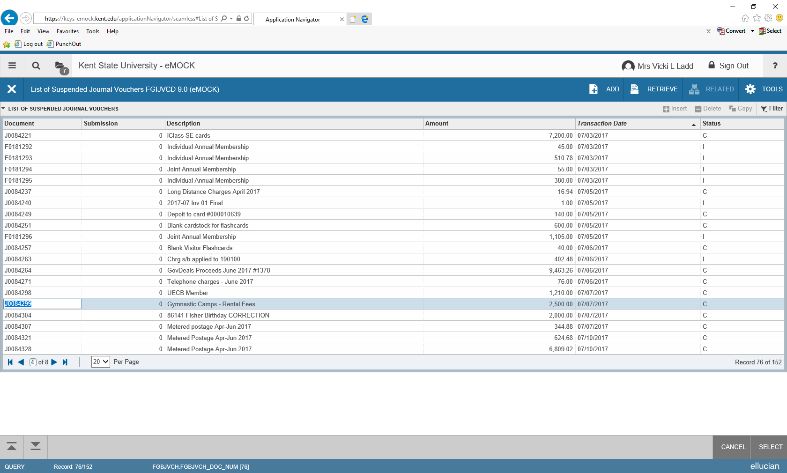
In this example 20 items will appear per page. You can select as few as 10 items or as many as 50 to appear on a page. Also note that there are multiple pages of unposted journal entries. An “I” in the Status column is an incomplete journal entry and it is not postable; it is either out of balance, contains an error, has been disapproved or the user may have the entry indicated as “in process”. A “C” under status indicates that the entry has been completed by the initiator but has not been approved yet by the Controller’s office. An item noted with a “C” cannot be viewed or changed by the creator; if you need to make a change you must contact the Controller’s office and request that the entry be disapproved. Once an item is disapproved the status will change to an “I”. Incomplete entries are deleted if they have not been corrected or completed in the month that they were initiated.
You can sort this file by Amount, Transaction Date or by Status. Once you find the journal you need to update, double click on the journal number or click on the number then click on SELECT (located bottom right of screen). Journal number will appear in the document number box, click Go.
If your entry has an “I” under status, then you will need to correct the entry before it can be posted.

DISAPPROVED JOURNAL ENTRIES
If an entry is disapproved by the Controller’s office the creator of the IDC will receive an email indicating that the entry was disapproved and why it was disapproved. The creator can use the steps above to retrieve the entry and make the needed corrections. An “I” in the status field can be due to a disapproved entry or an entry that was not marked as completed by the creator.
Once the error has been corrected be sure to section down and click on “Complete” so that the entry will appear as completed and ready to be reviewed by the Controller’s office. The Controller’s office does not review entries in an “Incomplete” status.

PRINTING AN IDC/JOURNAL ENTRY
It is easier to print a copy of the journal entry using Banner Self Service. The format is easier to read and the print is larger.
Login to FlashLine; locate Finance Self-Service Banner.
Click on View Document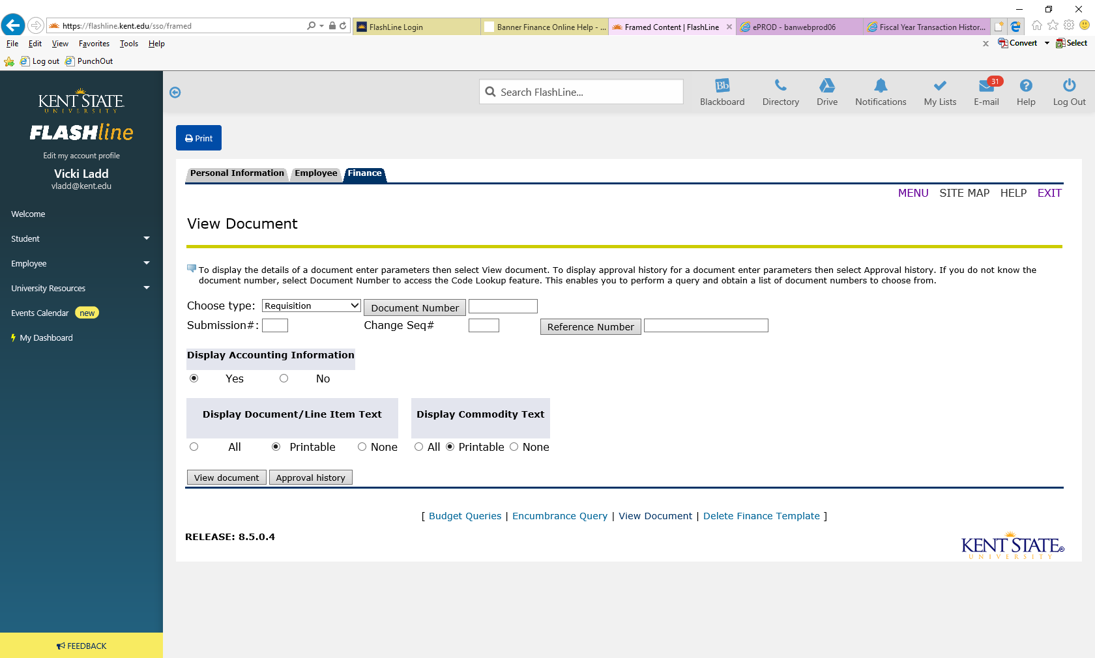
Using the drop down arrow change Requisition to Journal Voucher. Type in the Document number.
Display Accounting Information – Yes
Display Document/Line Item Text – Printable
Display Commodity Text – Printable
Click on View Document
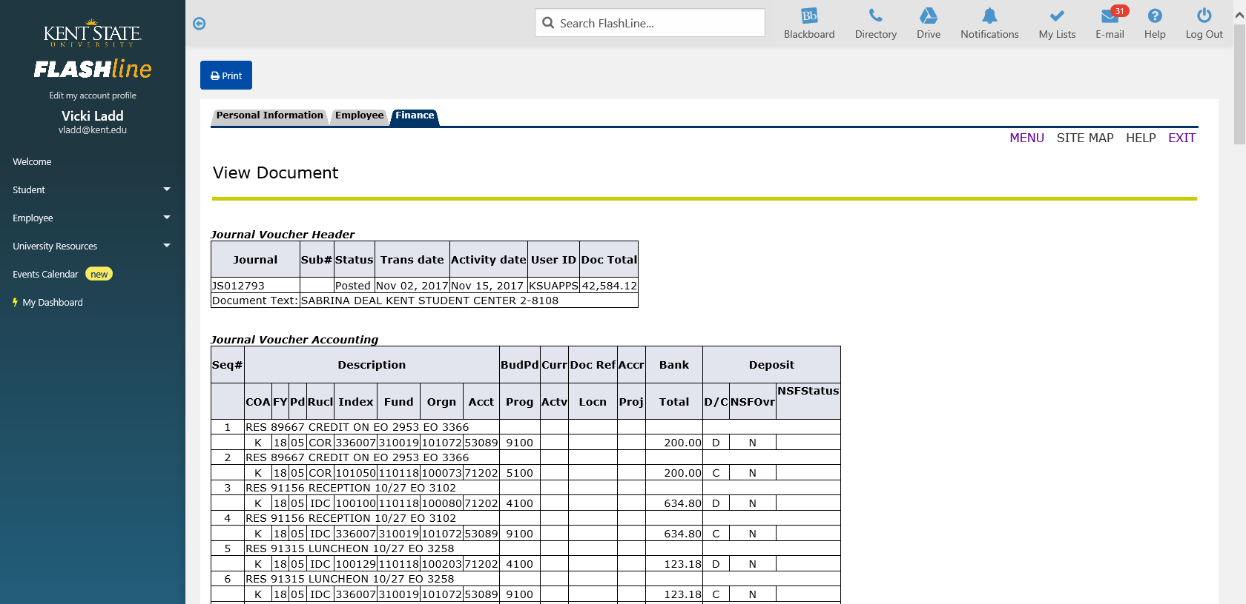

You will see the journal number, status of entry, transaction date, activity date, user ID, document total and text associated with the entry. The Journal Voucher Accounting area will provide all of the information associated with the journal entry.
To print the entry, click on the Print icon at the top of the page.

