Business Administrator Services

Forum Minutes

June 10, 2015

Kent Student Center Rm 310

Don Head, Occupational Health and Safety Coordinator

Environmental Health and Safety

Introduction to General Office Safety

Don provided the group with tips and guidelines to promote safety in our work environments.

He also addressed health and safety hazards. The office, like any other environment may present potential health and safety hazards. Many of these hazards may be eliminated by addressing such elements as ergonomics and environmental controls.

All occupational safety programs are based on responsibilities by management and employees. It is management’s responsibility to provide a hazard-free workplace and to also provide training regarding safety at work. Kent State University will provide training in Hazard Communications, Ergonomics Awareness, Basic Electrical Safety, Back Safety and Slip, Trips and Falls. It is each employee’s responsibility to follow safe work practices, report conditions that could be hazardous and maintain sanitary work conditions

Occupational Noise

Noise induced hearing loss is permanent and can cause serious physical, psychological and safety-related consequences. Most office noise is not loud enough to create a hazard which would require hearing protection; however, steps can be taken to reduce office background noise:
- Select quietest equipment available (when there is a choice between 2 or more products, sound levels should be considered)
- Properly maintain equipment – lubricate or tighten moving parts to eliminate squeaks and rattles
- Place loud equipment in an area that will be less detrimental
- Use dividers to isolate noise sources

Electrical Safety

If you are not qualified by KSU to work on or near electrical equipment, don’t do it.

Electric shock is different than electrocution but can still cause trauma to the body by passing electric currents through the body. The injuries associated with electric shock are categorized as follows:
- 1st degree - redness and pain, not permanent. Similar to mild sunburn.
- 2nd degree - blistering, skin will regenerate
- 3rd degree – total skin depth destroyed. Skin will not regenerate, requires grafting.
- 4th degree – underlying muscle damage exists

Do not open electrical panels or operate circuit breakers to use as light switches. Opening and closing the circuits in this manner is considered electrical work and is prohibited to non-qualified employees.

Safe Work Practices

In an effort to promote safe work practices the items below are reminders to everyone:
- Never stand on a chair or table to reach anything, use a step ladder instead.
- The top of your computer should be at eye level to avoid neck strain
- Keep aisles, hallways and corridors clear. These areas need to be clear to avoid falls and also in case of an emergency evacuation.
- Use safe lifting practices
  - Keep your back straight and lift with your legs.
  - If a load is too heavy to lift alone, get help.

Housekeeping

Good housekeeping is an important element of accident prevention in offices. Poor housekeeping can lead to injuries, unhealthy working conditions or even fires.
- Passageways in offices should be free and clear of obstructions
- Filing cabinet drawers should always be kept closed when not in use. Place heavy files in bottom file drawers.
- Materials stored within supply rooms must be neatly stacked with stacks short enough so that they don’t topple over. Adequate aisle space is required for easy accessibility. Under no circumstances can materials be stacked within 18 inches of ceiling fire sprinkler heads.
- Spills (both liquid and/or debris) should be cleaned up immediately or cordoned off to prevent slips, trips or falls.

Slips, Trips and Falls

Good housekeeping can eliminate many slips, trips and falls. During inclement weather employees should take their time when on wet or slippery terrain.
- Appropriate footwear is encouraged i.e. change into your dress shoes once you reach your destinations, use strap on cleats over shoes and boots etc.
- Keep cords out of traffic aisles or use a cord cover
- Clean up spills quickly
- Do not block passageways
- Keep office areas clean
- Keep storage areas safe – do not stack items higher than shoulder height. This reduces the risk of the stack falling and decreases muscle strain on the upper body when retrieving items from the top of the stack.

Indoor Air Quality

Indoor air quality (IAQ) is an increasingly important issue in the work environment. Some factors leading to poor indoor air quality include:
- HVAC systems may not have been changed to accommodate changes in floor plans
- Building renovations, new carpeting, installation of modular office partitions, painting, etc. can cause unpleasant odors
- Poor morale can manifest themselves as air quality concerns. Conservative estimates indicate that up to 50% of air quality concerns are attributable to poor morale.
- Strong fragrances such as perfumes, powders, aftershave lotion and cologne can be an irritant to other employees in the work area. Although one scent may be pleasing to one it could be a health risk for those with asthma, allergies or other sensitivity to smells.
- Plants may cause more harm than good with regard to air quality. While plants may slightly increase the level of oxygen, they are also prone to increasing the level of mold spores and insects as well.
- Don’t bring your pets to work; animals are limited to service pets only.

If you have concerns regarding indoor air quality contact the department of Environmental Health and Safety.

Employee Report of Injury

If an employee is injured at work they are to complete an Employee Report of Injury or Occupational Illness form. Page 1 is to be completed by the injured employee (if possible should be completed by the end of the work shift) and Section II, of page 2 is to be completed by the employee’s supervisor. Form is to be signed and dated then forwarded to Environmental Health and Safety, Room 310 Harbourt Hall.

If an injury or incident involves a non-employee, a non-employee injury form should be completed. Both forms can be found at www.kent.edu/compliance/risk-management.

Office Equipment

Learn how to operate office equipment. If you are uncertain, ask.
- Avoid loose clothing, jewelry and long hair from getting too close to machines
- Keep hands and fingers clear of machines while they are in operation
- Switch machines off before trying to clear a jam or a blockage. If possible, unplug them.

Common Office Chemicals

Many chemicals can produce hazards if used incorrectly; read the instructions to ensure proper use and storage. In the event of an accident or emergency, take the container with you to DeWeese Health Center or the hospital. Common office chemicals include cleaning agents, toners and inks, cleansers, solvents, paints and adhesives.

Emergency Evacuations

Pay attention to where the emergency exits are located. Know where stairs are located since elevators cannot be used in the event of a fire.

Employee Safety

We are responsible for our own safety. This responsibility includes understanding and practicing safe work habits, reporting hazardous conditions which others may not be aware of and not engaging in horseplay. Be sure to report situations that you believe may be unsafe.

Training regarding any safety issue can be provided by contacting the Environmental Health and Safety Manager at ext. 29565 or by visiting their website at www.kent.edu/compliance. Kent State’s safety training is also available through Flashtrain. Flashtrain offers a very easy method to access safety training presentations and quizzes. The following is a step-by-step introduction to using Flashtrain:

- Log into your FlashLine account
- Select the HR tab near the top of the screen
- Go to the Training and Development sidebar on the right hand side of the screen and select Environmental Health and Safety Training Program.
- Through FlashLine, you have logged into your personal Flashtrain page.
- Go to the Testing/Training tab on the left side of the screen and select “Select Test.”
- Choose the desired training module from the drop-down window.
- When you have finished viewing the video, click on the “Take Selected Test” tab and begin the test.
The test is graded by the Flashtrain system and you are notified if you passed or failed. If you failed, you will be given another opportunity to retake the test for a passing score.

Tom Euclide, AVP Facilities, Planning and Operations

Michael Bruder, Executive Director Office of University Architect

Summit Street Construction Project

Kent State has been working with the city of Kent for over 5 years to improve the traffic flow on Summit St. Together, a large project grant from the state for $16 million was received and Phase I of the project is scheduled to start in Fall 2015. Construction is anticipated to take 30-33 months.

In anticipation of the Summit Street project, the university is addressing long-term parking and traffic circulation issues in the area of the Student Center visitors parking lot and the Bowman/Satterfield parking lots. The Ceramics Building has been removed and excavation in that area is already underway for the first phase of parking enhancements.

As part of the long range plan for the area, this project will allow for the greening of the Summit Street corridor through the construction of the Student Green, the Summit Street improvements, and improved visitor parking and circulation. The project will include the reconfiguration and reconstruction of the Bowman and Satterfield Halls Parking Lots and the Student Center Visitor Lot, the construction of an internal loop road on Risman Drive, and a new drop-off area for the MAC Center.

Phase I of the Summit Street roadway project is expected to take about one year and will affect Summit St. between Loop Rd and Fraternity Circle.

Phase II will affect Fraternity Circle to Lincoln.

During construction Summit St. will be one way with traffic only eastbound. Two roundabouts will be constructed aiding in the flow of traffic. Traffic lights will remain at Loop, Morris, Janik as well as the Lincoln intersection.

A short video was shown showing the transformation of Summit St. complete with roundabouts, turning lanes, pedestrian crossings and landscaped medians.

The University is working with the City of Kent on the creation of a website specifically for the construction project. The videos for the improvements as well as videos highlighting the anticipated traffic detour routes will be included on this website. The website should be activated by September.

Joe Raftovich, Sr. Network Design Engineer

Telecommunication Services

Pinnacle Monthly Reporting

Pinnacle is the software application used to view, reconcile and manage department telephone bills. Internet Explorer or Firefox should be used when accessing Pinnacle. If you use Chrome or Safari you are not able to see all the buttons required for viewing your bills. All employees can see their own phone activity but you must request permissions to view bills other than your own.

Login to Pinnacle at https://pinnacle.kent.edu. Be sure to bookmark the site for easy monthly access. Your username and password are the same as FlashLine.

To view a department bill you will need to login as department manager, select billing and use the department billing tab. The department bills have 4 billing sections:
- Subscriber-Account Overview
  - Lists subscriber’s name, ID and monthly charges
- Service Summaries
  - Provides data for each service number and each service category
- Account Summaries
  - Provides data by account (Banner index) and by subcode (Banner account)
- Detail for Account
  - Provides data by subscriber and detail for each category expense

To print a department bill, hover the mouse at the bottom of the webpage. In the center, a grey menu bar should appear allowing you to print or save

The Pinnacle bills should match the account codes and amounts in your Banner index. Departments should review their bill each month. Do the service numbers (phone numbers) belong to your department? Does the subscriber (employee) belong to the department? Telecommunications must be notified if changes are required due to telephones being moved, employees moving to different departments, phones that need to be made inactive etc. Submit a helpdesk ticket referencing the service/subscriber that needs to be moved or removed as well as the associated index number(s).

Look for anything that looks out of the ordinary.

Long distance personal phone calls should not be made using a university phone. If the call is necessary, the employee should reimburse the university for the expenses incurred due to the personal phone call being made. Employees should review and verify the legitimacy of calls. Although the reimbursement of personal calls is on an honor system, departments may opt to assign an employee to review all telephone expenses.

Designated department personnel can access department phone bills and distribute the individual bills for review:
- Login as department manager and select the desired billing date
- In the blue ribbon, select “individual bills”
- Click “Search” to list all subscribers in the department
- Select the desired “Subscriber ID” in blue
- Click “View Report”
- Print or save

If a department opts to have each employee review their own bills:
- Have each employee login as customer using their FlashLine username and password
- Select “My Account”
- Use the “Statements” tab to view all monthly bills
- Click on the desired billing date in blue
- Click “View Bill”
- Print or save

Personal phone calls should be highlighted and bill should be submitted to appropriate department personnel along with payment for the personal calls. Deposits should be made at the Bursar’s office using the department index and Banner account 73107 for long distance calls.

Any issues you may have with the telephones should be reported using the helpdesk. Login to http://support.kent.edu and submit a support ticket. Make sure you are clear and concise with the description of the issue.

A copy of the presentation with detailed steps and screen shots is available at

Pinnacle Telephone Reconciliation.

Renee Romine, Manager HR Training and Development

Beyond Compliance Training

The Division of Human Resources set a minimum goal for two hours of Beyond Compliance training for all faculty and staff to complete each fiscal year.
Beyond Compliance training provides a mix of learning opportunities that are geared toward relevant university policies and laws as it pertains to unlawful discrimination, harassment prevention and violence prevention. While some fulfill annual compliance mandates, all provide a wealth of information designed to heighten awareness and offer prevention solutions.
A blend of training options are available; webinars, online courses and facilitator-led sessions. The majority of the training hours were captured via webinars. Moving forward, courses will be flagged with the letters “BC” after the title and the amount of hours so that the courses are easy to identify in the employee’s training records.
If you are involved in university-related training that is not coordinated by Human Resources and it relates to discrimination, harassment and/or violence prevention, please ask the instructor to notify Human Resources in advance to make sure your training would qualify. Content, participant verification and tracking training hours are really important. To locate the Beyond Compliance page, go to the Kent State homepage and hover over the About KSU tab, click on the Administration tab and scroll down to the HR link. Once on the HR site, hover over the Training and Development tab to locate the Beyond Compliance page. The URL is http://www.kent.edu/hr/training/beyond-compliance . There you will find a link that will take you to a list of offerings. Courses will be added throughout the year.
If you have questions regarding Beyond Compliance, please contact the Human Resources Training and Development Office at 330-672-2100 or hrd@kent.edu.

Paula DiVencenzo, Tax Manager

Tax Updates

Information Reporting Changes

Due to new law (Foreign Account Tax Compliance Act-FACTA), either a Form W-9 or W-8 is required to be collected and retained for payments from accounts payable. These forms are requested by Accounts Payable, KSU Tax Manager or Payroll. It is the university’s responsibility to obtain proper information and compare with the IRS database. The Internal Revenue Service (IRS) imposes a $250 (formerly $100) fine for each tax form (1099 or 1098T) that is returned due to names and federal tax ID not matching.

Departments are not required to obtain the forms however there are ways to help protect the university from tax assessments and penalties. The collection of the forms can take a few days especially with vendors overseas so allow time for processing the tax forms. For example, if a payment request for a student trip overseas on a TPR is sent in four days prior to the trip, the payment will not be made in time. There is not always an e-mail on the invoice thus providing an e-mail address and specific contact person would also be helpful.

The W-8 or W-9 is valid for three years from the date it was signed. New forms are required when payments occur after the three years. W-9’s are for US citizens, resident aliens and US companies. W-8’s are for non-us citizens, non-resident aliens or foreign entities/organizations. The two types of forms are compared in the chart below.

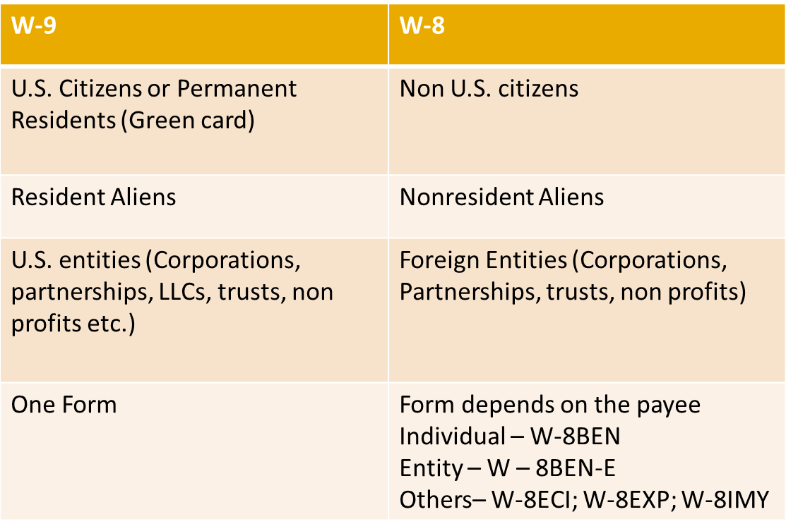

Requests for Kent State’s Form W-9

Outside parties may request Kent State’s Form W-9 before making payment. If you are asked to provide a W-9 to an individual or company, send your request to tax@kent.edu. Be sure to include the name and address of the person or entity that is requesting the information as well as the e-mail or fax number that the W-9 should be sent to. More details about Form W-9 can be found at http://www.kent.edu/tax/form-w-9-taxpayer-identification-number-certification.

Tax Website

The tax website is www.kent.edu/tax. Information about tax, the overlap between other departments and tax, and other information is provided for general knowledge. Taxation is heavily dependent upon the facts and circumstances therefore you are encouraged to seek tax guidance rather than using the information on the tax website for final conclusion especially with new arrangements or changes to existing situations.

Questions?

Tax related questions can be sent to tax@kent.edu or contact Paula at ext. 28622.

Tammy Slusser, Controller

Fiscal Year End Deadlines

E-mails were sent out to all departments on May 6, 2015 outlining the established cut-off dates for departments to send payment requests, transfer requests, expense reimbursements, deposits, IDC’s, funding requests and other financial transactions that need to be processed and included in FY15.

BAS Forum members were also reminded to review their departmental transactions for accuracy so that any corrections that are needed can be made. Additionally we were all reminded that the monthly reports should be reviewed monthly so that any corrections or changes that need made can be done in a timely manner.

NEXT BAS FORUM

OCTOBER 14, 2015

KENT STUDENT CENTER

GOVERNANCE CHAMBERS

As a reminder, if you have a topic that you would like to have discussed at an upcoming forum, please contact Vicki Ladd at vladd@kent.edu or at ext. 21956.

