Business Administrator Services

Forum Minutes

June 12, 2013 9:00 a.m. to 11:00 a.m.

Kent Student Center Room 204

Larry McWilliams - Assistant Manager, Procurement

Introduction of Ohio Desk

Larry introduced Colleen Kirkbride, Workplace consultant for Ohio Desk, an authorized dealer for Steelcase Furniture; and Don Carthorn, President of ASAP (American Shipping and Packing). Ohio Desk and ASAP have partnered and are a preferred vendor of Kent State University for office design, office furniture, office relocation and moving services.

Whether you are looking to relocate your office or upgrade your space you can count on Ohio Desk, authorized dealer of Steelcase office furniture, and ASAP to make the transition both smooth and functional. Designing a functional office space is only part of the responsibility assigned to Tammy Guinther, Education Solution Specialist with Steelcase.

The three companies: Ohio Desk, ASAP and Steelcase have been in business a combined 229 years. ASAP has been in business 24 years, Steelcase 100 years and Ohio Desk 105 years.

From ceiling to floors, designing and furnishing a functional workspace along with moving services and furniture assembly can all be provided by Tammy, Colleen and Don.

Promises are only as good as the company providing the promise. Ohio Desk and ASAP have made the following promises:
- To listen carefully and to ask the right questions to completely understand your needs
- To provide you with superior, customized solutions based on their knowledge, experience and expertise
- To communicate effectively and efficiently with you throughout the entire process
- To be responsive by being readily accessible and addressing your needs quickly
- Results by being on time, on budget, and following through until you are completely satisfied.

Selected office furniture and layout is determined by an extensive review of the area to be modified. Personnel are interviewed to determine the needs of the department. Furniture styles and needs are recommended based on the purpose of the space, workspace needs of the individuals and by analyzing the existing flows and functions of the department. Market research, office trends, use of space and needs are all taken into consideration resulting in a full scale model of the new space. Upon review and acceptance the next step is to place the order.

Steelcase is now included in the listing of punch-out catalogs in FlashCart which is located under the “My Action Items” in FlashLine.

Other services include carpet installation, carpet cleaning, fabri-coating and reupholstering. Remanufactured furniture is also available.

Design and Consultant Services
- Workplace surveys
- Design Development: field survey, inventory of existing furniture and needs analysis
- Provide preliminary layout and furniture budget
- Create final furniture drawings using 3D visualization tools and provide specifications
- Provide or assist with furniture selections and interior finishes
- Complete furniture installation drawings and attend any construction meetings as deemed necessary

Move Management Capabilities – depending on the extent of the project, the entire process may encompass many of the following:
- Inventory of existing furniture
- Space planning and configuring the offices
- Preparing time schedules
- Tagging and labeling
- Completing move flow charts
- Meeting with department managers
- Moving special items
- Supervising packing and moving of office contents
- Tearing down and re-installing existing furniture systems

For furniture questions or individual consultation contact Colleen Kirkbride at 330-498-6014 or ckirkbride@ohiodesk.com.

For moving services contact Don Carthorn at 800-597-2728 ext. #1.

A copy of the Active Learning Catalog can be dropped off for you. This has insights, applications and solutions for all areas on campus. Please contact Colleen Kirkbride if you are interested in obtaining a copy of the catalog.

Tammy Slusser, Controller

Request for New Index Number

Program Codes

Year-End Reminders

The “Request for New Banner Index and Fund/Org” form has been updated and the new form is now available on both the Controller’s website www.kent.edu/controller and the BAS website www.kent.edu/bas. Please discard any old forms and update any bookmarks that you may have on your computers. Note that this new form is to be used for non-sponsored programs only.

Each department index number has a unique combination of a fund + organization + program, often referred to as a FOP. The “program” is used for financial statement reporting as well as various external reporting for federal and state agencies and identifies the functional category of the expenses; in other words, the program indicates how the expenses are recorded.

The program code provides the greatest comparability of information across institutions and identifies the NACUBO (National Association of College and University Business Officers) classifications. It is used to generate the financial reporting of expenses by functional classification needed for the University’s Statement of Revenues, Expenses and Changes in Net Assets (i.e. income statement).

The program defines the “functional category of the expenditure” such as Instruction, Separately Budgeted Research, Public Service, Academic Support, Student Services, Institutional Support, Scholarships & Fellowships, Operation and Maintenance of Plant, and Auxiliary Enterprises.

New Information Required
- Name and Org number of the department that the new index will be associated with
- Suggested title of the new index
  - Limited to 35 characters including spaces
- Effective date of the new index
  - Unless specified the effective date will be the first day of the current month
- Purpose of Index
  - Why is the new index needed?
  - What is the new index to be used for?
  - What type of transactions will be recorded?
  - Attach any agreements or memo that will support the need and use of the new index
    - All documents are scanned and saved as part of the new index file
- Source of Funds
  - What is the funding source of the expenditures?
    - University operating budget
    - Revenues from charging a fee for the program
    - Membership fees, etc
- Will the index have revenue recorded in it?
- Will the index have positions assigned to it?
- Name and telephone extension of the person responsible for reviewing and reconciling the index
- Indicate the “Program” code that best describes the classification of expenditures to be recorded in the new index
  - Select the description that best describes the purpose of the expenses
  - A detailed description of each program type is provided
- Budget Officer is required to sign the form
  - Formerly signed by executive officer, this signature is no longer required
  - Regional campuses will be required to obtain Chris Hill’s signature

The new form is used to request a new index; however it can also be used for other purposes such as a change in organization, name change, termination of index etc. Tammy will continue to accept an e-mail from the business manager or budget officer requesting changes to an existing index; all new index requests must be made using the Request for New Banner Index and Fund/Org form.

Important:

If you are repurposing an index, you must review the “program” assigned to the index. Remember the index is a unique FOP and the FOP may need to be updated based on the new purpose.

To obtain the FOP associated with your index:
- From the Controller’s website select “FRS to Banner Crosswalk” from left menu
  - Input index number then submit
- From the BAS website select “Business and Finance Guidelines, Policies and Procedures” from the left menu
  - Under Banner-Index Listing you will find a listing of active indexes as of the date indicated on the file
- In Banner INB
  - FGRACCI
  - FTMACCI

Year End Reminders

Memos were previously emailed outlining the year-end cut off dates. These dates are crucial to ensuring a timely closing for FY13. Copies of the e-mails can be found under the June 12, 2013 forum minutes on the BAS website.

Emily Hermon stressed the need to allocate all department p-card transactions before 5:00 p.m. on July 5, 2013. Any transactions not allocated must be manually processed by Accounts Payable utilizing the same allocation process of each department. Unallocated transactions will be charged to the department’s primary index and office supplies code.

Please be advised that any unallocated transactions will result in the suspension of the department p-card. Before the card will be reactivated, the cardholder and approvers will have to repeat p-card training.

University Communications and Marketing

Rebecca Murphy - Associate Vice President, UCM

Dan Karp - Executive Director, Creative Services

Karen Mercer – Director, Marketing Research and Strategy
University Communications and Marketing provides professional consultation and resources designed to assist the communications and marketing efforts of programs and departments throughout Kent State University's eight-campus network. This includes help with advertising, editing, graphic design, media relations, photography, publications, public relations and web coordination, along with information about event planning and making speeches and presentations.
UCM is responsible for both internal and external news reporting. The e-Inside, faculty and staff blogs and success stories are all produced by UCM. They also prepare press releases, direct media pitches and supervise media visits and coverage.
UCM has won numerous awards including:
- 6 communicator awards from the International Academy of Visual Arts
- 6 awards from the Higher Education Marketing Report
- CASE awards for television spots, print advertisements, web and direct mail campaigns
- Gold SABRE Award for the Experience for Life campaign
- Most recently the team won 2 Addy’s for Mobius, the Fashion School Book and the “Raise a Red Flag” campaign for sexual assault awareness
Information can be shared with the university community in various ways. A request form along with details pertaining to each of the communications is located at http://www.kent.edu/ucm/services/comm/index.cfm#flashline
- FlashLine / Email Communication
  - Method of electronic information using either a targeted audience or the FlashLine portal (type of document will dictate avenue used)
  - Must be deemed as university business
    - Campus-wide critical notification
    - Important campus deadlines or other time-sensitive information for students
    - Important changes in student services
    - Announcement of official policies or changes in policy
    - Announcement from governance groups (USS/Faculty Senate/GSS)
- KSU Social Media
  - request should be submitted at least 1 week in advance of requested publication
  - KSU official Facebook page
  - Twitter
  - Google
- KSU Website
  - Request must be submitted 1 week in advance of the requested publication date to be considered
  - Must meet certain criteria and, due to timing and competing events, all requests may not be honored
    - Promotes upcoming events, news, and student, faculty and staff success stories
    - Means of communicating with the university and external community
- E-Inside
  - Faculty/staff newsletter
  - Management Update
  - Message Boards
- E-Calendar
  - http://www.kent.edu/news/event-submission.cfm
  - Event must have a definite time and place
  - Does not include announcements, holiday or closings
  - Needed at least 1 week in advance of the event
  - Departmental e-calendar accounts can be created if your department utilizes this calendar more than 10 times per year
- KSU Media Relations
  - Seek ways to generate coverage that will enhance the image of Kent State University
    - Local, regional, national and international
    - Includes print, broadcast and the internet
  - Story or event may be specialized or to a limited audience
    - Will work with you to determine the appropriate audience for your message
    - Will work with you to determine the appropriate message for your audience

Whether you are looking to advertise, update telephone directories, order business cards or request a social media post, UCM offers a variety of services and resources. Visit the UCM website at www.kent.edu/ucm or contact them at 2-2727.

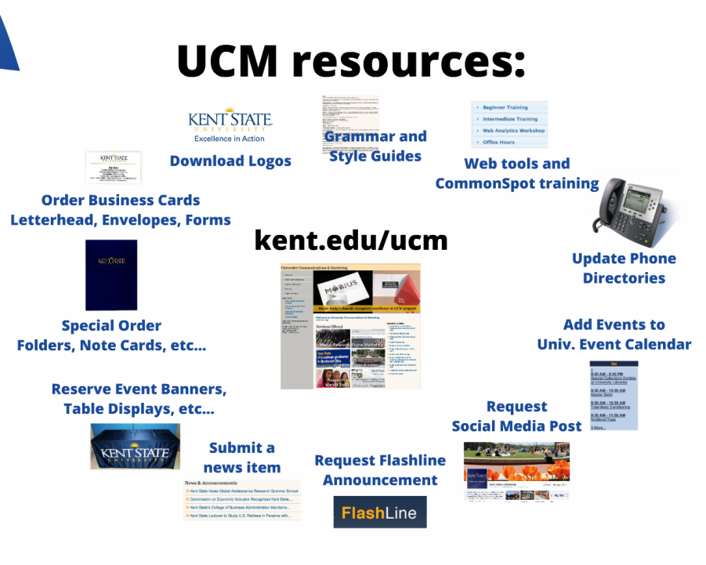

Cindy Gary, FAMIS System Specialist
University Facilities Management (UFM)
FlashTrack Updates and the Facilities Management Service Center

FlashTrack is a self-service work order system for faculty, staff and students used to enter all maintenance requests and services. FlashTrack allows requestors to create, view, manage and edit requests on their work orders. For reconciliation purposes it also provides a billing section that details material and labor charges.

FlashTrack can be accessed through the FlashLine portal, “My Action Items” tab under the FAMIS Resources section or by using a direct link https://flashtrack.kent.edu or by visiting the UFM website at www.kent.edu/ufm and clicking on the “How to Submit a Work Order” link in the left menu. Your username and password are required to access the system. A FlashTrack Reference Guide for Staff and Faculty is also available and provides step by step instructions on entering, viewing, printing, tracking and reconciling your work orders.

FlashTrack has recently been updated with new features that enable shortcuts and provide additional comment sections and icons to easily determine if a child work order has been created. A child work order is created when multiple services are needed to be performed by multiple crews. When child work orders are created, it allows the individual crew to close their own work orders when their part of the job is complete.

The FlashTrack homepage displays all open and closed work orders submitted by the user. If a child work order was created you will see an icon (similar to a double sheet of paper) to the right of the description.

Shortcuts were added to allow the user to type the first letter of their department and have a drop down list appear with the departments that begin with that letter. Note that the departments are listed as their names appear in Banner. If you do not know the building name you can scroll through the drop down listing.

To search for the index number associated with the department, click on the drop down and type in the index number you want to use and FlashTrack will pull it up.

Another new feature is the ability to see when charges have been split among more than one index. If there is a split billing, the indexes and totals will be displayed separately. The detailed information on the selected work order will be displayed.

If you have requested an estimate for work to be completed and have agreed upon a price with UFM, you will only see the estimated cost of the project once the work order has been closed. Details of the expense will not be shown.

If you are adding a comment to the Details area of the work order or if you are making a change to the work order, please be advised that there is no notification to the supervisor of any changes being made. To ensure clear communication of the change it is a good idea to follow up with an e-mail of the changes to either the supervisor or the service center.

Error messages may be received when accessing FlashTrack due to the following:
- Change in status, such as from full time to intermittent FMLA
- Change in university position
- Banner requesting an update to your permanent address

If you experience an error and your personal information has been updated, contact the UFM service center.

University Facilities Management Service Center

UFM is proud to announce the newly established University Facilities Management Service Center. It functions as the first point of contact between UFM and the university community. It operates 24 hours a day, seven days a week. The service center receives and communicates all incoming requests via telephone, FlashTrack, FAMIS and Fix It. (Fix It is the program utilized by students to notify UFM of work needed in academic areas.) They are also responsible for the data entry of all UFM work cards and work order updates.

Customer service is the number one priority of the service center.
- Follow up on work orders
- Provide directions for campus
- FlashTrack assistance
- Contact for pest control issues and scheduling of service
- Contact for elevator issues
- Customer surveys

To contact the service center email them at “ufm_service_center@kent.edu” or call 2-2345.

Vicki Ladd, Administrative Assistant

UFM Summer Clean-Up Initiative

Vicki reminded the forum members of the summer campus clean up. UFM Receiving and Distribution will be performing a summer campus clean-up for obsolete equipment and unwanted/junk furniture. Packets with detailed information, stickers and forms were mailed to the building curators. If you have items that can be disposed of please contact your building curator for further information.

Remember, all items (furniture and equipment) with potential use and value to another department must be posted on Procurement’s surplus website for 30 days prior to being included in the clean-up initiative.

Kent State Hotel and Conference Center

Cindy Sherman, Director of Sales

Sage Culley, Sales and Catering Manager

The Kent State University Hotel and Conference Center is set to open on June 14, 2013. Lawrence Carter has been hired by the KSU Foundation as the asset manager for the Hotel. Lawrence serves as the liaison between the University and the Kent State University Hotel and Conference Center.

The KSU Hotel and Conference Center is owned by Pizzuti with capital financing provided by the KSU Foundation. The close relationship with the University and the Foundation is integral to ensuring that the needs of the university community are met with the hotel and conference center programs.

The hotel offers 94 spacious boutique style rooms which include three executive suites and one presidential suite. All rooms have complimentary Wi-Fi, iPod docking stations, coffee maker (featuring Star Bucks coffee), hair dryer, microwave and mini refrigerator. Valet and self-laundry is available as well as a workout facility, heated indoor pool and a whirlpool. The executive suites have a full sized refrigerator, hospitality area and a small living room and the presidential suite has a full sized refrigerator, larger hospitality area, living room with a small terrace overlooking the esplanade and an adjoining king guest room.

Room service is available from 6:00 a.m. until 10:00 p.m. The business traveler can take advantage of the 24 hour business center and PrinterOn wireless printing service. A convenience mart, FlashMart, is onsite for those incidentals that may have been forgotten such as sundries, snacks and beverages.

The Kent State Hotel and Conference Center houses a full restaurant and bar. The restaurant, Zenas, is an upscale bistro seating 40-45 patrons and specializes in a classic menu with a twist. They are open from 6:00 a.m. – 10:00 p.m. daily serving breakfast, lunch and dinner. They utilize farm-fresh, local produce whenever possible and they offer a wide array of cuisine, including appetizers, salads, entrees and lighter fare.

Nineteen10 is the bar located within the hotel and conference center. They offer the very finest in liquor, wine, brews and mixed drinks. The bar is open 11:00 a.m. – 11:00 p.m. Monday through Thursday; 11:00 a.m. – 12 midnight on Friday and Saturday and from noon until 10:00 p.m. on Sunday.

Meeting space is also available:

The President’s Board Room seats 10 and is equipped with a complimentary HDTV and dry erase board for presentations. It has an adjoining terrace available for receptions or lunch overlooking downtown. The terrace can seat 30-50 guests.

The Pizzuti Grand Ballroom can be used as one large room or it can be divided into three sections. The large room can seat 210 for banquet rounds or up to 500 for reception or theatre style seating. The individual sections: Dix, Kent and McGilvery will each seat about 70 people. All rooms are equipped with complimentary Wi-Fi, LCD projector (mounted on the ceiling), projection screen and podium. An audio visual tech is not onsite but is available upon request at $60 per hour. Note: the speaker system with the podium is without additional fees.

Whether you want to host an event offsite or in the conference center, catering is available. The catering prices include coffee, tea and water and will also include a salad with a lunch or dinner selection. A 21% service charge will be added for all catered events.

The hotel and University Counsel worked together to establish a university wide contract ensuring that the contract meets the university’s needs. If booking a group event or a grouping of rooms a 50% deposit will be required with the final 50% due two (2) weeks after the final event date.

The rate structure for the hotel is based on local pricing. Prices indicated in these minutes were for a standard room as of the opening date of the hotel and are subject to change. Corporate rates are available Sun-Thurs. at $139 per night. Group rates (10 rooms or more) will be subject to availability and the rates will be negotiated. Weekend rates will range from $109 -$169.

The PARTA parking deck is located adjacent to the hotel and has 365 parking spaces. Hotel parking is $7 per 24 hour period which can be charged to a guest room or an event. Contact PARTA if you are looking for transportation to or from the Akron Canton or Cleveland Hopkins Airports.

Q & A Hotel and Conference Center

Q How should the contracts be written?

A Both hotel counsel and university counsel were involved in writing the contracts pertaining to Kent State. Payment is due 2 weeks after the event date.

Q How far in advance can rooms be booked?

A 1-2 years

Q Are there set prices for Kent State University departments booking rooms for incoming guests?

A At this time no. Prices are set taking local events, availability and season into consideration.

Q Is a government rate available for the rooms?

A Yes, but the hotel guest must provide a government ID to qualify for the rate. The university does not qualify for the rate simply by reserving the room(s); it is based on the government status of the guest.

Q Will you offer direct billing?

A Yes we can direct bill.

Q Why can’t an IDC be made?

A The Kent State University Hotel and Conference Center is not owned and operated by Kent State University. IDC’s must be done from one KSU index to another and the Hotel and Conference Center (similar to the Foundation) do not have KSU index numbers.

Q Is it true that the parking deck is the primary parking area for the key downtown businesses?

A Ametek, Davey and Gougler have permit parking from 8-5. The deck holds 365 vehicles and is available for downtown business patrons. Fees are charged for parking and rates are subject to length of time in the lot.

Q Will there be ample parking if the hotel is fully booked? Where is the alternate parking area?

A Parking cards were distributed showing the various parking areas downtown.

Q Will meeting room availability be accessible online?

A No, you will need to contact the hotel for availability.

Q How flexible will you be in working with KSU so that our internal purchasing and payment requirements will not be a deterrent in utilizing this new facility?

A The hotel and KSU have a significant relationship and are working to streamline this process.

The Kent State University Hotel and Conference Center carries Kent State’s name but is not owned or operated by Kent State University. The hotel is operated by the Riley Hotel Group and is bound by the policies which they have established. KSU will work closely with the Foundation and the Hotel and Conference Center. Any concerns can be directed to Vicki Ladd or Lawrence Carter; Vicki will continue to be the liaison between the 3 entities.

NEXT BAS FORUM

Wednesday

October 9, 2013

