Business Administrator Services

Forum Minutes

June 13, 2012 9:00 a.m. to 11:00 a.m.

Kent Student Center Room 204

Vicki Ladd - Administrative Assistant, Financial Reporting and Cash Management

Fiscal Year End Reminders

Please refer to the email sent out May 3, 2012 containing fiscal year 12 cut off dates. A copy of the cutoff dates can also be found on the Controller’s website at www.kent.edu/controller and the BAS website at www.kent.edu/bas.

Monthly reports should be reviewed and reconciled throughout the year. Any discrepancies that cannot be resolved by your department should be reported to the appropriate finance department to assist in resolving them. Corrections must also be completed by the posted FY12 cut-off dates.

Travel and/or miscellaneous expenses incurred on or before June 30, 2102 are considered FY12 activity. To ensure these expenses are properly recorded in the appropriate fiscal year the expense reimbursements must be approved by the final approver on or before June 29, 2012.

Travel and/or miscellaneous expenses spanning over both fiscal years or incurred after June 30, 2012 should be considered new fiscal year activity.

Department p-cards will be suspended if allocations are not completed by the July 6, 2012 deadline.

Foundation transfers must be received on the proper forms, with proper supporting documentation and all approving signatures (as required by the Foundation policy) by June 20, 2012 to allow sufficient time for the deposit to be made in the Bursar’s office by June 30. Questions pertaining to Foundation transactions should be directed to either Yvonne Lee at extension 21077 or Mary Kay Hluch at extension 20420.

Michquel Penn – Community Resource Officer, KSU Police Department

Police Services

Michquel (pronounced Myqwell) has been with the KSU Police Department for seven years and has served as the Community Resource Officer for the past two years.

The KSU Police Department is within the Department of Public Safety along with Parking Services and Fire Prevention. The police department employs 32 sworn police officers. On campus 911 calls are answered by the KSU police department. Calls made on the campus boundaries and in the City of Kent are answered by the Kent Police Department. Any calls that go to the City of Kent that should have gone to the KSU police are automatically transferred.

Emergencies – call 911 – if using a campus phone call goes directly to KSU Police Dept.
- Cell phones that call 911 are routed to the appropriate police department as identified by your location (cell tower)
- KSU police dispatcher will send police, fire or ambulance services

Non-Emergency – call 330-672-2212 for the KSU Police Department

KSU Police website – www.kent.edu/police
- Safety on Campus
- Crime Statistics
- Flash Alerts
- Threatline
- Daily Log – records criminal and alleged criminal incidents that are reported to the campus police

Kent State University Police Services was one of the first nationally accredited law enforcement agencies in Ohio and was the second university police department in the United States to be accredited by the Commission on Accreditation for Law Enforcement Agencies.

Kent State University Police Services is empowered by the State of Ohio to enforce state laws and is directed by the Board of Trustees to enforce certain rules and regulations of the University. Essentially, the police officers at Kent State University have the same authority as their state and municipal counterparts. Officers patrol the campus on foot, by bicycle, and by vehicle. Most officers work in uniform, however some do not.

COPS Program – Community Oriented Policing Services

THE COPS Program enhances the community policing efforts of the police department. Each Residence Hall is assigned a COPS Officer. These officers become familiar with the Residence Hall staff and residents of their assigned building. Some of their functions include attending hall meetings, addressing concerns, and providing Safety and Awareness presentations such as: alcohol/drug awareness; general safety; sexual assault awareness; partying responsibly, etc. Each Academic Building is also assigned a COPS Officer. These officers act as liaisons between the police department and that specific building. They become familiar with the staff and determine if there are any unreported concerns that the police department is able to assist with.

Crisis Intervention Team (CIT)

The first CIT program began in Memphis, Tennessee after an officer involved shooting resulted in the death of a mentally ill 27 year old man. The Crisis Intervention Team is a specialized training program in which law enforcement officers are educated about mental illness and substance abuse and learn skills to de-escalate certain individuals in crisis situations. Over half of the KSU police department officers have had over 40 hours of training in this specialized field. Officers are trained to also recognize suicidal tendencies. Two KSU officers have been awarded CIT Officer of the Year awards.

Workshops

A.L.I.C.E. – Alert, Lockdown, Information, Counter and Evacuation
- 90 minute session designed to give participants insight and response options when encountering an active shooter
- Highly effective, “common sense” training readily adopted by many educational law enforcement agencies
- Faculty and staff encouraged to attend
- Register at https://reg.abcsignup.com/view/view_month.aspx?as=55&aid=KENT&wp=137. If using the search feature make sure you put the periods between the letters
- Call Michquel if you would like to arrange “in department” training for your staff

Managing Disruptive Behavior
- 60 minute workshop sponsored by the Public Safety office
- Taught by officers that are part of the Crisis Intervention Team
- Designed to give participants insight and skills about recognizing and responding to unusual, disruptive or threatening behavior
- Dealing with difficult students
- Dealing with helicopter parents
- Dealing with disruptive colleague/co-worker
- Register at https://reg.abcsignup.com/view/view_month.aspx?as=55&aid=KENT&wp=137. If using the search feature type in “threatening behavior”

How are calls relating to “Person(s) in distress” handled by KSU PD?

In Progress | Not in Progress
Call is dispatched to CIT officer  Contact is made with the person calling and  With the person in distress  Action is determined | Call is dispatched to CIT officer  Report is taken  Need for “follow up” is determined  CIT officer or Detective conducts follow up

If you are unsure of whether or not you should report an incident to the police, call the police and let them determine if a report should be filed. Don’t wait until something happens; if you are suspicious then make the call and alert the police department of your suspicions.

Do you receive threatening phone calls, calls from irate students or parents, do you see wandering strangers in your building, are you suspicious of homeless people inhabiting campus buildings? These are scenarios that should be reported. Often it is found that several people have recalled incidents that have added up to a situation that could have been avoided. The police will investigate the reported concern and act accordingly. Anyone in need of help will be provided information and access to professionals whether it is a campus counseling center or another facility in Portage County.

Visit the KSU Police Department website for more information on services that they provide. Obtain information on the university’s emergency plan, location of tornado shelters, listing of registered sex offenders in your neighborhood, access to the threat line, crime statistics, license checks and more.

Michquel can be reached in the Department of Public Safety, Police Services Division at (330) 672-7165 or by email mpenn2@kent.edu.

Jason Wearley – Exec. Director for Networking, Telecommunications & Division Architect

Jay Frye – Manager, Information Services

Unified Communications

Kent State University is implementing new communication services on all campuses. The project began in 2011 and the transition to new phones, communications software and services will continue through 2014. Regional campuses will transition one at a time beginning in the summer of 2012. Kent campus buildings will begin transitioning in late fall 2012 continuing through 2014.

Unified Communications connects phone, messaging, data and video for anytime/anywhere communication.

Overview of Unified Communications

Voicemail Unified Messaging
- Voicemail received in email inbox for playback
- Messages played in email will be updated as played in your voice mail system (turns off phone indicator)
- Messages can also be played from cell phone mail client (needs a wav player)

Personal Communicator
- Softphone for computer based audio and video phone calls
- Chat client for instant messaging capabilities
- Desktop phone control for click-to-dial functionality
- Corporate directory searching
  - Will allow direct dial after searching directory by name
  - Will allow direct dialing from a phone number within an email
- Presence status integrating calendar, online status and phone status
  - PC based phone
  - Allows headphone capability

Conferencing and Collaboration
- Audio and video conferencing
- Impromptu, multiparty conferencing
- WebEx integration for desktop and application sharing
  - KSU will have its own 800 number
  - Will replace other sites utilized for telephone conferences

Mobility Extensions
- Mobile software to enable device as a university phone and integrate chat, audio and video conferencing
- Automatic call redirection
- Simultaneous location ring
- Time based and access list control
  - Call set can allow your cell phone to accept business calls for certain time frames

Contact Center
- Automatic call distribution
- Interactive voice response
- Call queuing
  - Will permit input of Banner ID
  - Allows calling agent to quickly obtain records from Banner system
- Call recording and quality management
- Desktop application integration
- Enhances supervisor features

Prior to the implementation of the new phone system in your department your LAN administrator will meet with departmental stakeholders to review the project details. During this time station design details will be reviewed and a Unified Communications feature demo will be presented. Once the station design has been completed and signed off, employees will be provided with training then the phone and technology deployment will begin. Generally this process takes approximately one week.

There will be several options to choose from when the transition is made. You can select a like for like phone that will act very similarly to your existing phone but will add features such as voicemail in email, caller ID memory, call history, 8-way conference calling and headset capabilities.

Other options or add-ons include:
- Software Client adds computer integration to your phone with features such as:
  - Click to dial
  - Chat
  - Video conferencing
  - Corporate directory search
- Mobility Connect allows you to use your everyday cell phone but adds:
  - Ability to forward calls from your desk to your cell phone quickly
  - Forward only the calls you want to your cell phone
  - Works anywhere you have cell coverage
  - Transfer calls between your desk phone and cell phone
- Mobile App allows you to use your cell phone as a campus phone complete with your extension. Install an application that allows your cell phone to:
  - Act like a campus phone while on FlashZone wireless
  - Shows your campus extension for caller ID on outgoing calls

Extended communication options are also available. These options include classroom phones, conference phones, multiline phones, voice mail only lines and a 6 line wireless phone.

- Classroom Phone
  - Replace your classroom phones with Cisco phones complete will all Unified features
- Conference Phone
  - High quality conference phone with optional expansion microphones for larger conference rooms
- Multiline Phone
  - Same great features as the standard phone with up to 6 lines
  - Options exist for up to 54 lines by upgrading and adding “side car” modules
- Voicemail Only Line
  - Easily set up voicemail for an extension without a phone
- 6 Line Wireless Phone w/speakerphone
  - Six line wireless phone with speakerphone in base
  - Works anywhere FlashZone is available

Each department and each user will have these options available but not all features will be provided to all phone users. Additional fees may apply. The cellular phone stipend is not included with this project.

A timeline of this project will be made available on the IS website.

Any questions regarding the Unified Communications project can be emailed to Jay Frye at j@kent.edu.

Sameer Jaleel – Director, Web Presence Information Services

KSU Mobile Version 2.2

Kent State has launched its new app, KSU Mobile. Download it now through the Apple App Store, through your devices’ app store or through the Android or BlackBerry marketplaces.
- Download from Android Marketplace
- Download from Apple App Store

Below is an array of features available on the KSU Mobile app:

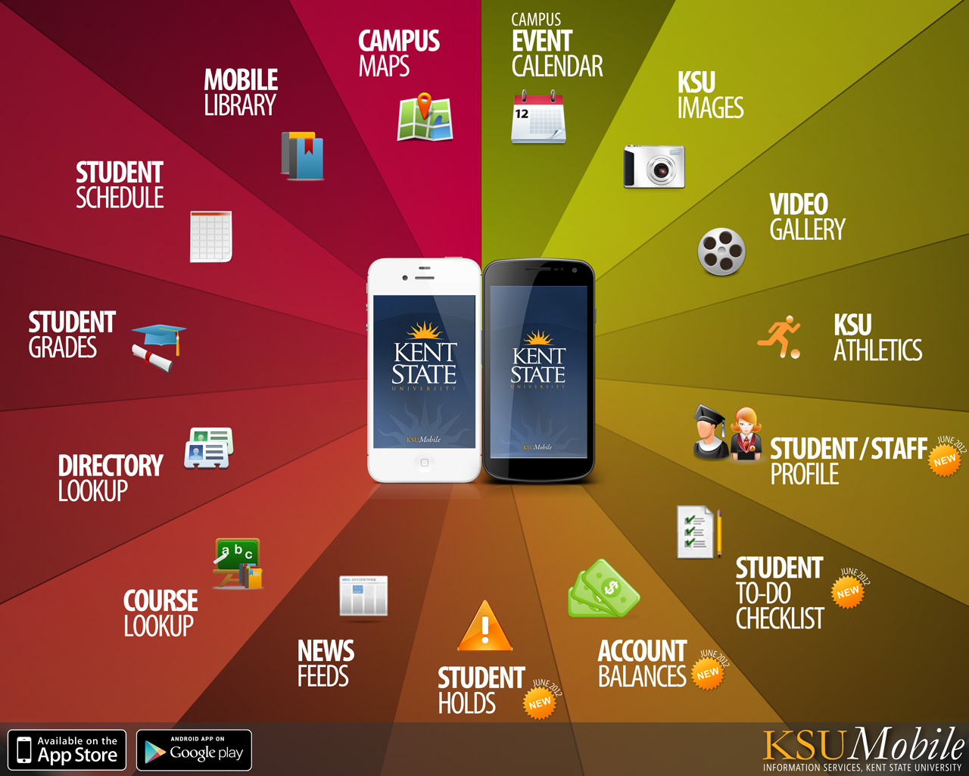

The items listed as “new” are currently in the final testing stage and should be available some time after June 22, 2012.

The News app will allow you to view the same information as you see on the KSU homepage Success Stories (located under the News & Events tab). Information available in FlashLine will be viewable using this app.

Me@KSU contains your student/staff profile. The availability to view flashcard balances will be coming soon in a future release.

The password to login to the mobile phone app (to view protected features like Me@KSU) is the same as your FlashLine password.

Information Services needs your feedback. The feedback will help provide information for added functionality to the app. You can provide feedback using the Twitter feed, Facebook page (both available within the mobile app) or the IS website at www.kent.edu/ksumobile.

Debra Leonard – Manager, Accounting Controller’s Office

Grants – Direct vs. Indirect Costs

One of the functions of Grants Accounting is to review expenditures to determine if the expense is allowable before it is processed on the grant. Realizing that there has been a lack of documentation, the offices of Sponsored Programs, the Controller’s Office and Grants Accounting have been creating a Grants Management Manual to assist in the administration of sponsored projects. As each section is completed it will be posted on the Sponsored Programs website. To date three sections of the manual have been completed: Roles and Responsibilities, Award Initiation and the latest section entitled Direct Costs.

When KSU accepts a grant, there is an expectation from the grantor that we will pay certain costs. The grantor assumes that the university will have a grant accountant to prepare financial reports. They also expect that the university has personnel to process invoices and pay them. The grantor expects us to have paper, pens and general office equipment. These types of costs are indirect costs. Indirect costs are those costs incurred for common or joint objectives and cannot be identified readily and specifically for a particular sponsored project.

In the direct costs section of the manual there are examples of typically allowable costs such as salaries, research, supplies and travel. There are also examples of unallowable costs such as donations, alcoholic beverages and gifts. Unallowable costs cannot be charged to a grant.

Expenses may also fall into a “gray” category that may be allowable or unallowable dependent on the circumstances. There are costs associated with implementing a sponsored project that are program specific and there are general costs incurred by the university for the administration of the program. These costs are grouped into two categories – direct and indirect.

The matrix below indicates when a particular cost is normally charged directly or indirectly to sponsored agreements. This listing provides examples of costs most commonly associated with sponsored agreements but it is not intended to be all inclusive.

Salaries and Wages / Fringe Benefits
Direct Costs (Charged to the sponsored agreement) | Facilities & Administrative Costs (Not charged to the sponsored agreement)
Faculty, technicians, research associates and assistants (including graduate research assistants and other students performing scientific or technical work), postdoctoral associates and other technical and programmatic personnel that are necessary to meet the goals of the project. | Administrative and clerical positions, such as secretaries, accountants, office personnel (including student workers), purchasing agents and buyers, administrative activities of directors and assistant and associate directors, executive assistants, and other administrators.

Travel
Direct Costs (Charged to the sponsored agreement) | Facilities & Administrative Costs (Not charged to the sponsored agreement)
Required to carry out the objectives of the sponsored agreement | Related to administrative activities

Supplies
Direct Costs (Charged to the sponsored agreement) | Facilities & Administrative Costs (Not charged to the sponsored agreement)
- Lab and scientific supplies  - Chemicals/Radioactive material  - Glassware  - Field supplies  - Compressed gases and liquids  - Animals  - Software  Rare and precious metals and nonprecious metals | - Office supplies  - Custodial supplies  - Parts and supplies associated with repair and maintenance of general purpose equipment and facilities  - Paper  - Forms  - Books and reference materials

Information & Communication
Direct Costs (Charged to the sponsored agreement) | Facilities & Administrative Costs (Not charged to the sponsored agreement)
- Printing: normally indirect unless the specific requirements of a particular project scope clearly indicates a need for a volume of costs beyond routine  - Photocopy charges: normally indirect unless specific requirements of a particular project scope clearly indicates a need for a volume of costs beyond routine  - Telephone long distance (project specific)  - Postage: normally indirect unless the specific requirements of a particular project scope clearly indicates a need for a volume of costs beyond routine.  Example: mass mailing  - Advertisement: recruitment of personnel approved for a specific project, recruitment of research subjects  - Reprints and page charges  - Photography | - Printing  - Photocopy charges  - Telephone – basic service, installation, repair, and line charges (including ATS, WATS, and fax)  - Cellular  - Postage (including Federal Express, etc.)  - Public relations  - General advertising  - Dues/memberships (other than those specifically required) in business, professional and technical organizations  - Subscriptions

Repairs, Maintenance and Operations
Direct Costs (Charged to the sponsored agreement) | Facilities & Administrative Costs (Not charged to the sponsored agreement)
- Repairs and maintenance (related to scientific and technical equipment)  - Lease/rental of vehicles and other equipment  - Lease/rental of off-campus facilities | - Repairs and maintenance (facilities and general purpose equipment)  - Utilities

Miscellaneous
Direct Costs (Charged to the sponsored agreement) | Facilities & Administrative Costs (Not charged to the sponsored agreement)
- Participant expenses and student/trainee non-compensatory support (training grants)  - Subject Payments  - Subawards  - Consultant’s fees | - Legal and financial services  - Insurance  - Fines and penalties (includes library fines)

Equipment
Direct Costs (Charged to the sponsored agreement) | Facilities & Administrative Costs (Not charged to the sponsored agreement)
- Lab, scientific, and field noncapital equipment  - Technical and scientific capital equipment | - General purpose noncapital equipment (includes computer and electronic devices)  - General purpose capital equipment

In a recent audit of another university, the National Science Foundation (NSF) listed an audit finding regarding file folders. The university explained that the files were used for research results in the lab and were therefore project related. When asked where the files were stored the auditors were directed to a common area within the department. Even though they could be justified as a grant related cost, they were accessible to anyone in the department and therefore the audit finding was upheld. So, even if it can be justified as a grant related cost, you need to be careful that only grant personnel has access to the supplies or materials.

It is very important to give a detailed explanation of grant expenses. Whenever possible state the purpose of the expense and how it is going to be used for the grant. When the cost is not adequately described it results in the need to contact the department which delays the processing and payment of the expense.

Computer purchases generally cannot be coded and charged to a grant. Grantors expect that faculty members have a PC. If you want to charge a computer to a grant you must ask yourself the following questions: Will the computer be used 100% for the grant? Will this PC be used for email? If the answer is yes, there will be email on the computer, then the computer is used for administrative purposes and is not fully grant related.

Many of the costs described as indirect costs could potentially be allowable to the grant under exceptional circumstances. Justification and approval will be required to direct charge these expenses. A form has been created to document the exceptional circumstances. See below for more information regarding the form.

Any questions about whether or not a charge is allowable to a grant should be directed to one of the grants accountants. Of course, it is always better to call before the purchase is made.

Debra Leonard dleonard@kent.edu Mike Login mlogin@kent.edu

Valerie Henry vhenry@kent.edu

Beverly Robertson – Assistant Director, Research and Sponsored Programs

Indirect Cost Exception Form

Approval is required to direct charge administrative and clerical salaries, as well as other administrative type expenses. In addition to meeting the definition of exceptional circumstances, costs must be specifically identifiable to a particular sponsored project, be reasonable, allowable and allocable. Ideally these charges will be identified and the form processed at the proposal stage. For any charges that fall into these categories on existing grants, a form will be initiated at the time the charges are identified.

Exceptional circumstances on the sponsored project would require one of the following: an extensive amount of administrative and/or clerical support or goods/services significantly greater than the routine level provided by the academic department or is geographically inaccessible to normal departmental administrative services.

The Indirect Cost Charge Exception Form can be found on the Sponsored Programs website at http://www.kent.edu/research/sponsoredprograms or on the BAS website at www.kent.edu/bas. The form on the BAS website is listed under Grant Indirect Cost Exception Form.

You will be required to select the types of costs to be considered as an exception and give a complete description as to the circumstances that would allow the charge as an exception on the project.

The form requires approval by the PI (Principal Investigator), Director/Chair, Sponsored Programs and Grants Accounting.

Heather Auld – Business Analyst, Project Management

Cell Phone Automation Process

The cell phone automation workflow became fully functional on May 29, 2012 and thus far has seen great results. Persons authorized to have university provided cell phones or who receive a stipend for their cell phone must complete the Cellular Device Authorization workflow by June 22, 2012 for the upcoming FY 13.

The workflow form is located in FlashLine under the My Action Items tab. Once you select the cell phone workflow you will see that all of your personal information located on the left side of the form is populated. Note that the budget for the cellular device stipend is allocated based on the labor distribution of the primary job of the employee.

The form contains multiple drop down boxes to allow easy selection of the plan choice, type of mobile device, carrier and monthly allotted amount. The employee must select a business purpose and describe the intended use of the cellular device. The bottom of the form includes an attestation that the phone is required for business purposes and that the employee will abide by the KSU Cellular Device Policy. It also acknowledges that the additional pay is taxable income and is subject to payroll taxes. Once the form is completed and the attestation/authorization box checked the form can be submitted electronically through the workflow process. The hierarchy used in this workflow is the same as that used for travel and entertainment approval.

Reports will be available shortly in Cognos that will show employee, position and plan data for workflows in progress, approved and denied. Prompts will allow for specific Divisions, Indexes and plan types to be specifically included. A prompt to search for an individual employee is available as well. A separate notification will be sent to the BAS listserv when the production versions are available.

Subsequent completion of the form will include the pre-populated fields on the form. Changes in plan choice or changes to the phone number must be reported. The termination process is still a manual process. The forms available next year will include options to check whether the form is for a renewal of an existing phone, a change to the existing plan or a new plan.

Only the approval process has been automated. Departments are still responsible for reviewing charges as outlined in the cell phone policy.

Tim Konczal – Director of Procurement

AG PrintPromo Solutions

Tim introduced Anup Gupta (President/Owner) of AG PrintPromo Solutions who has been named Kent State’s preferred promotional products and apparel supplier specializing in promotional products, gift programs, awards and incentives and also printed and embroidered corporate items.

AG PrintPromo has been working with numerous departments throughout Kent State and has an excellent track record. They have also been named preferred providers for Case Western Reserve University, John Carroll University, Shawnee State University and the IUCPG (Inter-University Council Purchasing Group). Other clients include Cleveland State, Columbus State Community College, Ohio State, University of Toledo and Youngstown State.

The AG PrintPromo team is available to assist with all of our promotional needs. They will adhere to KSU’s branding standards ensuring that the correct ink colors are used and that the logo layout and design meet the standards set forth by KSU.

They offer quality products that you will be proud to hand out, recommend “Go Green” eco friendly products whenever possible and guarantee on time delivery of products ordered.

Orders are placed through SciQuest (FlashCart) found under the My Action Items tab in FlashLine. The website features an advanced product search engine to help departments find the right product. You can streamline your search by product features such as price, production time, colors, union made, made in the USA etc.)

Most of the simple orders are designed at no charge but if you need help creating a custom design AG PrintPromo offers a design service at a reduced charge.

When ordering products it is important to provide as much information as possible. Not only do they need to know what you wish to order but they would like to know the demographics of the target market, event dates, distribution method, venue, budget etc.

AG PrintPromo will be happy to assist you with your product selection and/or design. Call one of the AG Team members below for advice and expertise:

AG PrintPromo Solutions

960 Graham Road, Ste 1, Cuyahoga Falls, OH 44221

330-315-9600 Fax 330-315-9603

www.theaggroup.com

Chard Herrington – Head Graphic Designer and Creative Services

Cricket Holt – Graphic Designer/Customer Service

Priscilla Kiehl – Customer Service/Sales

Anup Gupta – Pricing on special projects

NEXT BAS FORUM MEETING

Wednesday

October 10, 2012

Kent Student Center

Governance Chambers

