Authorization for Direct Deposit for Student Employees

Employee Name:_____________________________________________ Campus Dept:________________________________________________
Employee KSU ID or last 4-digits of SSN: ___________________________________ Employee Phone:________________________________
Check which applies: ( ) Initial Authorization ( ) Change in Depository ( ) Change in Account ( ) Change in Percentage or Amount
- Please allow up to two pay cycles for direct deposit or changes to take affect.
- Please attach a voided check (checking accounts) or deposit slip (savings accounts only).

I request my deposit to be sent to:

_____________________________________ __________________________________________ _______ ______________________________
Name of Financial Institution City State Phone

Nine-Digit Routing Number _____________________________________ Account Number ______________________________________________

[ ] Checking or [ ] Savings Amount: __________ or Percentage: __________

I request my deposit to be sent to: (if splitting pay between two accounts)

_____________________________________ __________________________________________ _______ ______________________________
Name of Financial Institution City State Phone

Nine Digit Routing Number _____________________________________ Account Number ______________________________________________

[ ] Checking or [ ] Savings Amount: __________ or Percentage: __________ or Remaining Amount: [ ]

I hereby authorize Kent State University to initiate direct deposit of my net pay each payroll period to the account(s) and financial institution(s) indicated above. I agree to indemnify KSU against any loss sustained by me reason of such action. In the event that KSU deposits fund erroneously into my account, I authorize KSU to debit my account for any amount not to exceed the original amount of credit. Termination of this agreement must be made by me in written notification form, and brought to Payroll Department, 236 Schwartz Center.

Signature__________________________________________________________ Date ________________________________

Return completed form to Career Exploration and Development or Payroll

Setting Up Direct Deposit Online: If you are unable to return this form prior to beginning work,
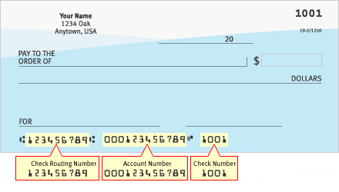
follow the steps below to set up your direct deposit:

- Log into FLASHLINE
- Select Employee on the left side bar
- Under Employee, select Dashboard
- Select Payroll Direct Deposit
- Scroll to the bottom and select
Add a New Direct Deposit
- Add your banking account information
11/2/2016

