Spain & Portugal Study Abroad
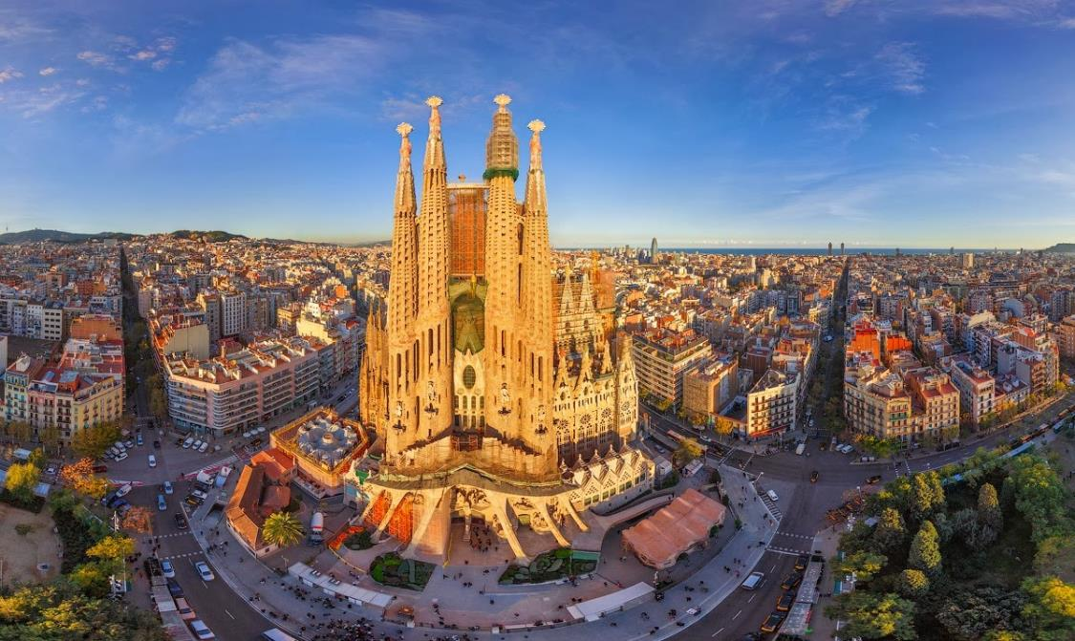

Summer Intersession: May 14-30

Historic Landscapes of the Iberian Peninsula
  - Led by
  - Dr. David Kaplan
  - Kathryn Hannum

  - Syllabus

The Iberian Peninsula includes a fascinating modern history of shifting boundaries, internal colonialism, nationalist movements, and authoritarianism. In this course, we will study and directly experience the national cultures and landscapes of Spain and Portugal. In an area about the size of Texas, we will encounter five distinct languages, cultures, histories, and landscapes. We will journey from Lisbon in southern Portugal to the northern Porto region, into Spain through Galicia, on to Basque Country, and end our trip in Catalonia. These regional differences are tied to different national identities that are felt and expressed in each place. Portugal is the product of national breakaway from Spain in the 12th century, and to this day at least four different national identities exist within the Spanish state.
How is this possible? How has Iberia hosted so many strong national identities? We will be using the texts and our field experiences to ponder how history has shaped the landscape, the variety of cultures found throughout the Peninsula, contemporary developments, and what these mean for the future of Spain and Portugal.
Most learning will come from our 16-day excursion. But we also will ask students to read the following:

- Smith, A. D. (1992). National identity and the idea of European unity. International Affairs
- Hatton, B. (2011). The Portuguese: A Modern History. Signal Books.
- Tremlett, G. (2006). Ghosts of Spain: Travels Through Spain and its Silent Past. London: Faber and Faber. Chapters 1, 2, 3, 10, 11, & 12

There will be three brief classes held before the field trip in order to go over logistics and a bit of Iberian history, culture and politics. The last day of our trip will include a debriefing in which to discuss what we have seen and learned.
For students who are taking this field trip for three credits, assignments will consist of a daily reflective diary and a final project that will tie into the student’s particular interests.
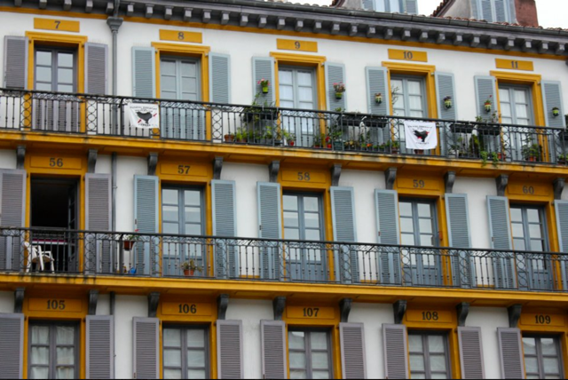

  - Itinerary

  - Day 1
  - Depart Cleveland in the morning. Arrive in Lisbon.
  - After a bit of walking to orient yourselves, we will go to the top of Lisbon via Elevator de Santa Justisio to familiarize ourselves with the city.
  - Dinner at Park rooftop bar

  - Day 2
  - Lisbon
  - After breakfast at the hotel we will get the story of Lisbon at the Praca do Commercio. After Lunch at Time out Market, we will take the historic line 28 tram to the old Moorish Castle. Pre-dinner drinks at Topo rooftop bar, followed by group dinner and a Fado performance.
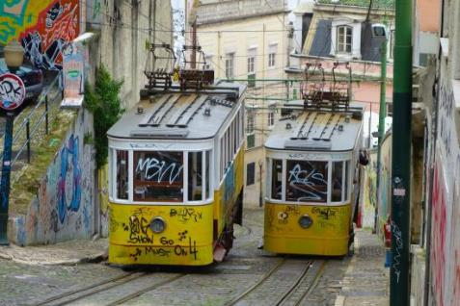

  - Day 3
  - Lisbon
  - After breakfast at the hotel we will visit the botanical garden and get a traditional Portuguese coffee before visiting san Rouque Church. After lunch you have a free afternoon to explore before the Portuguese (read, humane) Bullfight!

  - Day 4
  - Lisbon
  - After breakfast at the hotel, we will take the historic #15 tram to Belem, a monument park by the sea. We will then walk to Monisario de Jorominos while grabbing lunch from a street kiosk.

  - Day 5
  - Sintra/Travel/Porto
  - Today we leave Lisbon for the royal residence of Sintra. There we will eat lunch and explore the countryside estate of Portuguese monarchs dating back to the middle ages. We will head from there up the coast in our bus to Porto. Check into Porto Hotel

  - Day 6
  - Porto
  - After breakfast at the hotel, we will climb the Torre de Clericos to get the best view of the city. After that we will wander to liverilla Lello to see the famous staircase and browse books. After lunch we will head down to the river to explore. We will take a river cruise to get a different point of view of the city before tasting port at the world famous Sandeman Port Distillery.
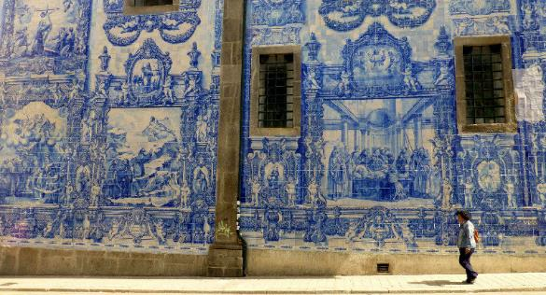

  - Day 7
  - Porto/Travel/Santiago
  - After our hotel breakfast we will leave for Galicia, Spain. Crossing the River Mino, we will notice the landscape change as we enter the second nation on our itinerary. We will stop for a group lunch in a small village with a world-class restaurant. When we arrive in Santiago we will make our way to the Cathedral. Galician tapas at El Gato negro before dinner.

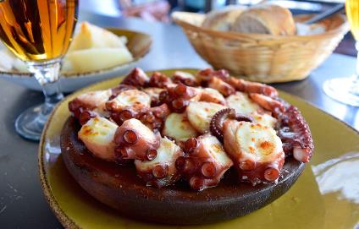

  - Day 8
  - Santiago/Finniserre/A Coruna
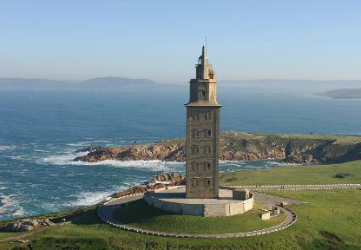
  - Today we will head out for a hike to the end of the earth! Or, at least what the Romans thought was the end of the earth, at Finnisterre. After lunch we will head to A Coruna where we will get a personalized tour of the university and the city architecture. Return to Santiago for Dinner.

  - Day 9
  - Santiago/Travel/Cathedral Beach
  - After breakfast we will head out to Lugo to walk the best preserved Roman wall in the world, which surrounds old town Lugo. After lunch we will head to Cathedral Beach to revel in nature’s might and glory. Check into our small hotel nearby.

  - Day 10
  - Travel/Bilbao/San Sebastian
  - After breakfast we will hit the road headed for Basque Country, the second of the internal nations we will visit. In Bilbao we will see the world famous Guggenheim and eat Lunch. We will stop to climb the stairs at Moniserio Gaztelugatxe, where they filmed portions of Game of Thrones. Then it’s into the Pyrenees mountains for San Sebastian. Once we get settled we will do as the Basque do and eat our way from bar to bar for dinner.

  - Those who are up for it can stay out and enjoy the vibrant local music scene at Club Dabada.

  - Day 11.
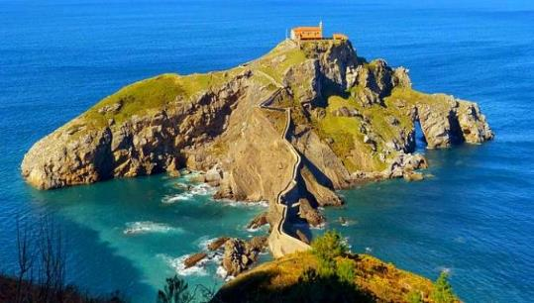
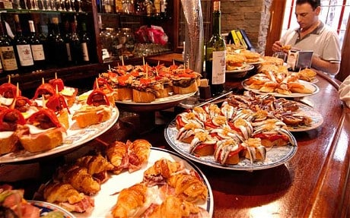
  - San Sebastian
  - Option 1 will be a hike up Monte Urguill to the castle on the hill. Option two will be a visit to Parque de Cristina Enea. After lunch we will visit the Basque Museo de San Telmo.

  - Day 12
  - San Sebastian/Travel/Zaragoza
  - After breakfast at our hotel in San Sebastian. We will leave for Zaragoza. We will visit the Palacio de la Aljaferia, an Islamic castle from the 1400s. After lunch you have a free afternoon to explore on your own.
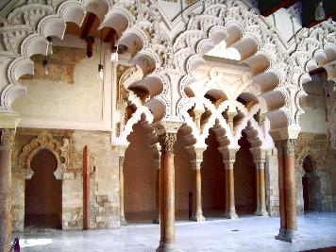

  - Day 13
  - Zaragoza/Travel/Barcelona
  - After our hotel breakfast we will get on our bus to Barcelona. Once in the capital of Catalonia, we will head to Park Guel to familiarize ourselves with this iconic city.

  - Day 14
  - Barcelona
  - After breakfast in the hotel we will take a tour of la Pedrera, one of Gaudi’s architectural gems. Lunch will be at the marketplace La Boqueria. After lunch we will explore the narrow winding streets of the Gothic Quarter and find some Sardana dancing at the Cathedral de Barcelona. We will grab some tapas before finding dinner.

  - Day 15
  - Barcelona
  - Breakfast at the hotel will be followed by a guided Segrada Familia Tour. This unfinished cathedral was Gaudi’s masterpiece, and we get to see the construction progress. The afternoon is yours to explore. We will meet for a group dinner that night.
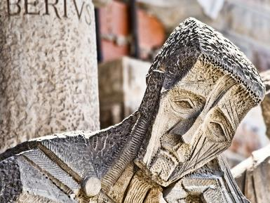
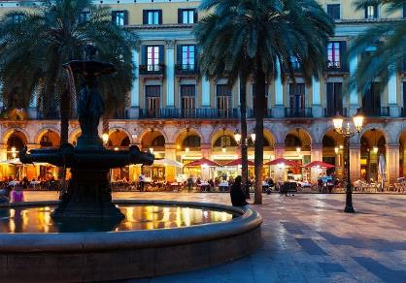

  - Day 16
  - Barcelona
  - After breakfast we will head up the hill of Montjuc via Funicular to the Museu Naccional d’art Catalunya. After lunch we will see Monjuc castle before heading back to prepare for our journey home in the morning.

  - Day 17
  - Barcelona/Travel/Cleveland
  - Leave for Cleveland.

  - Scholarship Opportunities

  - To get started with the fundraising process or for any scholarship questions contact Alana Thompson: aabaudo@kent.edu

Office of Global Education: $500-$1000 (and perhaps more) – available for ethnic/racial minorities, students with disabilities, students with high financial need, 1st gen college students, LGBTQ-identified students, underrepresented academic majors, student athletes, first experience abroad
Arts and Sciences: $250-$500 (dependent on available funds)
Geography (up to $500)
Financial aid: Both student loans and financial aid can be applied to study abroad. You must meet with your financial aid counselor to discuss the details. Complete the summer financial aid FAFSA at kent.edu/financialaid/summer
Search the web! There are hundreds of competitive scholarships out there just waiting for you to apply.
Make a fundraising page: Indigogo, GoFundMe, and Kickstarter are all public fundraising pages that offer great platforms to raise money.

  - Study Abroad Financial Checklist

  - Look over program budget in flyer or online at education abroad.kent.edu and click “budget sheets”

  - Create a personal budget for food, passport, and other expenses.

  - Determine payment deadline for program payment and deadline for personal fundraising

Meet with financial aid advisor to determine scholarships, loans or financial aid eligibility.

Apply for Scholarships within the Kent system

Utilize outside fundraising.

Pay your bill

Go Abroad!

  - If you or your families have any questions at all do not hesitate to contact us at any point in the process!

