FGIENCD – Detail Encumbrance Activity
Use this screen to view purchase order balances and see payments paid against the PO.

- Login to Banner and type FGIENCD in the search box and then hit Enter.

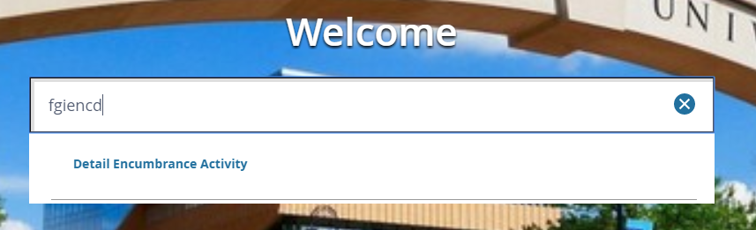

- You will be taken to the Detail Encumbrance Activity form, which can be used to check the balance on a purchase order and see each payment that has been processed against it.

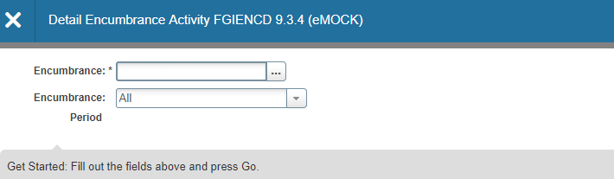

- Enter the PO number in the Encumbrance field and click either GO or Alt-PageDown.
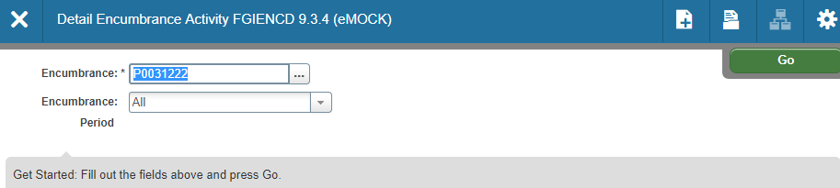

- You will now see the Encumbrance Information and your cursor will be in the Encumbrance Detail section. By clicking the right arrow on the bottom left corner of the Encumbrance Detail area, you can scroll through every line of the PO.

- Note the following Encumbrance Information:
  - Description – vendor name
  - Status – O or C indicates whether the PO is open or closed
  - Type – P indicates that this is a PO
  - Date Established – date PO was created
  - Balance – balance left on PO
  - Vendor – vendor ID and name

- Note the following Encumbrance Details:
  - Item – a numbered list of what was ordered on the PO
  - Sequence – each different FOAP combination on a line is considered to be a sequence
  - Fiscal Year – FY in which PO was created
  - Status – O or C, indicating open or closed
  - Commit Indicator – U
  - Index, Fund, Orgn, Acct, and Prog – FOAP string
  - Encumbrance – original amount encumbered on this line
  - Liquidation – total of all payments made against the line
  - Balance – encumbrance remaining on the line
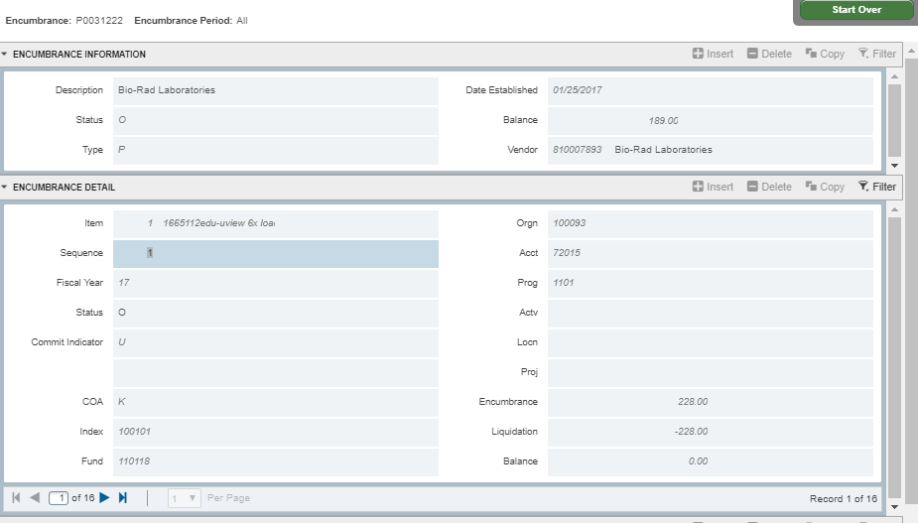

- As you scroll through the lines in the Encumbrance Detail, the Transaction Activity section reflects the activity for each line.

Transaction types:
- PORD = PO created
- CORD = Change to PO (a.k.a. “Change Order”)
- INEI = Invoice entry
- ICEI = Invoice cancellation
- INEC = Credit memo entry
- ICEC = Credit memo cancellation
- E090 = Encumbrance roll from previous year

The screenshot below shows the 12th of 16 lines on a PO. The line originally encumbered $32.00. One payment for $32.00 has been processed against it, leaving the remaining balance at $0.00.
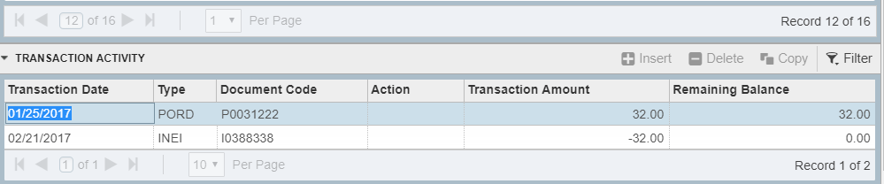
The screenshot below shows the 2nd of two lines on a PO. The line originally encumbered $2500.00. It shows four payments and two change orders. It also shows that the balance has rolled forward two fiscal years.
