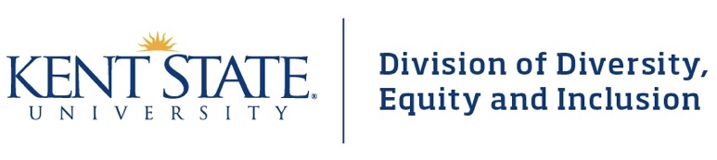
University Diversity Action Council Advance
September 6, 2019

Kent State University Stark Conference Center

AGENDA
8:00 – 8:30 a.m. | Continental Breakfast | All
8:30– 8:45 a.m. | Welcome | Dr. Alfreda Brown  Vice President  Division of Diversity, Equity & Inclusion
8:45– 9:00 a.m. | Review Agenda & Purpose for the Day  The University & UDAC | Dr. Dana Lawless-Andric  Associate Vice President  Division of Diversity, Equity & Inclusion
9:00– 9:45a.m. | What Does it Mean to be a UDAC Rep  Getting to Know Each Other | Sonya Williams  Interim Executive Director  Division of Diversity, Equity & Inclusion
9:45 – 10:45 a.m. | Building Community | Sonya Williams  Interim Executive Director  Division of Diversity, Equity & Inclusion
UDAC Photo & Networking Break
11:15 a.m. – 12:15 p.m. | UDAC Then & Now | Shana Lee  Director, Diversity & Inclusion Leadership  Vicki Migge  Kent State Salem UDAC Rep
Lunch (12:15 p.m. – 1:15 p.m.)
Fear & Hope Activity
1:15 p.m. - 3:45 p.m. | Setting Our Collective UDAC Agenda  How Would a Kent State Free from Bias Look?  Four Questions  3, 6, 9 Months  Pulling it All Together for the Year | Jennie O’Connell, Director  Center for Sexual & Relationship Violence Support Services  Yvette Roberts, Support Services Coordinator  Center for SRVSS  Dr. Dana Lawless-Andric & Sonya Williams
3:45 p.m. – 4:00 p.m. | Closing Remarks | Dr. Alfreda Brown  Vice President  Division of Diversity, Equity & Inclusion

