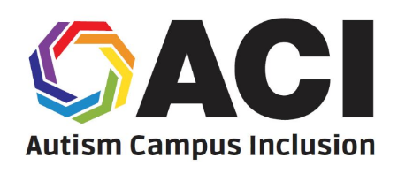
Autism Campus Inclusion (ACI)
Summer Leadership Academy

What is the Autism Campus
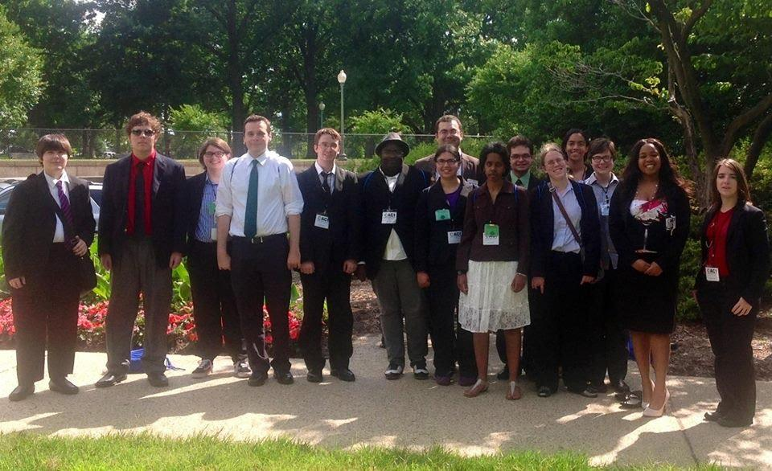
Inclusion (ACI) Leadership Academy?
The Autism Campus Inclusion (ACI) Summer
Leadership Academy, a project of the Autistic
Self Advocacy Network (ASAN), helps
Autistic students learn to make their college campuses better for people with disabilities. ACI
participants learn about making student groups,
understanding disability policy, and talking to
people in the government. After the Academy,
students get help from ASAN to meet their
advocacy goals at their college.
ASAN pays for travel and rooms for
all Academy students.

When and where will this Leadership Academy take place?
The ACI Summer Leadership Academy takes place each year in Washington, D.C., usually during the 1st or 2nd week of June.

Can I participate in ACI?
To be a part of ACI, you must:
• Be on the Autism Spectrum
• Be a student at a college, and have at least one year left at college before you graduate
• Live in one of the 50 states or the District of Columbia, Puerto Rico, or Canada

How do I apply?
Applications for the ACI Summer Leadership Academy are put on the ASAN website in early January each year, and are due at the end of February. To send your finished application or ask questions about ACI, please email Reid Caplan at rcaplan@autisticadvocacy.org

