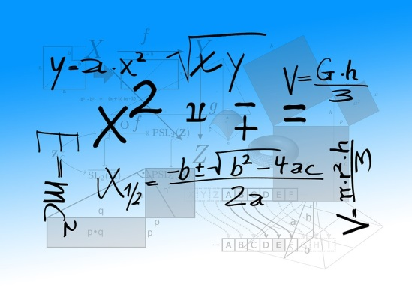

KATHLEEN WOLF BOOK AWARD
APPLICATION FORM

Deadline: April 24, 2023, 5:00 PM

Each spring the Department of Mathematical Sciences names one outstanding developmental mathematics student as recipient of the Kathleen Wolf Scholarship in honor of the late Mrs. Wolf, longtime developmental mathematics instructor and coordinator. Up to three other students may be awarded an honorable mention. Total scholarship monies available this year is $1,000. We will notify the winner during final exam week. Any Freshman, Sophomore, or Junior Kent State University student who has completed one or more of the following courses during the current academic year (Summer 2022 – Spring 2023) OR is currently enrolled in any one of the following courses may apply: (Former winners are not eligible.)

MATH 00020 Pre-Algebra | MATH 00021 Basic Algebra I
MATH 00022 Basic Algebra 2 | MATH 10771 Basic Math Concepts 1 Plus
MATH 10772 Modeling Algebra Plus

Please complete all application items below. Note that you need to respond to three questions ON THE BACK OF THIS FORM. You also need to submit ONE LETTER OF RECOMMENDATION from one of your mathematics instructors at Kent State University.

NAME: Kent State Banner ID: Email:

Local address:  Local phone: | Permanent address:  Permanent phone:

Please list all the math courses you have taken at Kent State University.

Math Course Number and Name | Semester taken | Grade | Instructor’s name

Letter of Recommendation from: ______________________________________________________________

PLEASE ASK YOUR INSTRUCTOR TO EMAIL THE RECOMMENDATION LETTER TO breed1@kent.edu or to send it via campus mail to the address on the back of this form.

Scholarship consideration will be based on the following criteria:
- Achievement in your mathematics course(s) at Kent State University
- Class Attendance
- Consistent effort and/or significant improvement
- Written essay – see the back of this form

Please respond with a short paragraph to each of the questions on the back side of this page.
OVER

PLEASE ATTACH TO THIS APPLICATION FORM, A ONE-PAGE TYPED ESSAY IN WHICH YOU ANSWER THE FOLLOWING:

- Why do you think you are qualified to receive this award?

- What special insights have you gained from taking your mathematics course(s) here at Kent State?

- Discuss any hardships or frustrations that you have encountered in your mathematics course(s) and how you have overcome them. Have you developed any successful strategies in your mathematics class that you might apply as you move forward in your coursework?

APPLICATION CHECKLIST:
Completed application form
Letter of recommendation sent directly to breed1@kent.edu
Essay responses to three questions above

Send this completed application form to KATHLEEN WOLF SCHOLARSHIP
MATHEMATICAL SCIENCES

ROOM 233 MSB – Kent Campus

You may use Campus Mail or e-mail (breed1@kent.edu)
Applications are due April 24, 2023, by 5:00 PM

Incomplete applications will not be considered for the award.

