H2H Instructor Statement for Blackboard Learn/Syllabus

About Student Mental Wellness

The pressures of being a college student can sometimes feel overwhelming. If you, a friend or one of your peers is feeling overwhelmed or is struggling with issues related to mental health, please know that I am here to support you.
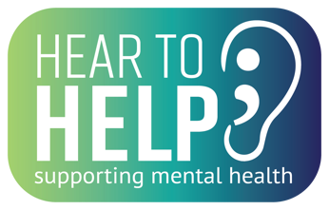
I participate in the Hear to Help initiative, which identifies me as someone who has been trained to assist students who may be struggling with mental health-related issues, including anxiety, depression, and drug abuse.

If you, a friend or peer is experiencing issues related to mental health, please do not hesitate to reach out, I will listen to your concerns and, if appropriate, help you, a friend or a peer connect with services. You can call [PHONE], email or talk with me directly.

[INSTRUCTOR NAME]
KSU Psychological Services
Self-help and other resources can be found HERE.
Text 4hope to 741741 to connect with Ohio's free and anonymous crisis text line.
24-Hour Resources can be found here.
For emergencies, call 911.

SCREENSHOT FROM BLACKBOARD:
