Google Drive- Creating Docs, Sheets, and Slides Online
This Document Covers:
• Logging in to your Google account
• Creating a new document (including choosing the type) and inserting images
• Uploading other files from your computer (i.e. Office documents to be viewed or edited in
Google Drive)
• Sharing your document with others

Learning Advantages
• Create and share documents - word processes, spreadsheets, presentations - online
• Upload, edit, and access your existing files from anywhere
• Common desktop feel makes editing and sharing simple

Technology Summary
Google Docs is a free, web-based word processor, spreadsheet, and presentation application offered by Google. It allows users to create and edit documents online while collaborating in real-time with other users.
Documents, spreadsheets, and presentations can be created within the application itself, imported through the web interface, or sent via email. They can also be saved to the user's computer in a range of formats and published as a web page for others to view. The files are saved to Google’s servers, which eliminate the need for storage media. Open documents are automatically saved to prevent data loss, and a full revision history is automatically kept. Documents can be tagged and archived for
organizational purposes as well.
An important and nifty feature is collaboration between users. Documents can be shared, opened, and edited by multiple users at the same/real time. The application supports popular Office file types such as ‘.doc’, ‘.xls’, and ‘.ppt’. A new feature of Google Docs the ability to upload and share PDF files.

Technical needs
• Google account needed
• Web Browser - Internet Explorer, Mozilla Firefox, Safari, etc. - needed. (Google supports the latest versions of browsers)
Google Docs: Step-by-Step Instructions
- Logging in
- Open your internet browser (i.e. Google Chrome, Mozilla Firefox, Safari, Internet Explorer, etc.)
- Type ‘google.com’ into the URL bar at the top
- Click the button that is located in the upper right corner of the screen
- You will then be prompted to enter your email address (or you will need to create an account)
  - Click the button
- You will then be prompted to enter your password
  - Click the button
- You will be brought back to the first screen you came to, but there will be a different icon in the corner where the button was
- Choose your file type (Docs, Sheets, Slides)
- To the left of where the button was, there will be a icon, click it
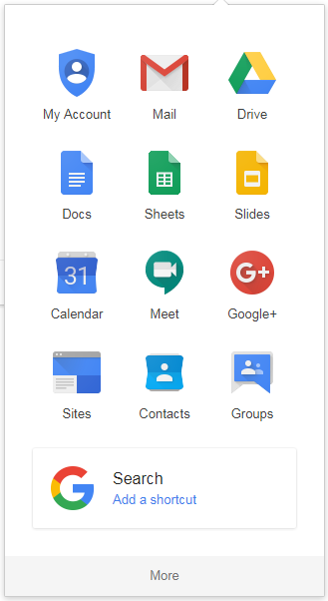
- This will open:
- Select which type of file you would like to create
- Docs: document
- Sheets: spreadsheet
- Slides: presentation
- Option 1: Creating a Google Doc
- Click the blue Docs icon (from 2)
- In the lower left corner click the icon
- Click in the upper left corner
  - Type the name of the document
- Click on the main white space and type the body of
the document
- The document will save automatically when connected
to the internet, so you can close or print it when done
- Option 2: Creating a Google Sheet
- Click the green Sheets icon (from 2)
- In the lower left corner click the icon
- Click in the upper left corner
  - Type the name of the spreadsheet
- Click on the main grid and enter in the data for the spreadsheet
- The spreadsheet will save automatically when connected to the internet, so you can close or print it when done
- Option 3: Creating a Google Slide
- Click the gold Slides icon (from 2)
- In the lower left corner click the icon
- Click in the upper left corner
  - Type the name of the presentation
- Select your presentation theme and type the information for the presentation in the main white area
- The spreadsheet will save automatically when connected to the internet, so you can close or print it when done
- Inserting an Image
- Locate the ‘Insert’ button near the top of the page:
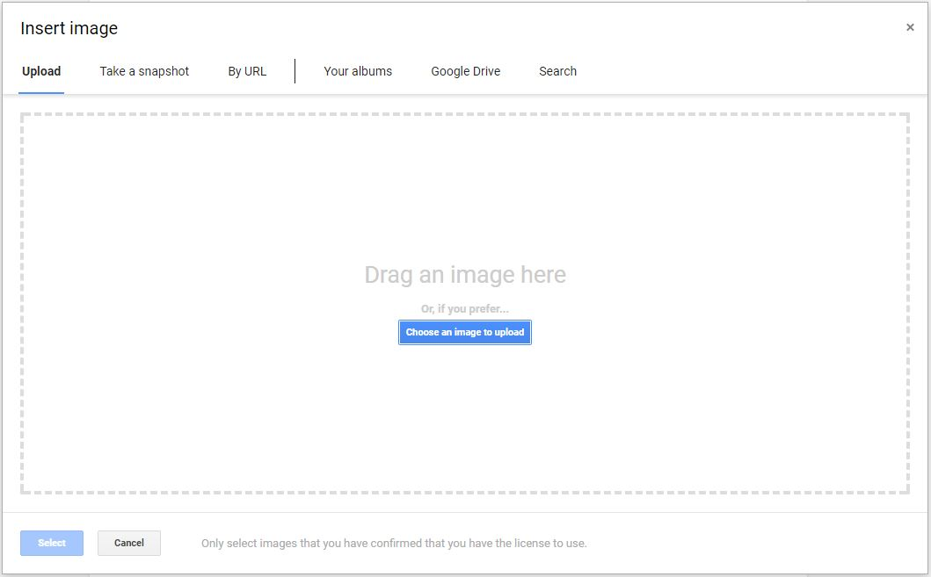
- Select the first option ‘Image,’ and this window will pop up:

- Here you have the option to upload an image from your computer, take a picture of a window on your computer, upload an image by URL, or access your Google Photos albums
- Select the option you require and follow the prompts given by Google
- When you have finished uploading your image, click the blue ‘Select’ button in the lower left corner of the pop-up window
- Uploading a File to your Google Drive
- Click the icon on the page you get to after completing Step 2
- Select the Upload tab:
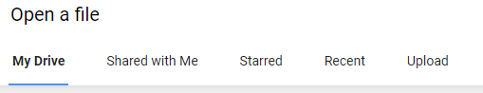
- Then you may either drag the icon of the document into the box or you may click the I icon to select the file from your computer
- When you have your file selected your file click the blue Open button at the bottom left of the pop-up
- Sharing your Document
- Click the button in the upper right corner (below your email address)
- You will be prompted with this box:
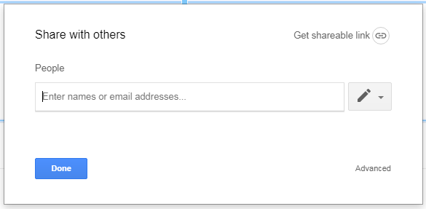
- Type in the email addresses of the individuals you would like to share your document (separated with commas)
- Click the red circled icon to choose whether the people you shared your document with can either edit, only comment on, or only view your document
- Alternatively, you may click and email that link to share your document
  - In the pop-up you may also select the viewers’ privileges

