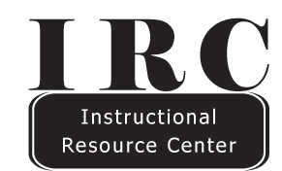
Poster Printing Instructions

- We ask that your file is a PowerPoint document that is appropriately sized. The maximum width for posters is 36”, but it may be as long as needed.
- To set the dimensions of your PowerPoint, click the “design” tab, and select “slide size” on the right.
- Select “custom slide size” from the drop down menu.
- Change the dimensions of the slide. Set the dimensions BEFORE creating the slide’s design, so that the size change will not affect your poster.
- Create your slide and ensure the sizing and formatting is right, as the IRC will not format any documents.
- Save the file on a flash drive and bring it in to the IRC or email the poster to acs-ga@kent.edu.

Poster Printing Prices at the IRC
$6.00 per linear foot.
*Paper selection may be based on availability

