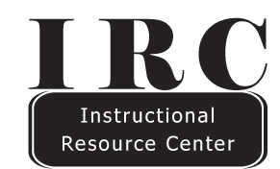
Information Literacy: The Learning Paradigm and Effective Assignments
What is Information Literacy?
Information literacy, the ability to identify, find, evaluate and incorporate information into work and life in meaningful ways, is a combination of skills and literacies that enables critical learning.
Learning Advantages
• Easily lends itself to learner-centered approaches.
• Fosters a process for career-based learning and life-long learning.
• Connects information literacy to your content area.
• Gives students experiences in using information and technology in meaningful ways.
• Fosters student and university success.
Summary
Well-crafted library assignments create a structure and process for students to develop and master
information literacy. Technology (e.g. the internet, Blackboard Learn, streaming learning modules) can create both challenges and opportunities. KSU librarians can support your library assignments in a number of ways:
1. Collaborate and consult on designing assignments.
2. Provide access to ready-made instructional modules and approaches.
3. Deliver customized instruction to your students during a class visit.
4. Partner in developing programmatic approaches to information literacy instruction (e.g. English Writing Program) that utilize a combination of approaches and technologies.
Resources
The following links will connect you to much of the information:
• Reference Services in the Information Commons: www.library.kent.edu/about/departments/reference
• Assignment Design and Assumptions: www.library.kent.edu/about/departments/instruction
• Library Skill Modules: https://libguides.library.kent.edu/tutorials
Where to get help
• Library Web Site: www.library.kent.edu
• Liaison Librarians: www.library.kent.edu/subject-librarians-name

