Pulling Multiple Index Reports at the Same Time Using Multiple Indexes Reports in Cognos
If you are responsible for pulling multiple index reports each month, you can save time by utilizing the Multiple Indexes Monthly Transactions report located in Cognos. Note that multiple reports are also available for budget summaries as well as multiple index fiscal-year-to-date transactions. These reports are all pulled in a similar way.
In Flashline go to your Employee dashboard, scroll down to Reports (Cognos) and click on Finance Reports. You will see a variety of finance reports that are available. You can add any of these reports to the “My Dashboard” by typing Finance in Search Flashline located in the blue bar of the screen, hover over any of the reports that you may want to add to your dashboard then click on the pin to the right of the file.
For this example we are using the Multiple Indexes Monthly Transaction Report
Sign into IBM Cognos Analytics with your Flashline username and password
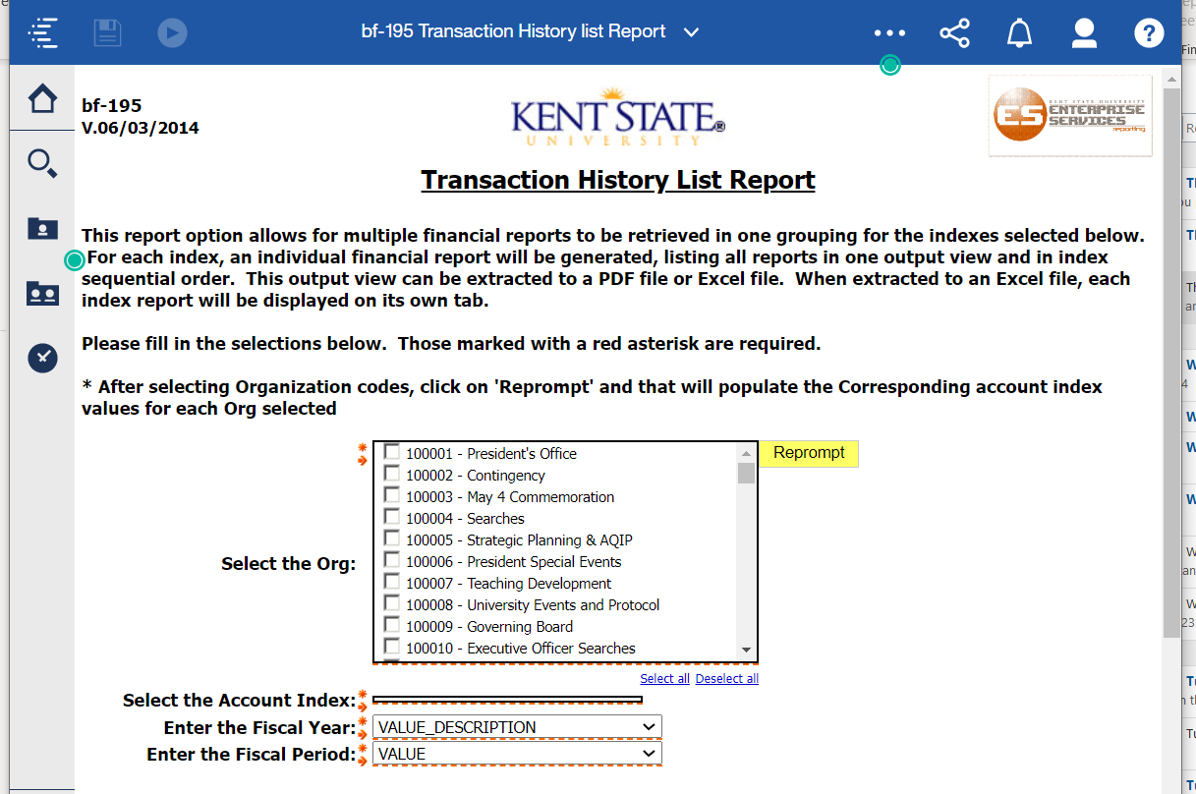
This report is pulled using org codes then when reprompt selected will allow you to select indexes.
Click in the box to the left of each org you would like to pull (I
Click on the yellow Reprompt.
Index options will include all indexes within the org code(s) you chose
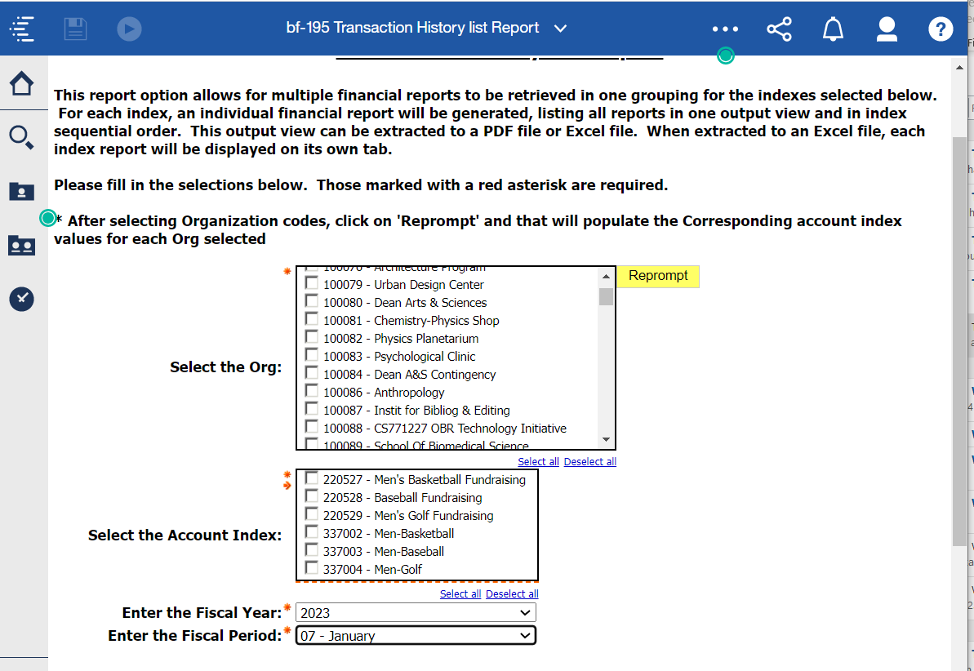
Select all indexes you wish to view.
Select fiscal year.
Select fiscal period.
Scroll down to bottom of page and click on Finish.
Once a report appears, go up to the “Run As” icon and select PDF or Excel
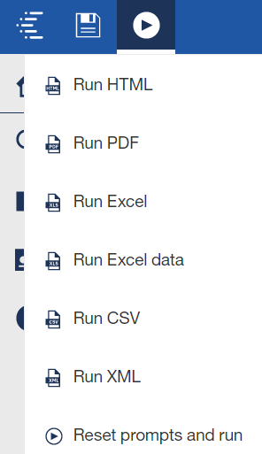
The .pdf report will print all indexes in one file, but no more than one index will appear on a single page.
The excel file will print as one file with each index as a separate tab. The tab naming convention is the fund followed by org and prog. The individual index numbers appear on their respective reports.

