Open Encumbrances Report
If you need to review your index for open encumbrances (commitments), the Open Encumbrance Report in Banner is a great starting point. Below is a quick tutorial on how to run and use this report.
- Log into Banner 9 Admin Pages through Flashline.
- Navigate to FGROPNE – Open Encumbrance Report.
- On the Printer Control section, ensure that printer is set to DATABASE (see image on step #4).
- Populate the appropriate fields. We suggest making Report Layout = F (FOAPAL), then in 03, 04, 05, 06, 09, & 10 using the Fund, Org and Program assigned to your index (Controller’s Office is used below as an example):

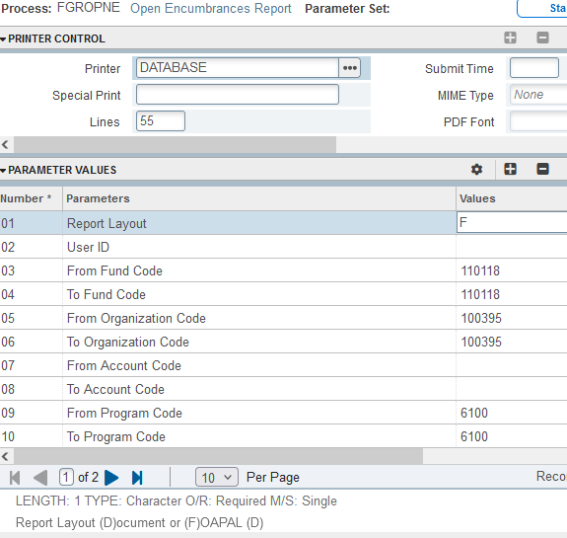

- Once fields 01-10 are filled in, click the next section button in the bottom left corner of your screen (when you hover over the button, it will look like this: 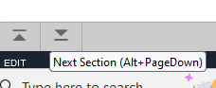

- Click Save. You know it worked if you see this in the top right: 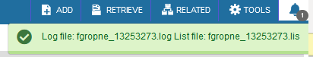

- Click Related at the top right and select Review Output: 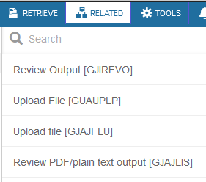

- Double Click the empty field next to File Name (top left of your screen): 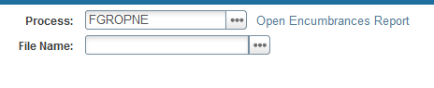
- On the Available Files box that pops up, double click the .lis file: 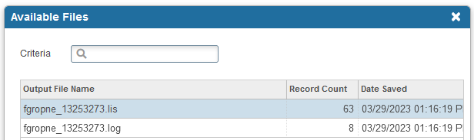

- Your report will appear in Banner, listing all open Purchase Orders on the FOP (Fund, Org, Program) that you entered in step 4, sorted by account. To export this report out of Banner, click Tools and select Show Document (under the Options subheading). Banner will give you a red warning box in the top right corner asking if you wish to continue, select Yes. 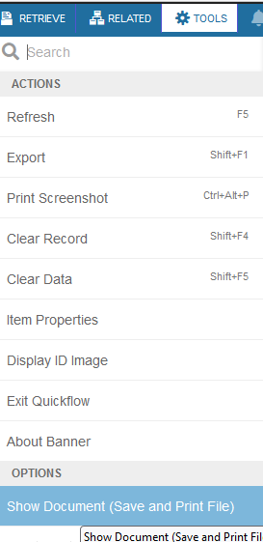 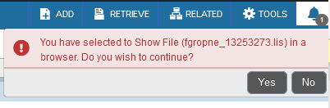

- Your output will show up in a new browser window/tab and appear like this: 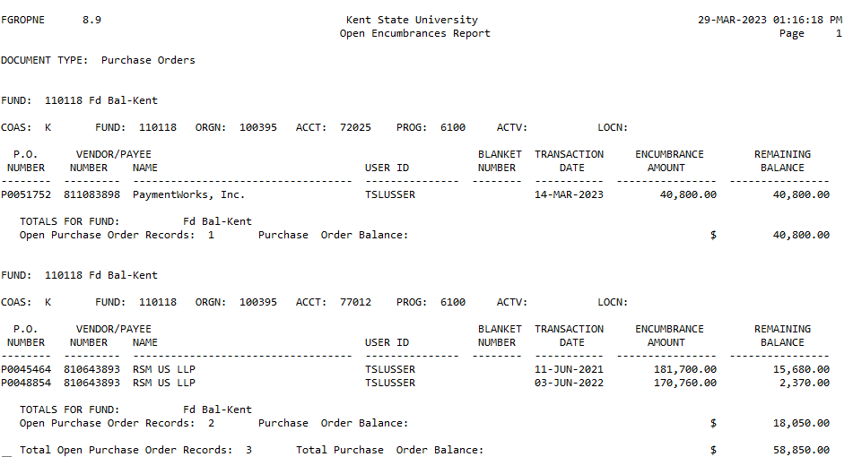

Special Notes:
- If you do not know your Fund/Organization Code/Program Code, go to Banner Screen FGIBDST, type in your Banner index, and press the tab key on your keyboard. The FOP elements should automatically populate:
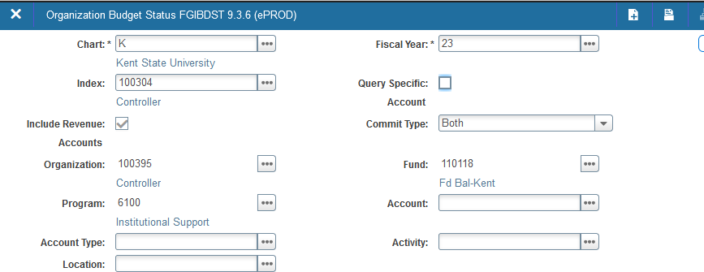

- Purchase orders will roll forward year-to-year until they are closed. They can be closed by being paid via AP or by contacting the Procurement department.
- Current Year Purchase Orders will show in your transaction reports as their PO #. Prior year PO’s that have rolled into the current year will appear like this in your transaction history: 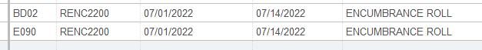
- This report will only show encumbrances that originate from an open Purchase Order. Labor Encumbrances will not be listed on this report.
- A good practice would be to run this report on a quarterly basis and once in late May/early June to ensure that all completed PO’s are closed before the fiscal year end roll-forward jobs run.

