Empower Timekeeping

Scheduling for

Non Primary Supervisors
March 10, 2015
Note for Apple Macintosh computer users:
Where the instructions indicate Right Mouse Click, Mac users should use Control-click to view pop-up menus.
Example: Click in a field to select the field, Control-click to open the menu, click on a menu item to select it.

Manually Create a Schedule
If a schedule is being created for a site or position other than the primary job of the employee, additional data entry will be necessary to assure accurate communication and time keeping.
- On the grid, find the employee to be scheduled at left, and select the day of the week to be scheduled. Select the cell in the appropriate schedule column.
- Type the shift hours into the cell. (Examples: 8a-5p, 8:00a-5:00p).
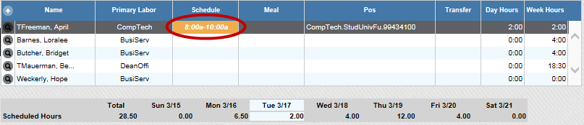
- Click the Save icon in the toolbar. The shift appears on the Schedule Grid and Viewer.

This will schedule a shift for the employee, but will be for their primary site and position

Transfer a Shift
Once the shift is created, edit the shift to reflect the correct job information by updating the scheduled Site and Position information.
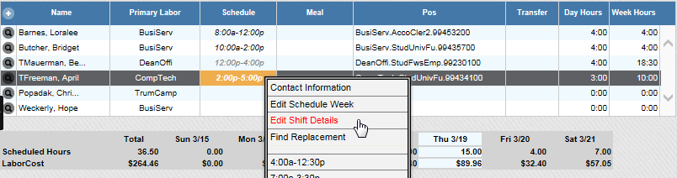
- Right-click the time in the cell of the newly created shift. Select “Edit Shift Details”.
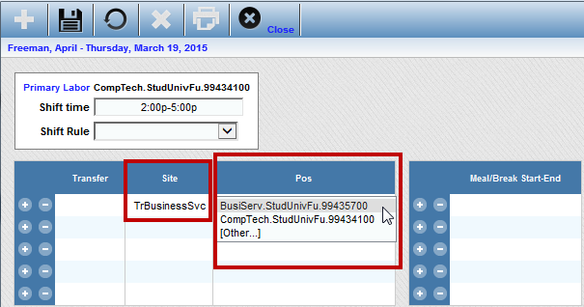
- In the Schedule Detail pop up window, enter the correct schedule information by clicking in a cell in the Site column and selecting the correct data from the drop down menu. Edit the data similarly for the Employee Position in a cell in the Pos column.
- Click the Save icon in the toolbar. Click the Close icon to return to the Scheduler page. The edited shift appears on the Viewer.
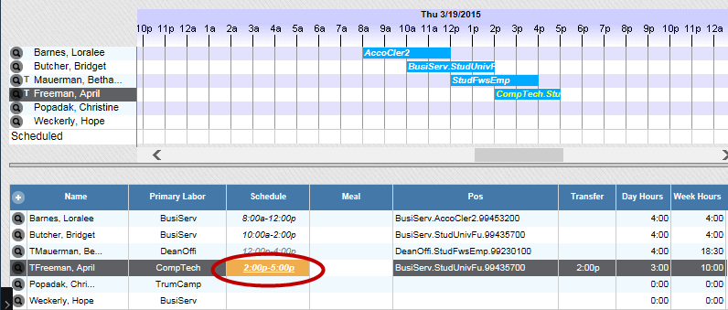
- Click the Refresh icon to display the shift in the Schedule Grid as underlined notifying the Supervisor that the employee is scheduled to work at a site or position other than primary.

Schedule Additional Transfer Shifts
Once an initial shift has been scheduled and the shift has been corrected for site and position, other shifts for the week can be edited to reflect roles other than the primary job.
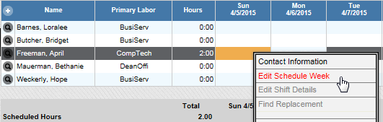
- Right-click the time in the cell of the newly created shift. Select “Edit Schedule Week”.
- Enter Additional shifts for each day as necessary including Site and Position.
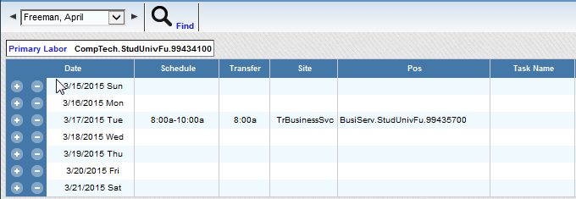
- Click the Save icon in the toolbar. Click the Close icon to return to the Scheduler page. The edited shift appears on the Viewer
- Click the Refresh icon to display the shifts in the Schedule Grid as underlined notifying the Supervisor that the employee is scheduled to work at a site or position other than primary.
In Employee Self Service, an asterisk will indicate to the employee that the scheduled shift is for a site/position other than primary.

