

Updated Empower Timekeeping

Student Employee Guide

June 2015

**Note for Apple Macintosh computer users:**Where the instructions indicate Right Mouse Click, Mac users should use Control-click to view pop-up menus.

Example: Click in a field to select the field, Control-click to open the menu, click on a menu item to select it.

#### Student Employee Procedures

# Employee Web Punch Procedures

## Punch in/Punch out using the computer

1. 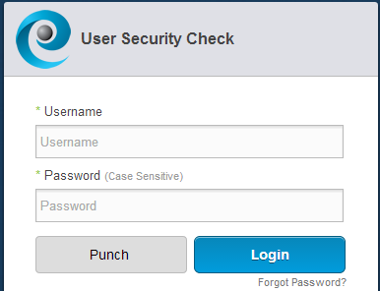A computer on a KSU campus must be used in order to use the Empower web tool.
   1. Open a web browser
   2. Go to **http://timekeeping.kent.edu/**
2. Punch button**Quick Punch:** Type the FlashLine username and password, and click on the **Punch** button.

punch confirmation messageA confirmation message will appear.

1. **Punch to transfer hours:** Type your FlashLine username and password.
   1. log in buttonClick **Log In**.

**\*\* (Only needed if transferring IN)**

* 1. clock button. click to punchClick the **Clock** icon in the upper right corner to punch.
  2. If you have more than one job, select both the site and position.
  3. sign out button**\*\*(Punch to transfer hours is only needed for the *In Punch* for a transfer of site and position, DO NOT transfer on an out clock punch.)**

1. To **sign out**, click the wheel icon.

# Employee Time Clock Punch Procedures

## Punch in/Punch out using the time clock

* Swipe your card in the groove on the right to punch. (1 beep)  
  The screen displays “Punch Accepted” and your first name.
* If you do not have your card, type in your Kent State ID number (Banner ID).

Do not swipe again for at least 60 seconds. If you do, you will hear 4 warning beeps and see a warning message on the screen.

## Special Functions

### Site Transfer only – F1 key

1. Press the F1 key.
2. The clock will ask for the Badge number.   
   Swipe your card or key in the ID number.
3. A prompt for the site code appears.
4. Type the site code and hit enter.
5. A ‘transfer accepted’ prompt will appear.

### Site & Job Transfer – F2 key

1. Press the F2 key.
2. The clock will ask for the Badge number.   
   Swipe your card or key in the ID number.
3. A prompt for the site code appears.
4. Type the site code and hit enter.
5. A prompt for the job number will appear.
6. Type in the job number and hit enter.
7. A ‘transfer accepted’ prompt will appear.

### 

### View last Punch - F4 key

1. Press the F4 key.
2. A prompt asks for the badge number to get the last punch.   
   Swipe your card or key in the ID number.
3. timeclock imageThe screen will display the last punch.

**\*Badges issued prior to 2007 will not contain KSU ID numbers, and cannot be read by the Time Clocks. If an ID cannot be read, manually type the KSU ID number and punch in or out.**

Note: The time clock does not print receipts.

**Student Self Service**

1. Student time Sheet View tabClick **Student Timesheet View** to view your timecard.
2. My Schedule tabClick **My Schedule** to view your work schedule for the week as assigned by your supervisor.
3. My Availability tabClick **My Availability** to indicate the hours that you are available to work.
4. MyPersonal info tabClick **My Personal info** to view primary labor and e-mail address on file.

**Indicate Availability to WORK (student employees)**

1. My Availability tabSelect My Availability
2. Select effective start date to indicate your availability.

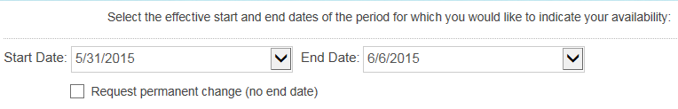

1. 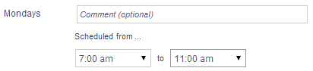Select the hours you are available to work by selecting the begin and end times from the drop down menus.

***Note the AM and PM indicators.***

1. Comment entry fieldYou may add a **comment** for your supervisor.
2. Submit request buttonClick the **Submit Request** button to save your availability information.