Bistable switchable liquid crystal window

KSU.302

Inventors: Deng-Ke Yang, Lei Shi and Rui Bao

Abstract:

Our scientists have invented a bistable switchable liquid crystal window that can be switched between a transparent state and a milky state by a one-second-wide voltage pulse. Although similar technologies are available in the industry, they require low voltage that has to be constantly applied to sustain the states. Fortunately, the present invention requires no voltage to sustain the optical states, making this smart window present energy-savings. This switchable window is based on polymer stabilized cholesteric texture (PSCT) liquid crystal technology, which is owned by Kent State University. The transparent state is the homeotropic state where the liquid crystal is uniformly aligned in the cell normal direction. Another advantage is that we have greater clarity than former polymer dispersed liquid crystal (PDLC) switchable window technology.

Applications:

- Interior/exterior settings for sun/heat control (such as buildings, greenhouses, automobile sunroofs, side windows on aircraft, etc.)
- Customizable privacy setting (such as offices, conference rooms, hospital areas, bathrooms/showers, etc.)
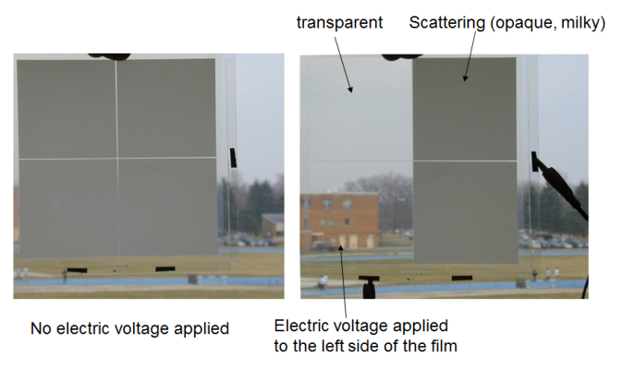

FIG: Schematic diagram of the window in scattering and transparent states
Advantages:

- Energy savings
- Suitable for mass production
- Can be used in production of large-sized windows
- High stability

Patent Status:

- Patent – 8,913,215

