Apparatus and methods for real-time multimedia network traffic management and control in wireless networks

KSU.335

Inventor: Augustine Samba

Abstract:

Current network management procedures and network management systems provide monitoring aspects to the system and their architectures are centralized and based on statically managed objects. Today’s industry procedures such as SNMP (Simple Network Management Protocol) and TNM (Telecom Network Management) present a number of limitations for the complex and heterogeneous telecommunication networks. As multimedia data is increasing in the world (video calls, live video transmission, etc.), handling the data efficiently and reliably becomes important. We propose an effective and efficient framework to facilitate network management and control. The architecture facilitates peer-to-peer networking under the supervision of a novel Integrated Network Management System (INMS). The invention is directed towards network management systems and methods that provide substantially real-time network management and control capabilities of multimedia streaming traffic in telecommunication networks. The invention provides pre-emptive and autonomous network management and control capabilities and may include shared intelligence of embedded systems - Heterogeneous Sensor Entities (HSE) and the Sensor Service Management (SSM) system.

Applications:

  - Telecom vendors, wireless, wireline and cable network service providers, ISPs
  - Mobile multimedia services
  - IPTV
  - Converged/standalone voice, video and data services
  - Broadband access and Wide Area Networks

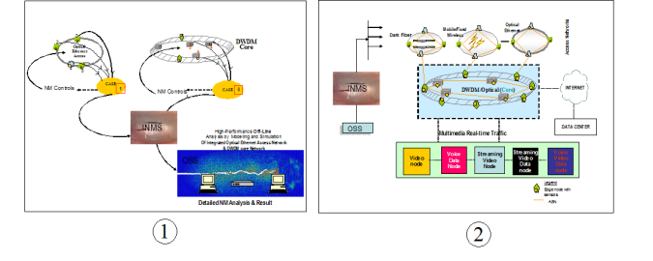

FIG 1-Integrated view of Real-time Network Management
FIG2- Integrated Network Management Framework
Advantages:

- Real-time network management
- Autonomous control of multimedia traffic
- Real-time provisioning of network management and control functions
- Efficient network reliability and restoration procedures

Patent Status:

- Patent – 8,868,725

