Super piezoelectric composite fiber mats for power generation and soft actuators

KSU.418

Inventors: Antal Jákli, Ebru Aylin Buyuktanir, John L West, Jason Morvan and John Ernest Harden Jr.

Abstract:

Materials designed to flex or change shape can be made from responsive fibers that contract or expand upon application of an electric field. Conversely, they produce electricity when input is given mechanically. Our scientists have developed a cloth-like material (fiber mat) that can effectively and efficiently convert the energies via super-piezoelectricity. The voltage from a single layer can be easily detected and is enough to switch an LCD display (greater than 2 volts). In converse mode, an applied voltage will cause the material to move. The material is an electrospun fiber mat that incorporates ferroelectric barium titanate nanoparticles (BaTi02). The scientists have also demonstrated that linear electromechanical responses of the fiber mats have an effect that is orders of magnitude larger than pure BaTi02 films, due to the fact that electrospinning poles the particles while the fiber is being formed. The fibers, in turn, produce a huge surface area in a small space. The net result is a material that is easy to manufacture, highly efficient and yields a substantial weight savings.

Applications:

- Artificial muscles
- Heel strike generators and similar
- Microphone, speakers and actuators that can be used to generate electricity
- Every push button (keyboard keys, switches) that utilizes mechanical parts
- Traffic counters, pressure sensors, on-demand power supply

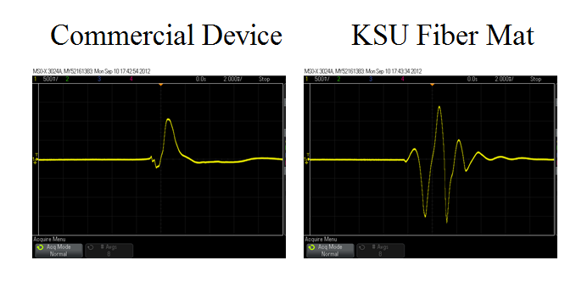

FIG: Voltage generation in commercial device and Fiber Mat
Advantages:

- Energy savings and energy generation
- Ease of manufacturing as technology for meter-wide sheets already exists and can be placed on a roll-to-roll system
- 30 times lighter than current PVDF based piezoelectric sheets
- Room temperature manufacturing as compared to near Curie point for competition (PVDF)

Patent Status:

- Provisional Patent - 14/051,763

