Patterning of liquid crystal alignment using inkjet-printed gold nanoparticles and their use to produce patterned, electro-optically addressable devices

KSU.425

Inventors: Torsten Hegmann, Dmytro Reznikov and Anshul Sharma

Abstract:

Inkjet printing (non-contact type) is a unique printing technique used to fabricate structures from nanomaterials, biomaterials and liquid crystals. Many liquid crystal-based electro-optical devices such as diffraction gratings, Fresnel zone plates, adaptive lenses or sensors require patterned alignment surfaces. Present available methods provide good resolutions with predictable results but are time-consuming and the patterning surfaces do not actively influence the electro-optical response of the liquid crystal. Our inventors have demonstrated a new technique for obtaining patterned structures with the modulated director configuration in the liquid crystal cells using ink-jet printing of the golden thiol-capped nanoparticles. This technique produces highly conductive, high resolution patterns to be fabricated using low-cost and easy design processes.

Applications:

- Liquid crystal optical lenses
- Fresnel lenses
- Waveguides
- Patterned display applications
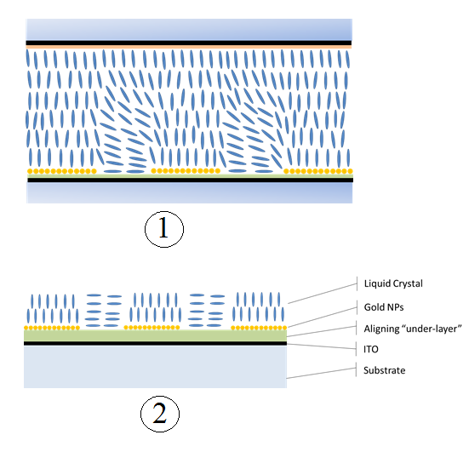

FIG 1-Schematic image of the hybrid structure
FIG2- Schematic image of LC cell with ITO electrodes and two alignment layers
Advantages:

- High conductivity, high resolution and flexibility
- Enhanced surface smoothness
- Fast, easy and straightforward approach to pattern alignment, resulting in optical contrast in liquid crystal-based devices
- Easily scaled up to larger and flexible substrates
- Roll-to-roll manufacturing is viable

Patent Status:

- Patent Pending- PCT/US2014/033945

