Nanosecond liquid crystalline optical modulator

KSU.429

Inventors: Volodymyr Borshch, Sergij V. Shiyanovskii and Oleg D. Lavrentovich

Abstract:

Optical modulators are devices used to control and manipulate the properties of light. Liquid crystal-based modulators are best suited for this purpose. Transition time in optical devices is one of the main properties that affect quality and other characteristics where the component is used. Current available technologies use pretilt angles that have rise times of several hundred nanoseconds, while maintaining a slow fall time. Our scientists’ new invention uses change of the birefringence due to the change of the order parameter. The optical response is caused by two processes with approximately equal amplitudes and characteristic times of 1 ns and 30 ns, making the total ’90-10 fall time’ around 50 ns.

Applications:

Electro optics applications such as

- Optical switches
- Light modulators, telecommunication devices
- Beam steering
- Optical shutters, LC lens
- Light limiting and controlling displays
- Fast switching optical displays
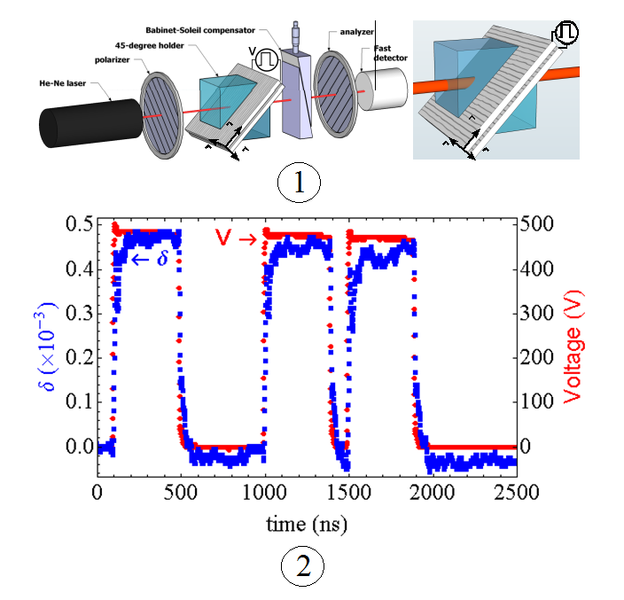

FIG 1- Experimental setup with 45 º holder and an LC cell
FIG2- Switch on and off times of the order of magnitude of ns
Advantages:

- Nano second response
- Least rise and fall time
- Use of geometrical constraints to compensate the effects of the fluctuations

Patent Status:

- Provisional Patent – 61/756,867

