Title: Biocompatible smart responsive scaffold and polymer foams

KSU.430 and KSU.452

Inventor: Elda Hegmann, Torsten Hegmann and Yunxiang Gao

Abstract:

The inventors of this technology have developed biocompatible controlled biodegradable smart responsive scaffold (SRS) materials that enhance attachment and viability of cells, i.e. actively guiding their expansion, proliferation, and in some cases, differentiation, while increasing their biomechanical functionality, an important key issue for tissue regeneration. Chemically built-in functionality in these biodegradable SRS materials is achieved by varying structural functionalization with biocompatible liquid crystal motifs and general polymer composition, allowing for regulation and alteration of tensile strength, surface ordering, bioadhesion and biodegradability, bulk liquid crystal phase behavior, porosity and cell response to external stimuli. Liquid crystal modification of such polymeric scaffolds is an ideal tool to induce macroscopic ordering events through external stimuli. None of said approaches have been demonstrated in prior art and the use of biocompatible scaffolds that respond to a variety of external stimuli resulting in a macroscopic ordering event is a novel aspect addressed through this invention. These scaffolds, made of FDA-approved precursor materials, have been successfully tested with several representative cells lines. The pore size of the elastomers has been increased in order to use them for a wide selection of cells, as well as permitting the incorporation of growth factors, when needed, for enhancing cell viability and proliferation. The inventors are now proposing a new method for pore size preparation in the form of fully interconnected channels that allow for the holding a desirable load (e.g., a dye), which will leach out under pressure or encapsulate a temperature-sensitive liquid crystal mixture (e.g., cholesteric temperature sensors).

Applications:

- The use of metal foam as template is novel for generating artificial muscles, tunable liquid crystal lasers, actuators and sensors
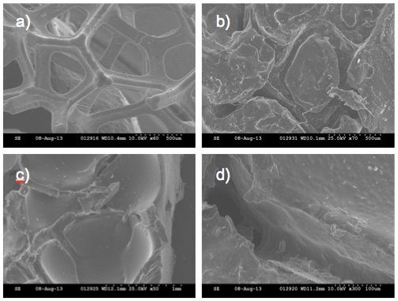

FIG- SEM images: (a) Nickel foam template and (b-d) SBC₁-LC elastomer showing fully interconnected channels with an average pore size of 100 and 150 µm at intersections.
Advantages:

- Biocompatible, biodegradable elastomer
- Liquid crystal polymer and elastomer foams with controlled internal structure and network-like porosity
- Commercially available Ni foams are used as templates
- Removal of the template leaves behind a full set of interconnected channels that can be filled with other materials, enhancing the properties and uses in unique ways

Patent Status:

- KSU.430- PCT US 2014/033967
- KSU 452-US Provisional– 61/918,084

