End effector and robot workcell for automated assembly of fuel cells stacks using robotic technology

KSU.448

Inventor: Vladimir Gurau

Abstract:

Automated fuel cell assembly allows high quality, high performance production of fuel cells that serve as an alternative and a promising source of electrical energy in the modern world. End-effector and the fuel cell components are designed with features for accurate component alignment during the assembly process. Insufficient integration of the fuel cell design process is a major drawback in the procedure. The new invention overcomes this drawback and also provides an innovative, inexpensive end-effector capable of handling a variety of fuel cell components. These components include MEA’s, bipolar plates and gaskets, which perfectly align the fuel cells in the stack as a way to avoid overboard reactant gas leaks, thus possessing passive compliance. Other aspects of the invention include providing a method to align fuel cell components in the stack during the automated assembly process, providing passive compliance to the end-effector and providing the workcell for automated fuel cell assembly.

Applications:

- Fuel cell industry- automated assembly of fuel cells
- Automotive applications
- Battery applications
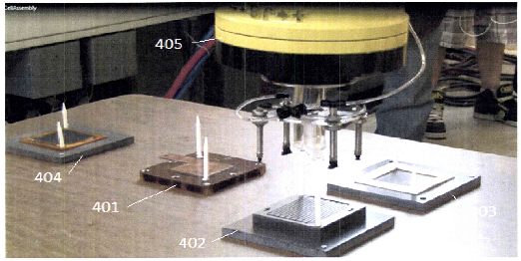

FIG illustrates the workcell for automated fuel assembly according to the present invention. 401-Fuel cell endplate, 402- bipolar plate, 403-gaskets, 404- MEA’s and 405-robot

Advantages:

Capable of handling a variety of fuel cell components and perfectly aligning them in fuel cell stacks with:
- Increased accuracy and repeatability
- Inexpensive and efficient automated assembly of fuel cells
- Avoiding overboard reactant leaks during fuel cell operation
- Integrated processes for manufacturing
- Increased stack quality

Patent Status:

- Provisional Patent – 61/914,558

