Mechanochemical sensing methods using DNA origami nanostructures

KSU.457

Inventor: Hanbin Mao, Deepak P. Koirala, Hiroshi Sugiyama and Masayuki Endo

Abstract:

DNA origami has been used to fabricate a wide variety of 2D and 3D DNA nanostructures. Such nanostructures have been extensively used in various applications like nanorobotics, molecular computation and drug delivery. Its applications in biosensing have not yet been explored well. While biosensing at single molecule level offers the ultimate detection limit, its throughput is often compromised due to the restricted platforms, in which only a single sensing event is reported at a time. To address this problem, the inventors have used DNA origami nanostructures as unique platforms in a new sensing approach based on the mechanochemical principles. Binding of a specific target molecule to its corresponding probe induces a change in 2D or 3D arrangement of the origami nanostructure, which can be monitored in real time by using optical tweezers as a variation in the tension of the nanostructure. With the versatile nature of DNA origami nanoassembly and the highly sensitive mechanical measurement by optical tweezers, it is anticipated that the platform can extend the limits of self-assembled DNA nanostructures for mechanochemical investigations in the fields of nanotechnology, biomedicine and biosensing.

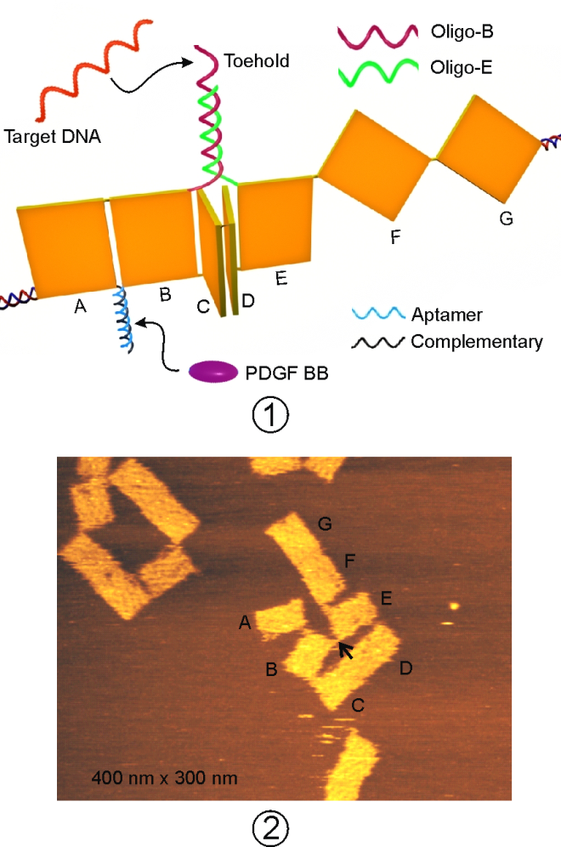

Applications:
- High-throughput sensing of multiple targets such as nucleic acids, proteins, small molecules and metal ions in the same platform
- Potential to investigate affinity interactions between molecules
- Mechanochemical studies in biocompatible platform using DNA nanostructures

FIG 1 – Schematic of the sensing platform to
simultaneously detect DNA and protein targets
FIG 2 – AFM image of the construct without handles showing connection between Band E tiles
Advantages:

- Simple, reliable and biocompatible platform
- High throughput and highly sensitive detection
- Versatile and facile integration of detection probes
- Noise-free mechanical signal to warrant an ultimate detection limit
- Flexibility of designing 2D or 3D DNA nanostructures for mechanochemical sensing

Patent Status:

- Provisional Patent – 62/084,68

