Additive formwork: 3D printed flexible formwork for precast concrete
KSU.460
Inventor: Brian Paul Peters

Abstract:
The precast concrete industry has steadily grown since gaining popularity in the 1960s. It is now represented by several national organizations such as the Architectural Precast Association (APA), the National Precast Concrete Association (NPCA) and the Prestressed Concrete Institute (PCI). The NPCA recently stated that the precast concrete industry sales in 2013 were $15.9 billion, of which the building applications accounted for $3.02 billion. The application of this patent focuses on architecture and building applications and could be expanded to further precast applications such as transportation, utility and industrial. Historically, casting custom textures in concrete relied on creating a mold from an existing object. For example, if a designer desired a wood grain texture on a precast panel, strips of wood were used as the mold, allowing the concrete to be imprinted with the texture. Fortunately, over the past few decades, new fabrication techniques have emerged that allow for the casting of complex geometries or offer a wide variety of textured finishes instead of usually flat and unadorned surfaces. One of these techniques is the use of CNC milling machines that sculpt the negative of a mold out of foam or other solid material, which is then cast in a flexible material such as silicon. This new invention reconsiders the process, eliminating the initial step of sculpting a negative, thereby eliminating waste, reducing fabrication time and offering greater design flexibility. This invention demonstrates the advantages of 3D printed, flexible form work for architectural applications, specifically precast concrete panels. Rather than directly printing a wall or section of a building in concrete, a flexible formwork is 3D printed for the casting of a concrete wall section or roof assembly.

Applications:

- 3D printed flexible "form liners" for precast concrete
- Fabrication of wall panels in the factory
- 3D models to be used on construction site

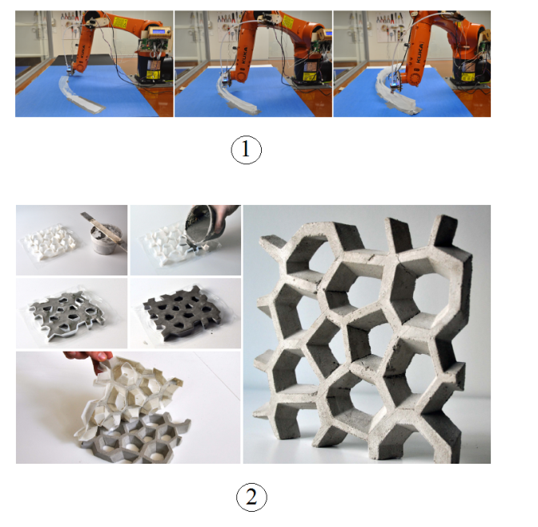

FIG 1- 3 D printing using a robotic arm
FIG 2- Demonstrates simple and efficient casting process
Advantages:
- Recyclable, 3D printed plastic formwork can be shredded and remade into 3D printing filament, allowing it to be reprinted multiple times
- Each 3D print can be unique, allowing the designer more design options opposed to selecting a predefined pattern or texture
- Removes a step in the mold making process, meaning less materials and time to fabricate
- Molds are lightweight, easy to transport and can be reused to cast multiple sets and then ultimately recycled and reprinted as a different form
- The flexible material allows a single formwork to be recast multiple times with no damage to the mold itself; standard rigid plastic forms do not allow for this

Patent Status:

- Provisional Patent – 62/001,949

