SCHOOL OF COMMUNICATION STUDIES

Master’s Graduate Program Handbook of Policies and Procedures

Amended October, 2013

TABLE OF CONTENTS

Introduction 4
How to use the handbook 4
History of the School of Communication Studies 4
The faculty and the academic areas of emphasis 4
Interpersonal communication 5
Mediated/Mass communication 6
Health communication 6
Global communication 6
What everyone needs to know 7
Getting started 7
Temporary academic advisor 7
Official academic advisor 7
Registration 8
Transfer credits 8
Individual investigation 8
Research hours 9
Full course load 9
Good standing 9
Early dismissal 10
M.A. program plan 10
Annual review 11
Normal progress 11
Thesis option 11
Coursework-only option 14
Project option 15
Internship option 17
Appeal policy 20
Student academic complaint policy 20
Student cheating and plagiarism 21
Withdrawal from courses and the university 21
Institutional Review Board 21
Graduate student association 22
What a student on an assistantship needs to know 22
Conditions of appointment 22
Selection criteria 23
Class assignments and teaching expectations 23
Research assistants and expectations 24
Appendix A – Program Plan
M.A. program plan instruction for faculty 25
How to ask your advisee for revision 29
M.A. program plan instruction for students 31
What if I need to make changes? 32
Appendix B – Annual Review ……………………………………………………...41
Appendix C – Project Option
Examples of Potential Projects 42
Project Final Paper Evaluation Form for Faculty Advisor 43
Appendix D – Internship Option
Internship Agreement Form 44
Internship Agreement Form Sample 47
Internship Bi-Weekly Journal Form 50
Internship Midterm and Final Evaluation Form for Supervisor 51
Internship Final Paper Evaluation Form for Faculty Advisor 54

INTRODUCTION

How to Use the Handbook

Welcome to the Kent State University graduate program in the School of Communication Studies. This handbook is your official guide to the policies and procedures that structure your graduate study in the School of Communication Studies at Kent State University. Read it carefully and refer to it often, so that you are familiar with the necessary steps you need to take throughout your study here. The contents of the graduate handbook are constantly under review and may change at the discretion of the School. Therefore, if you have any question about a specific policy or requirement, your first source of help will be your academic advisor. If both you and your academic advisor need more clarification, you should ask the Coordinator of Graduate Studies.

This handbook is organized into two primary sections. The first section, “What Everyone Needs to Know,” includes information relevant to all graduate studies, whether you are on assistantship or not. The second section, “What an MA Assistant Needs to Know” contains information pertaining to your assistantship appointment in the Master’s program.

History of the School of Communication Studies

Kent State University’s School of Speech was established in 1931 and, in 1932, began offering programs leading toward the baccalaureate degree in rhetoric and communication, speech pathology and audiology, telecommunications, and theatre. Coursework leading to the Master of Arts degree in Speech was added to the program in 1936, and the department was officially renamed the School of Speech in 1941. Dr. L. Leroy Cowperthwaite took the helm of the School in 1953, and under his direction, the School grew in number of students and depth of programs. The Doctor of Philosophy program began in 1968 and graduated its first candidate in 1971.

In 1983, the School of Speech separated into three independent schools: Speech Communication (which encompassed the rhetoric and communication and telecommunications divisions), Speech Pathology and Audiology, and Theatre. In 1988, the telecommunication component of Speech Communication merged with the School of Journalism to become the School of Journalism and Mass Communication. And in 1989-1990, Speech Communication changed its name to the School of Communication Studies to reflect the breadth and depth of the current offerings within the School. Subsequently, in July 2002, the School became part of a new college, the College of Communication and Information, and Dr. James Gaudino was hired as its Charter Dean. In July 2009 Dr. Stanley Wearden, director of School of Communication Studies (2005-2009), became Dean of the College of Communication and Information.

The Faculty and the Academic Areas of Emphasis
The Masters’ program in Communication Studies is guided by a nationally and internationally recognized group of faculty members. The faculty members are passionate about teaching and research, and are closely involved in larger communities—in Northeast Ohio, other parts of the US, and around the world. Our faculty conducts cutting edge research on a variety of topics, such as media effects, psychological well-being and new communication technologies, health communication campaigns and cognitive processes, public health crisis and social support, presidential elections and political identity, family communication and political socialization, privacy management in social media use, online intervention for caregivers of stroke patients, aging-related issues and communication processes, emotion in supportive messages, globalization, new communication technologies, and much more. Our faculty members have a strong interest in interdisciplinary research and work collaboratively with colleagues in the College of Communication and Information, and with prominent scholars in different fields. You are always encouraged to talk to faculty members about their research agenda and yours and be part of the research projects.
The Masters’ offers opportunities for students to concentrate in one of the following areas, Interpersonal Communication, Mediated/Mass Communication, Health Communication, and Global Communication. Students are also able to propose program of study that bridge across these areas. The Masters’ program is flexible too, allowing students to prepare for PhD work or to build upon and enhance their professional work. In addition, students are encouraged to work with one another as well as with faculty on cutting-edge research efforts, many of which address specific social problems. Taking both a core set of courses, and pursuing a variety of electives allows students not only to build upon a foundation of knowledge but also to develop a strong cohort group.
In today's rapidly changing and turbulent economy, a strong mix of theoretical and practical knowledge is one of the best ways to adapt and succeed, at any point in one's career path (or multiple paths). The communication discipline is uniquely poised with an emphasis on both the production and analysis of messages, interactions, campaigns, networks, and discourses.
A Masters’ degree in communication studies helps to prepare students for advancement in an array of jobs and careers. A Masters’ degree in communication studies also may be usefully combined with another degree programs and courses, including those in business, law, public health, counseling, marketing, human resources management, public relations, alternative dispute resolution, and public administration. Additional information on the program and faculty members can be found on the School’s website: http://www.kent.edu/comm
Interpersonal Communication Emphasis
Interpersonal Communication is one of the longest-standing concentrations in the School of Communication Studies, with students choosing to study interpersonal dynamics for over 30 years at Kent State University. Regardless of the career, a valuable skill is the ability to listen and communicate effectively with others. Interpersonal communication majors will develop refined abilities to assess verbal and nonverbal messages, evaluate intended and unintended effects of messages, interpret diverse meaning, and produce culturally sensitive messages. Interpersonal Communication students will also develop an enhanced capability to make use of new communication technologies available for interaction. The most recent job outlook statistics from the National Association for Colleges and Employers rank effective communication skills as the most important job characteristic employers consider when making hiring decisions, ranking above even technical skills.

Mediated/Mass Communication Emphasis

The mediated and mass communication concentration offers opportunities to study a wide range of media uses and effects, including the use of media for mass, interpersonal, organizational, and group communication. The speed, amount, and complexity of communication have increased in a modern interconnected world. Coursework introduces students to theory and practice related to persuasive communication, analysis of media processes, uses, and effects (e.g., the impact of violence and sex in the media, the impact of the media on the political process). Coursework also addresses various communication tactics used by individuals, organizations, and government to reach and influence the public.

Communication and information-related occupations are seeing strong employment growth. These career examples include working in media promotions, public relations, political campaigns or lobbying, social media management, advertising, community outreach, media campaign development, media consulting, motivational speaking, market and audience research, public affairs, strategic message design, corporate communication, etc. With a firm understanding of theory and practice, graduates of this concentration also pursue higher education in prestigious Ph.D. programs.

Health Communication Emphasis

Communication plays critical roles in health and risk behavior, health care, health promotion, and influences both health outcomes and the cost of health care. In the past decade, the U.S. Surgeon General and the Department of Health and Human Services have recognized communication as vital to achieving the nation’s health promotion and disease prevention agenda. The study of health communication addresses such areas as: how health care providers communicate with their patients and how patients can be empowered in these interactions; how media messages can affect understandings of risk, health, illness and disease; how everyday conversations influence health and risk behavior; how traditional and new media are used in health promotion and education; and how to design effective messages to reduce risk, prevent disease, and promote health.

One of the areas of greatest job growth is in health-related professions. These include health care-related professions, health marketing, public health, patient advocacy and support, and health promotion through agencies and non-profit organizations.

Global Communication Emphasis

The very ways in which we communicate and with whom we communicate are changing rapidly in a globalizing but also fragmented world. The sheer speed of communication, the changing nature of interaction, the variety of informal as well as formal networks, and the diverse forms of social movements are but a few ways in which changes in communication across the planet demand our attention and are contributing to new understandings of “how the world works.”

The Global Communication concentration provides exposure to comparative group and organizational practices, employee participation and organizational democracy in U.S. and international contexts, a variety of types of communication networks, and a range of issues directly relevant to the engagement of multiculturalism at home and interaction abroad. Our program helps equip students to for careers related to multi-cultural and multi-national management, diplomacy, the leadership of non-governmental organizations, international information architecture, the design of international media or health campaigns, and for new and creative positions in the coordination of communication practices in all sectors.

WHAT EVERYONE NEEDS TO KNOW

Getting Started

Before officially entering the program, you will be contacted by the Coordinator of the Graduate Program about the orientation, which normally happens one week before the Fall semester starts. At this orientation, you will learn about the program, your temporary advisor, and course schedules for your first year of study. Students who are on assistantship will sign the necessary paperwork at this orientation as well. Your temporary advisor will guide your initial selection of coursework.

Temporary Academic Advisor

Early in the Fall semester, the Graduate Coordinator will assign you a temporary advisor (within the your area of concentration in most cases) who will advise you regarding courses for the spring term. Your temporary advisor is responsible for 1) monitoring your progress the first semester, 2) providing guidance and information on the policies of the graduate program, and 3) assisting you in identifying an appropriate academic advisor before the submission of the program plan. Your temporary academic advisor should be your first point of contact whenever you have questions and/or concerns about your study here.

Official Academic Advisor

By the end of the Fall semester or early Spring semester you should select your academic advisor. It is a courtesy to discuss this issue with your temporary advisor first. At this time, you should obtain preliminary agreement from the faculty member and work with him/her, along with your temporary advisor to complete the Program Plan (See the Program Plan section below).

The academic advisor will advise your selection of courses and, with you, be responsible for guiding your acquisition of specialized knowledge and methodological skills needed to complete the graduate program. The academic advisor normally will supervise your progress and ensure that you follow the approved program plan, and direct your thesis, project, internship, or completion of coursework.
Whenever you are considering changes in your program of study, you must discuss proposed changes in your program of study with your advisor and receive approval from him/her. If you wish to change your academic advisor at a later point, you can do so but it should prior to beginning a thesis, project or internship. Students who choose a coursework-only option should not change their advisor the last semester in which they plan to graduate. In situations where an advisor wishes to terminate the advising relationship with the student, the advisor should consult with the Graduate Coordinator before notifying the student. The student will then need to obtain another advisor within the same semester.

Registration

For the first semester, you will begin registration after the orientation. After the first semester, you are responsible for following the university registration schedule and completing your registration before the beginning of the next semester. You should register for courses according to your program plan. In cases where a class is canceled or no longer available, you must discuss alternatives with your academic advisor. Late registration will result in university charging for late fee and more paperwork for you and your academic advisor.

Transfer Credits

A maximum of 12 semester credit hours from the accredited institutions offering the Master’s degree may be accepted for transfer towards a master’s degree. Please check with the Graduate Coordinator for policy updates. Credits can only be transferred upon the approval of the Graduate Studies Committee prior to the student’s first graduate registration at Kent State University. For a complete description of transfer student admission, see the University webpage: http://www.kent.edu/catalog/2011/policies/all-policies.cfm#TRANSFERSTUDENTADMISSIONSGRADUATE

For students who transferred twelve credit hours from another accredited institution, credit hours for courses taken outside the School of Communication Studies may not be counted toward the requirements for the Master’s degree. Exceptions will be made only in rare cases.

Individual Investigation

Master’s degree students can enroll in no more than six semester credit hours of individual investigation (COMM 65096) throughout their program of study in the School of Communication Studies. The purpose of an individual investigation is for students to obtain knowledge and skills that are specialized in an area where a similar content is not available in regular class offerings in the current or following semester, or in time to prepare the students to conduct a thesis/project/internship. Students should consult with their academic advisor first for approval if an individual investigation is not included in the Program Plan.

An individual investigation could be an extensive literature review, a research project, an applied research project or an internship (a separate internship from an internship graduation option). Instructors directing the individual investigation project should specify the expectations of the performance and criteria of evaluation at the beginning of the semester. Instructors may require regular meetings during the semester depending on the nature of the assignments(s). Instructors should determine the number of semester credit hours based on the workload.
Students are expected to complete the assignment in one semester. In cases where students need additional semester(s) to complete the course, the instructor will enter an “IP” grade for the course and change it to an “S” at the end of the semester in which the student finishes the assignment(s). Students are not advised to enroll in another individual investigation until the first one is completed.

Research Hours

Research hours may be taken when students are not taking a full course load at the end of their program and to assume full-time enrollment with approval of their academic advisor. Before a student registers for research hours, he/she must first consult with their academic advisor for approval. Students should register for research hours with their academic advisor, and should register for not more than is required and approved by their advisor. In the summer time, students can only register for research hours once (Summer I, or Summer II, or Summer III). It cannot be divided over different summer sessions. Students’ academic advisor will enter an “S” grade at the end of the semester.

Full Course Load

A full-course load normally refers to a minimum of 8 hours of coursework load each term. Students who are on assistantship appointment and students who are on F-1 status should maintain a full course load during the Fall and spring semesters until completion of their program. There are situations where students may not need 8 credit hours: 1) Students may be employed to teach courses as part-time instructors in the summer sessions. Part-time employment covers tuition for up to 4 credit hours of coursework, 2) Students who are not on assistantship and are working on their thesis/project/internship the last semester prior to or in the semester of their graduation. Students on F-1 status should contact the International Students and Scholar Services Office to complete necessary paperwork to exempt from the full-course load requirement. Students who are on assistantship appointment may be able to take fewer than 8 hours in the semester of their graduation (see the Form Library of the Division of Graduate Studies website for Request for Exception to Full-Time Enrollment).

You should consult with your academic advisor to ensure that you register for the correct number of credit hours each term, and make corrections before the end of the add/drop period.

Good Standing

You are required to maintain a minimum GPA of 3.0 to remain in good standing in the program. If you failed to do so, you are subject to dismissal from the program. If you receive a grade of B- or lower for one course, you will receive a letter from the School or the College of Communication and Information as a warning. You are expected to improve your academic performance the following semester. Grades below C are not counted toward completion of required coursework, but are counted towards your GPA. A graduate student who receives a combination of more than 8 credit hours of B- or lower grades, or more than 4 credit hours of grades lower than C is subject to dismissal.

Early Dismissal

Students may be recommended for early dismissal by the Graduate Coordinator if they fail to make satisfactory progress (see the next paragraph). The Graduate Coordinator will recommend early dismissal to the Graduate Studies Committee after reviewing the student’s progress with his/her advisor. After the Graduate Studies Committee votes, the recommendation will be sent to the College of Communication and Information and the student will be notified by the Graduate Coordinator. Students who are placed on academic probation may be recommended for early dismissal if they fail to meet the specified performance requirements.

The advisor should determine whether a student is making satisfactory progress and notify the Graduate Coordinator when a student fails to do so. A general guideline is recommended as follows: Students taking the thesis option are expected to turn in a minimum of two drafts (evidencing significant progress satisfactory to the student’s thesis advisor) beginning the semester they first register for thesis hours and each semester thereafter until completion. Students taking the project option are expected to complete the project requirements in one semester. If an additional semester is needed, students are expected to turn in a minimum of two drafts (i.e., project essay) each semester until completion. Students taking the internship option are expected to complete the internship requirements in one semester. If an additional semester is needed, students are expected to turn in a minimum of two drafts (i.e., reflection paper) each semester until completion. Students taking the coursework-only option will be subject to the university policy requirements (see the Good Standing section) as criteria for early dismissal.

M.A. Program Plan

Upon completion of 8 semester hours of coursework in the M. A. program, you, in consultation with your academic advisor (and the temporary advisor) will prepare a program plan document by completing the program plan on Qualtrics, an online survey software program. This program plan is to lay out your proposed coursework, research interests, and the proposed graduation option (See Appendix A for specific instruction). You will be notified by an email that the online program study is ready to be used in the semester when you need to complete it.

Once the program plan is approved, you and your academic advisor must follow the approved program of study. This document is considered an agreement between you and your academic advisor. Advisor will place a copy of your program plan in your student file when it is completed. You must to obtain approval from your advisor before making any changes. Your academic advisor will review your program plan during the semester you plan to graduate. Any unapproved deviation from the program plan may result in additional course(s) or required work before you can graduate and earn the degree in the school of communication studies.

Annual Review

You and your advisor will complete an annual review by September 30th of the second year in the program and each subsequent Fall semester of enrollment. This annual review is to report your progress in coursework, graduation option and anticipated graduation date.

This annual review will be completed after you and your advisor meet and before the deadline and will be completed by your advisor. Signatures are required for both you and your advisor after the form is completed (see Appendix B for the form). Completed copies will go to the graduate coordinator, student, and advisor.

Normal Progress

You are required to maintain normal progress towards degree completion. You are required to complete a minimum of 32 semester hours, including your graduation option credit hours. No more than 6 hours of coursework may be taken from programs outside of the School of Communication Studies. Only the graduate level courses are counted towards completion of coursework, and among these courses, only up to two classes of 50000 level will be permitted. Exception is made only for programmatic reasons. Normal progress includes the following actions by you:

1. Successful completion of required courses.

a. Foundations of Communication Inquiry (COMM 65000)
b. Quantitative Research Methods in Communication (COMM 65020). Your academic advisor may direct you to take one or more additional courses that pertain to the research methodology to be used in the thesis, project, or internship.
c. Theories of Communication (COMM 65652)
d. Teaching College Communication (COMM 65794). Required of all incoming teaching assistants.

2. Successful completion of required courses in one of the areas of emphasis (i.e., Interpersonal, Mediated/Mass Communication, Health, and Global Communication). You have an option to combine two of the areas of emphasis according to your career goals and needs (in consultation with your advisor).

3. Successful completion of one of the graduation options.

You can choose one of four options: (a) thesis, (b) coursework-only, (c) project, and (d) internship.

I. Thesis Option

Completion of a thesis is required of those students for whom the M.A. is preparatory for a Ph.D. or other advanced degree program. A thesis is also recommended when the M.A. is expected to be a terminal degree for the student, yet whose professional competence would be enhanced by the experience of completing a thesis.

1) Students are required to complete a minimum of 26 semester hours of coursework.

2) In addition, students must register for a minimum of 6 semester hours of COMM 60199, Thesis I. If the student does not complete his/her thesis within the six hours of Thesis I, the student must then continue to register for 2 hours of COMM 60299, Thesis II, during each semester (including summers) until all degree requirements are met, and during the semester of graduation. Students will register for Thesis hours with their academic advisor (including summer time) until they successfully complete the thesis. Advisor will enter an “IP” for thesis hours and enter “S” at the end of the semester in which the student completes the thesis requirements.

3) After the student completes a substantial number of courses, the student and his/her advisor should begin to discuss a possible thesis topic. The thesis committee will be composed of the student's advisor, who serves as director of the thesis, and at least two additional members, at least one of whom must be from the graduate faculty of the School of Communication Studies. Faculty from other NE Ohio universities may be approved to participate on thesis committees if qualified; they will be treated as “temporary” members of the graduate faculty. A majority of the departmental members of a thesis committee must come from the regular tenured or tenure-track faculty of the School who are approved to serve on such committees. After a prospectus is approved, the advisor or committee members should not be changed unless the faculty member leaves the university, chooses not to participate on the committee, or, owing to extraordinary circumstances, cannot participate.

4) Requests for changes in thesis topic and/or committee should be agreed upon between the student and his/her advisor. If a student wishes to change the thesis topic after his/her thesis prospectus is passed, the student needs to re-submit a new thesis proposal and go through the thesis prospectus procedure.

5) Thesis and Dissertation deadlines (i.e., oral defense) for each semester are listed in the graduate catalog. See http://www.kent.edu/academics/resources/academic-calendar.cfm.

6) Students will submit a thesis prospectus:
  - The student, in consultation with his or her academic advisor, will prepare a fully detailed prospectus based on the approved statement of a proposed research problem.
  - The student will deliver copies of the prospectus to members of the thesis committee at least 10 days before the prospectus meeting, which shall be an open meeting. Also, a copy of the prospectus will be made available through the School of Communication Studies. There is no university specified deadline for the thesis prospectus meeting. The advice is to hold the meeting no later than 10 days before the end of the finals week of the semester prior to the semester where the thesis oral defense is held.
  - The student's advisor will notify the Administrative Assistant to complete the form "Notification of Approved Thesis Topic, convene the thesis committee and moderate the prospectus meeting, at which time the student will appear to:
    - Present a summary of the thesis proposal,
    - be questioned on the clarity, scope, and methodology of the proposed study, and
    - receive suggestions to improve the study.
  - The student will be excused from the meeting while the prospectus is (by majority vote of the thesis committee):
    - approved, or
    - conditionally accepted (specified changes to be made subject to the approval of the student's advisor), or
    - returned for revision and resubmission to the entire committee, or
    - disapproved.
  - After "approval" is obtained, the form "Notification of Approved Thesis Topic" will be forwarded to the Director of the School of Communication Studies and the College of Communication and Information by the student's advisor.

6) If the proposed thesis project involves the use of human subjects, it is the obligation of the student to secure clearance through the university's Institutional Review Board before collecting data. If the student is unable to obtain the IRB approval by the time he/she presents the study at the prospectus meeting, he/she should indicate “IRB pending; anticipated approval date is____,” in the “Notification of the Thesis Approved Topic” form. Submit the official IRB approval document to the College of Communication and Information once it is approved.

7) Students who did not pass the prospectus (5.d.ii, iii, iv) need to successfully complete and defend their revised thesis prospectus no later than the end of the following semester (including summer time). Failure to do so may result in dismissal.

8) Oral defense of the thesis:
- All members of the examining committee must receive copies of the thesis at least 10 days before the planned examination, and a copy of the thesis will be made available through the School of Communication Studies. All College deadlines must be met.
- At a time mutually agreeable to the final examining committee and the student, an oral defense will be held for the purpose of accepting, recommending changes in, or rejecting the completed thesis.
- During the oral defense, the student will usually present a short summary of the research and then be questioned by committee members about the research. Following these questions, guests may be permitted to ask additional questions. Examining Committee members will vote “pass” or “fail” and a majority must vote to pass in order for the student to pass the defense. Conditional stipulations may be made by the committee regarding changes, additions, or deletions in the final draft of the thesis.
- After completing the oral defense, the form "Report of Final Examination (see the Form Library at the Division of Graduate Studies)" will be signed by the committee and forwarded to the Director of the School of Communication Studies and the College by the student's advisor.
- One bound copy of the thesis will be deposited with the School of Communication Studies, and one bound copy will be given to the advisor. Additionally, students will also abide by the University guidelines for electronic submission (see the Advising and Graduation page on the College of Communication and Information).

9) It is the student’s responsibility to adhere to all School, College and University guidelines and time frames for graduation in a given semester.

10) Thesis prospectus and oral defense of the thesis cannot take place in the same semester. The earliest time a student can have an oral defense of his/her thesis is the semester following the successful completion of the thesis prospectus.

II. Coursework-only Option

A coursework-only option is recommended for students who are interested in obtaining a broad spectrum of knowledge in communication, or whose career goals are cross-disciplinary, and for whom the MA is intended to be a terminal degree. Students who choose this option should fulfill the following requirements:

1) According to university graduation requirements, in order to qualify for graduation, the student must have a 3.0 average in all graduate courses attempted. Grades below C (2.0) are not counted toward completion of requirements for any advanced degree, but are counted in evaluating a student’s grade point average. Only graduate course credits count toward a graduate degree. Please refer to http://www.kent.edu/catalog/2010/policies/requirements-graduate.cfm#GRADEPOINT for detailed descriptions of GPA.

2) Students will complete a minimum of 32 credit hours of classes.

3) In consultation with the student’s advisor, normally no more than 2 classes within the minimum of 32 credit hours can be taken from outside of School of Communication Studies. The courses taken outside of School of Communication Studies should be from the same institution (i.e., Kent State University). In addition, no more than 2 classes can be taken at the 50000 level. Exception is made only for programmatic reasons.

4) Students should indicate a coursework-only option as their graduate exit path in their program plan for approval.

5) Students who wish to switch to a coursework-only option after their program plan is approved, need to
  - Consult with their academic advisor first for approval of the change.
  - If the request is approved, submit the revised program plan with appropriate changes.
If the request is approved, the advisor will notify the Graduate Coordinator, who will send a signed memo to the students and their academic advisor. A copy of the signed memo will be placed in the student’s file.

6) Upon graduation, the academic advisor should audit the student’s academic transcript for the following requirements
- An average of 3.0 GPA or higher
- Grades for courses counted towards completion of requirements of the degree are not below C.
- No more than two courses are taken from departments or programs outside of the School of Communication Studies.
- The student’s program plan reflects the transcript.
Students should follow the CCI guideline for graduation clearance (see Advising and Graduation Section of the CCI website. http://www.kent.edu/CCI/Advising/index.cfm

III. Project Option:

A project option is recommended to students who are interested in understanding the ways in which communication theories can be applied to a specific context of their choosing, and for whom the MA is expected to be a terminal degree. Students who choose this option should fulfill the following requirements:

1) According to university graduation requirements, in order to qualify for graduation, the student must have a 3.0 average in all graduate courses attempted. Grades below C (2.0) are not counted toward completion of requirements for any advanced degree, but are counted in evaluating a student’s grade point average. Only graduate course credits count toward a graduate degree. Please refer to http://www.kent.edu/catalog/2010/policies/requirements-graduate.cfm#GRADEPOINT for detailed descriptions of GPA.

2) Students will complete a minimum of 29 credit hours of classes, and are expected to begin and complete the project during the final semester in the program (i.e., the semester in which they plan to graduate).

3) In consultation with the student’s advisor, normally no more than 2 classes within the minimum of 32 credit hours can be taken from outside of School of Communication Studies. In addition, no more than 2 classes can be taken at the 50000 level. The courses taken outside of School of Communication Studies should be from the same institution (i.e., Kent State University). Exception is made only for programmatic reasons.

4) Students should indicate a project option as their graduate exit path in their program plan for approval.

5) Students who wish to switch to a project option after their program plan is approved should submit and receive approval prior to the semester where they begin the project. Students need to
  - Consult with their academic advisor first for approval of the change. Students should have a possible project topic ready for discussion when requesting the change.
  - If the request is approved, submit the revised program plan with appropriate changes

If the request is approved, the advisor will notify the Graduate Coordinator, who will send a signed memo to the students and their academic advisor. A copy of the signed memo will be placed in the student’s file.

6) In consultation with the student’s advisor, the student will propose a project that is theoretically or conceptually driven with an emphasis on application. Examples of possible project topics are listed in Appendix C. Submit a 5 to 8-page written proposal to the academic advisor and the reader (i.e., another faculty member) for approval prior to the semester (including the summer time) in which the project is to begin. The written proposal should include 1) Rationale, 2) Goals of the project, 3) Theoretical Framework used to guide the project, 4) Procedure, and 5) Anticipated Outcomes

The student should contact the Division of Graduate Studies if an IRB approval is needed for the project. If IRB approval is needed, the student must obtain IRB approval before conducting the project.

The advisor and the student will mutually agree to select a faculty member with graduate faculty status to serve as the faculty reader. This process should be completed prior to the semester where the student registers for the project hours. The faculty reader’s involvement can go beyond evaluating the final project, and should be determined by the advisor, the student, and the faculty reader.

7) Once approved, the student will register for 3 credit hours of project (i.e., COMM 61198) with his/her academic advisor. If the student needs additional semester(s) to complete the project, he/she will register for research hours with his/her academic advisor until completion of the project. The academic advisor will enter an “IP” for COMM 61198 and enter an “S” at the end of the semester in which the student completes the project. For research hours, the advisor will enter “S” at the end of each semester.

8) The student will deliver the final project (e.g., training program, presentation, workshop, video, brochure, training program) and write a 20 to 25-page paper upon the completion of the project and submit it to his/her academic advisor and the reader who will determine whether the project paper is deemed satisfactory for graduation. The final evaluation should reflect both the advisor’s and the reader’s ratings of the quality of the project. Advisor and the second reader should be invited to attend the presentation if the final project involves a workshop/training type of project. The student should follow the same deadlines as the thesis deadlines for project paper submission. For example, if the deadline for the thesis oral defense for the spring semester is April 15th, your advisor and the faculty reader need to make the determination whether you pass or fail the project no later than April 15th. Therefore, you should submit your project paper to your advisor and the faculty reader at least 2 weeks before April 15th. The advisor should obtain a copy of all submitted documents for the student’s file and place it in the student file.

Thesis and Dissertation deadlines (i.e., oral defense) for each semester are listed in the graduate catalog. See http://www.kent.edu/academics/resources/academic-calendar.cfm.

If the project is deemed unsatisfactory, the student will fail to receive a Master’s degree in the School of Communication Studies. See Appendix C for evaluation criteria for project

9) Upon graduation, the academic advisor should audit the student’s academic transcript for the following requirements
- An average of 3.0 GPA or higher
- Grades for courses counted towards completion of requirements of the degree are not below C.
- No more than two courses are taken from departments or programs outside of the School of Communication Studies.
- The student’s program plan reflects the transcript.
10) The student’s program plan reflects the transcript. Students should follow the CCI guideline for graduation clearance (see Advising and Graduation Section of the CCI website. http://www.kent.edu/CCI/Advising/index.cfm)

IV. Internship Option:

An internship option is recommended to students who are interested in applying communication knowledge to a specific context of their choosing to obtain communication skill sets relevant to their future careers, and for whom the MA is expected to be a terminal degree. Students who choose this option should fulfill the following requirements:

1) According to university graduation requirements, in order to qualify for graduation, the student must have a 3.0 average in all graduate courses attempted. Grades below C (2.0) are not counted toward completion of requirements for any advanced degree, but are counted in evaluating a student’s grade point average. Only graduate course credits count toward a graduate degree. Please refer to http://www.kent.edu/catalog/2010/policies/requirements-graduate.cfm#GRADEPOINT for detailed descriptions of GPA.

2) Students will complete a minimum of 29 credit hours of classes, and are expected to begin and complete the internship during the final semester in the program (i.e., the semester in which they plan to graduate).

3) In consultation with the student’s advisor, normally no more than 2 classes within the minimum of 32 credit hours can be taken from outside of School of Communication Studies. In addition, no more than 2 classes can be taken at the 50000 level. The courses taken outside of School of Communication Studies should be from the same institution (i.e., Kent State University). Exception is made only for programmatic reasons.

4) Students should indicate an internship option as their graduate exit path in their program plan for approval.

5) Students who wish to switch to an internship option after their program plan is approved should submit and receive approval prior to the semester where they begin the internship. Students need to
  - Consult with their academic advisor first for approval of the change. Students should have a possible internship position and job description ready for discussion when requesting the change.
  - If the request is approved, submit the revised program plan with appropriate changes.
6) If the request is approved, the advisor will notify the Graduate Coordinator, who will send a signed memo to the students and their academic advisor. A copy of the signed memo will be placed in the student’s file.

7) In consultation with the academic advisor, the student will choose an internship position that requires the student to utilize communication skills and knowledge. It is the student’s responsibility to secure an internship position that is appropriate within the parameter of the requirements of this option. The minimum hours for internship are 135 hours on site. Complete the MA Internship Agreement Form (see Appendix D) prior to the semester in which the internship is to begin. The form should be typed and signed by all parties.

Advisor and the student will mutually agree to select a faculty member with graduate faculty status to serve as the faculty reader. This process should be completed prior to the semester where the student registers for the internship hours. The faculty reader’s involvement can go beyond the minimum requirements laid out in this handbook, and should be determined by the advisor, the student, and the faculty reader.

8) Once approved, the student will register for 3 credit hours of internship (i.e., COMM 64092) with his/her academic advisor. If the student needs additional semester(s) to complete the internship, he/she will register for research hours with his/her academic advisor until completion of the internship. The academic advisor will enter an “IP” for COMM 64092 and change it to “S” at the end of the semester in which the student completes the internship. For research hours, the advisor will enter “S” at the end of each semester.

9) The student will keep a bi-weekly journal reflecting on the internship experience of the week, and the role of communication in the process (See Appendix D for the Internship Bi-Weekly Journal Form). Depending on the nature of the internship, the academic advisor and the student should agree upon the number and length of the journal throughout the internship period.

10) The student will submit a mid-term evaluation to his/her academic advisor and the reader. The faculty reader should submit his/her comments/feedback to the advisor in writing. The faculty advisor will then synthesize the comments and provide feedback to the student in writing. Use the Internship Midterm and Final Evaluation Form for Supervisor (see Appendix D). Student’s internship supervisor and the student should review the performance together based on the evaluation and both sign the evaluation form before submitting it to the academic advisor and the reader.

11) Upon completion of internship, student will submit a 15-page reflection paper guided by appropriate theories. A final evaluation form from the internship supervisor is also required. Using the “Internship Midterm and Final Evaluation Form for Supervisor (see Appendix D). The student should follow the same deadlines as the thesis deadlines for internship reflection paper submission. For example, if the deadline for the thesis oral defense for the spring semester is April 15th, your advisor and the faculty reader need to make the determination whether you pass or fail the reflection paper along with other documents no later than April 15th. Therefore, you should submit your paper and other required documents to your advisor and the faculty reader at least 2 weeks before April 15th.

Thesis and Dissertation deadlines (i.e., oral defense) for each semester are listed in the graduate catalog. See http://www.kent.edu/academics/resources/academic-calendar.cfm.

12) The student’s academic advisor and the reader will determine, along with the midterm and final evaluations from the employer, the journal and the reflection paper using the “Internship Final Paper Evaluation Form for Faculty Advisor Criteria for Judging MA Internship Final Paper (see Appendix D), whether the overall internship performance is deemed satisfactory for graduation. The final evaluation should reflect both the advisor’s and the reader’s ratings of the quality of the internship. The advisor should obtain copies of all submitted documents and place them in the student file.

13) If the internship performance is deemed unsatisfactory, student will fail to receive a Master’s degree in the School of Communication Studies.

14) Upon graduation, the academic advisor should audit the student’s academic transcript for the following requirements
- An average of 3.0 GPA or higher
- Grades for courses counted towards completion of requirements of the degree are not below C.
- No more than two courses are taken from departments or programs outside of the School of Communication Studies.
- The student’s program plan reflects the transcript.
15) Students should follow the CCI guideline for graduation clearance (see Advising and Graduation Section of the CCI website. http://www.kent.edu/CCI/Advising/index.cfm)

Appeal Policy

Graduate students may appeal policies or actions of the Graduate Studies Committee or the Graduate Coordinator. Appeals should be in writing and addressed to the Director of the School of Communication Studies who will then call a meeting of the Graduate Faculty for the purpose of discussing the appeal. The graduate faculty will make a recommendation for action to the School director. Then, the director will make a recommendation for action to the Graduate Studies Committee and Graduate Coordinator, and also notify the student. A student wishing to appeal the Director’s recommendation should submit an appeal in writing to the Associate Dean of the College of Communication and Information.

Student Academic Complaint (Grievance) Policy

Graduate students who wish to register complaints should follow section 3342-4-16 of the University Policy Register. What follows is a condensation of this policy. Any changes to the University Policy Register made after the publication of this Handbook superseded the provision in this Handbook.

Complaint Procedures

Informal resolution. The student is expected first to review the matter with the instructor in an attempt to resolve the issue immediately. If the matter is not resolved immediately, the student should discuss the matter with the Graduate Coordinator). The student may also consult with the student ombudsman to try to resolve the problem informally.

Formal resolution. If the above attempts are unsuccessful, the student may lodge a formal complaint by submitting, in writing, the complaint to the School Director. It should include the nature of the complaint, the facts and circumstances leading to the complaint, reasons in support of the complaint, a description of any attempts at informal resolution, any evidence pertinent thereto, as well as the remedy or remedies requested. The Graduate Coordinator should be copied. The complaint will be referred to the School’s Academic Appeals Committee (either the Graduate Studies Committee or the School Grievance Committee) for consideration. The chair of the Academic Appeals Committee will send a copy of the complaint to the instructor, who will respond in writing. The complaint and instructor will appear before the committee and provide any additional evidence required. The committee’s decision will be forwarded to the School Director for a written recommendation. Students may appeal the department decision to the Associate Dean of the College of Communication and Information, who will review the documents and make a decision. Where circumstances warrant, the Dean’s recommendation can be appealed to Graduate Studies.

Time limits. Note there are time limits for complaints. Following an unsuccessful informal resolution, a written complaint must be submitted within 15 days after the occurrence of the event. If the questioned action occurs after a regular semester or during a summer session, students have up to 15 days at the start of the next semester to submit a complaint. The School Director must provide a copy of the complaint to the respondent and members of the student academic complaint committee within 10 days of receipt of the complaint. Respondents have 10 days from date of receipt to provide a written response to the department chair, with a copy to the complainant and members of the complaint committee. The chair of the complaint committee normally provides the School Director with the Grievance Committee’s recommendation within 10 days of the committee’s meeting. If either party wishes to appeal the Director’s decision, it must be submitted in writing to the dean within 5 days of receipt of the departmental decision. The dean will provide a decision within 15 days.

Student Cheating and Plagiarism

It is the policy of the university that students enrolled in the university, at all its campuses, are to perform their academic work according to standards set by faculty members, departments, school, and colleges of the university. Cheating and plagiarism constitute fraudulent misrepresentation for which no credit can be given and for which appropriate sanctions are warranted and will be applied. University policies regarding what constitutes cheating and plagiarism, as well as related sanctions, can be found at http://www.kent.edu/policyreg/policydetails.cfm?customel_datapageid_1976529=2037779

Withdrawal from Courses and the University

Individual course withdrawals may be processed from the first day of classes through the tenth week of the semester, with appropriate proportional adjustments for courses of shorter duration. Students who withdraw from the university any time during a term will receive a mark of “W.” Final examination week is not considered part of the academic term for purposes of withdrawal. Students must complete a university Exit Application at the College of Communication and Information office or do so online. For more information about withdrawal procedures, please consult the University Policy Register.

Institutional Review Board (IRB)

All research that involves humans (not just at Kent State University, but anywhere in the world) must be approved by the University’s Institutional Review Board. Applications are available on the Division of Research and Sponsored Program homepage and must be fully completed before being signed by the student’s academic advisor. Once submitted to the IRB, the proposal will be identified as a level I, II, or III; Level III proposals require attendance at an IRB meeting to defend the proposal. Any research conducted without IRB approval will result in the following sanctions: 1) The research will be discarded, 2) The student or students will be dismissed from the graduate program in the School of Communication Studies, 3) If research from such data has been published, the Graduate Studies Coordinator will send a letter to the appropriate publication indicating this violation, and 4) Additional sanctions may be imposed on the student in this case by the University.

Graduate Student Association

The Communication Graduate Student Association (CGSA) provides a professional and social network for graduate students in the School of Communication Studies. Through this organization, graduate students are represented in University and School decision-making. The CGSA also provides a forum for graduate students to discuss concerns and special interests.

WHAT A STUDENT ON AN ASSISTANTSHIP NEEDS TO KNOW

The following is applicable to students who are on assistantship made through the College.

Conditions of Appointment

1. You must be in good standing in the College and/or School and enrolled in a specific degree program. To be in good standing in the School of Communication, you must maintain a GPA of 3.0. Failure to meet this requirement for two consecutive semesters will result in the service appointment being withdrawn. Special Non-Degree students are not eligible for appointments. Appointments or reappointments, including tuition scholarships, are not automatic, but are contingent upon satisfactory progress towards the degree and performance duties.

2. You must comply with the course load requirement. This pertains to full-time, half-time, and quarter-time appointees (a quarter-time appointee is one who devotes an average of 5 hours per week in service time and is not expected to have primary instructional responsibilities for courses). A full-time graduate assistant is expected to devote 49% of the university-defined full-time work load per week in service (average of 20 hours per week).

3. The nature of the service furnished by a graduate appointee will be clearly related to your major field. The primary criterion for selecting a graduate appointee is academic excellence in the field in which you are to be employed. Therefore, this employment should be beneficial to your training or background in the field. A graduate appointee who holds an academic year full-time appointment is expected to provide service to the department that approximates 20 hours per week each week of the semester. You may also be asked to be available during breaks between and during semesters of your contract.

4. As a graduate teaching assistant, you normally perform instruction or instructional duties beneficial to your professional development. Teaching assistants in the M.A. program typically teach COMM 15000, an introductory communication course. Teaching a non-15000 undergraduate class is possible, but very rare.

5. In cases where you are employed as a research assistant, the nature of this research must be clearly related to your special research or in direct participation with a faculty member’s research. This research service must be under the direct supervision of the faculty member of this project.

6. The graduate appointments are intended to provide the support required to enable a student to spend the maximum amount of time in pursuit of his/her graduate studies with the objective of completing the degree in the shortest amount of time. To this end, it is inappropriate for a full-time graduate appointee in the School of Communication Studies to be engaged in additional outside employment. Except in unusual circumstances, and then only with the approval of the Graduate Studies Committee, the Director of the School of Communication Studies, and the Dean of the College of Communication and Information, a graduate appointee may not hold an additional formal appointment through which the total commitment of service at Kent State University exceeds 20 hours per week.

7. Assuming satisfactory progress towards the degree, Master’s degree students can expect 2 years of support. Notification of non-reappointment and reappointment normally will be given to you by April 1st.

8. All international students holding graduate appointments must take the TOEFL test to be admitted and the University English Language Examination (ELE). There are two segments in the ELE: a written examination and an individual oral examination. Students who do not pass both segments of this examination may not teach. Students who do not pass the examination are not eligible for graduate reappointments.

9. Summer employment is not guaranteed. Students will be employed as part-time instructors contingent upon the availability of summer sessions.

Selection Criteria

For initial appointees, gradate point average, GRE scores, letters of recommendation, and statement of goals will assist the Graduate Studies Committee in its choice of new appointees.

For reappointments, progress towards the degree, grade point average, and other information provided in the Annual Review document will be used. Evaluation of performance in the students’ assignment will also be considered before reappointment. The Graduate Coordinator, along with the recommendation from the Graduate Studies Committee, will provide students with feedback concerning their first semester performance so that deficiencies may be remedied before the reappointment notification dates of April 1st.

If summer appointments are available, they are awarded to: Students continuing coursework in the program the following Fall semester, and those who are making satisfactory progress towards the degree. GPA, teaching ability, and School needs will also be used to make final decisions.

Class Assignments and Teaching Expectations

All incoming teaching assistants on appointment are expected to complete the Graduate Student Orientation (GSO) program provided by the Division of Graduate Studies. In addition, all new teaching assistants are required to take College of Teaching of Communication for 3 credit hours during their first semester, even if their teaching appointment will not formally begin until Spring. This class provides instruction in basic pedagogy principles and experience in observing experienced teachers.

The School may assign teaching assistants to classes based on area of study and experience in teaching classes. To this end, students are required to work with a full-time faculty mentor who is teaching a particular class before (or in the case of COMM 15000), while teaching it by him/herself (see the graduate program page for application to intern form on the School of Communication Studies website). If the course is not being taught by a full-time faculty member, a part-time faculty member or experienced doctoral student may serve as a mentor.

Research Assistant and Expectations

Students may be awarded a research assistantship based on faculty members’ grant funding and after the primary teaching assignments of the School are completed. These assistantships could be for ½ or all of a Master’s students’ assistantship. These research assistantships are awarded as semester-by-semester assignments; renewable upon mutual agreement between faculty member and student. Research assistants:

a. may only be assigned to full-time faculty
b. are selected only after a faculty member’s request is approved by the Graduate Studies Committee, and Director of the School.
c. must receive a satisfactory written evaluation from the faculty mentor to be re-assigned on the semester basis. This written evaluation should be sent to the Graduate Studies Committee by the last week of the fall semester, the third week of March in the spring semester. The evaluation should include the student’s performance over the semester, and the faculty mentor’s recommendation to (dis)continue the appointment.
d. students should be notified before April 1st whether summer employment is possible.

Appendix A

Program Plan

Instruction for Faculty

M.A. PROGRAM PLAN
Instructions for Faculty

Do I need a Qualtrics account? Where can I open one?
The MA program plan is built on Qualtrics.com engine. In order to review your advisee’s MA program plan, you need to have an account on Qualtrics.com. You can open an account on the following webpage:
http://www.qualtrics.com/academic-solutions/kent-state-university

HOW TO REVIEW .
Where can I review my advisee’s MA program plan?
When you log in Qualtrics at http://www.qualtrics.com/
- Click “view results” tab
** If there are multiple surveys on your qualtrics account, make sure that the current survey is set as “MA first-year Program Plan (Spring 20xx).”

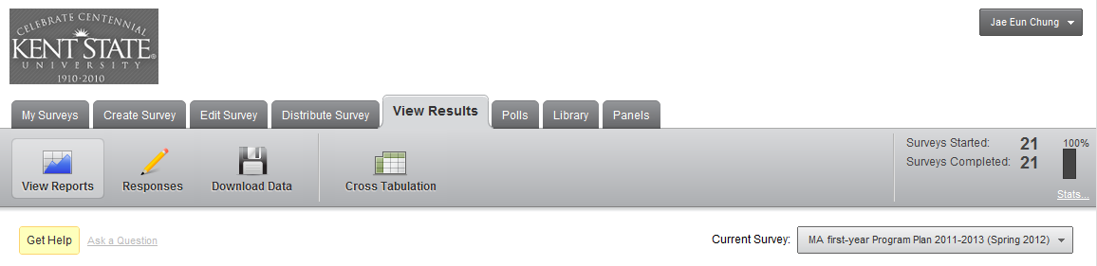

- Click “Responses”

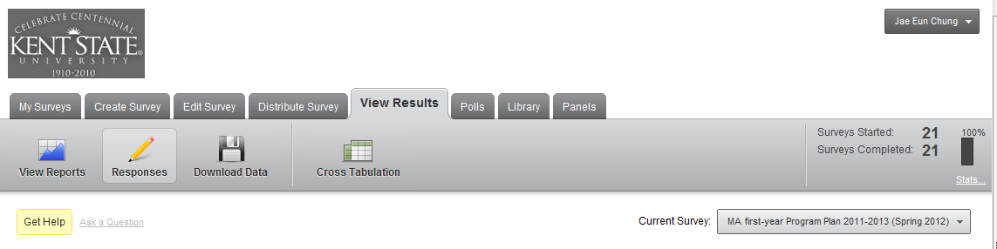.

- Type your advisee’s last name in the “Last Name” box and hit “Search”

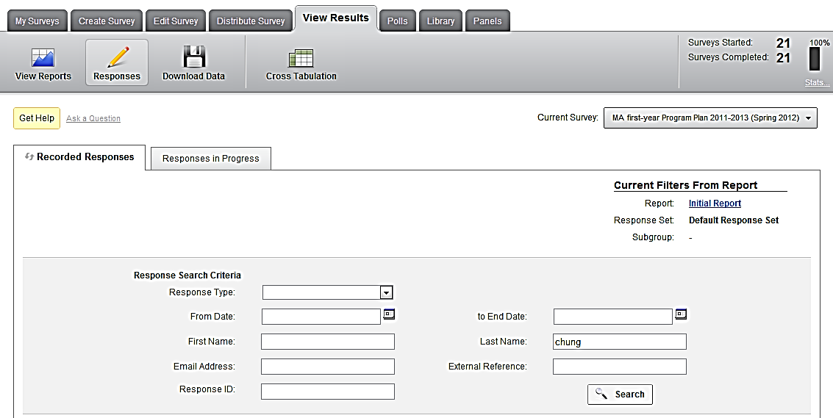

- Your advisee’s response will be shown right below the search panel
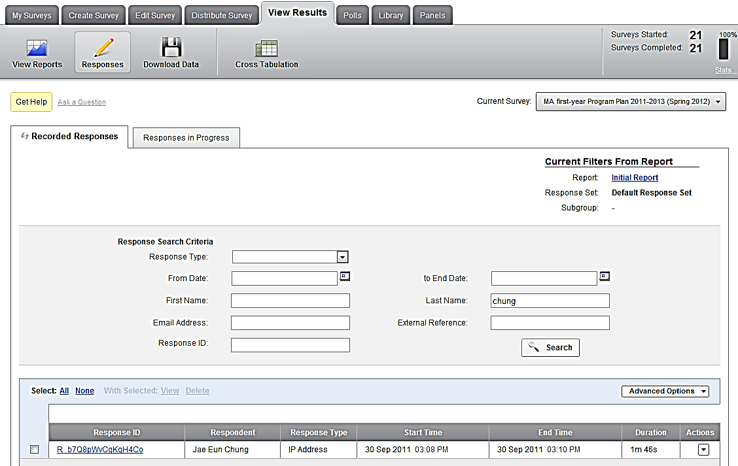

- Click on the hyperlink under “response ID”

- Now your advisee’s response will show up in a separate window. You can review the file online. Or you can download the PDF file by clicking on PDF icon on the top right corner.
*** It is generally a good idea to keep this PDF copy on your computer so that you do not need to go through these steps again.
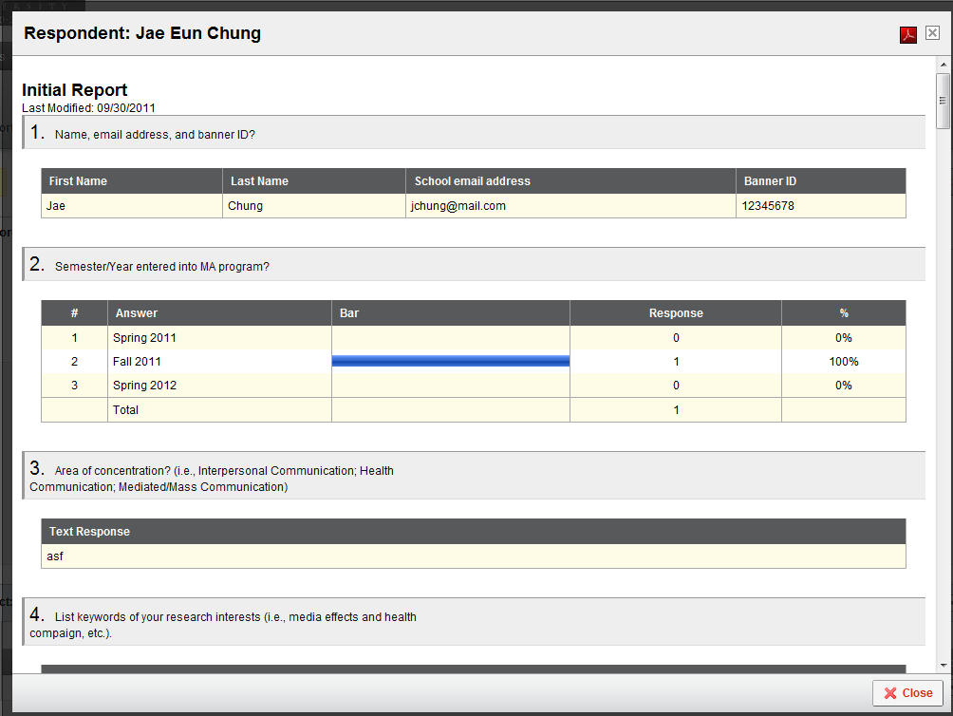

- When you click on the PDF icon, a “PDF Export” window will pop up. Name the file and click on “export”. Now you should have a copy on your computer.

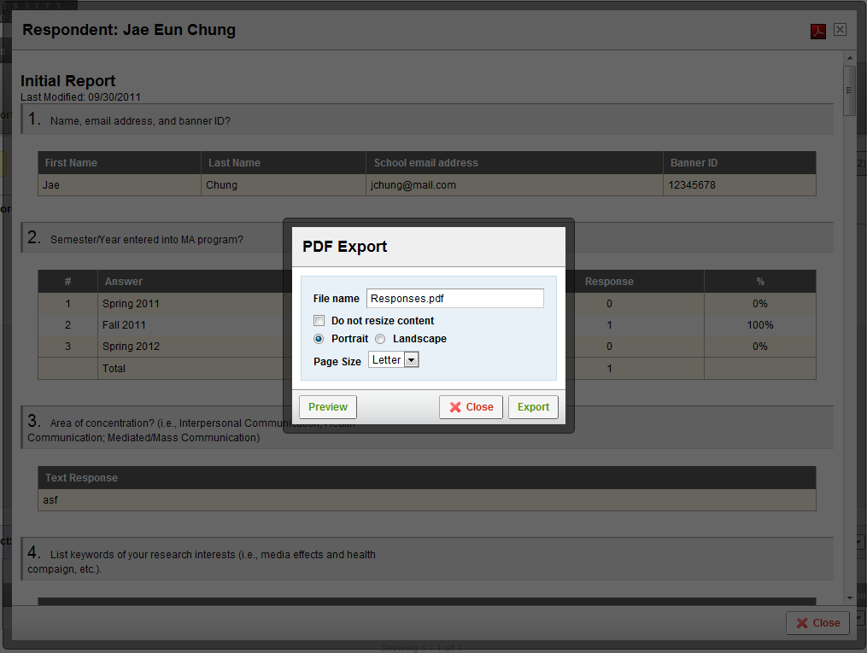

HOW TO ASK FOR REVISIONS .
What if I need to ask my advisees to make changes to their program plan?
When you log in Qualtrics at http://www.qualtrics.com/
- Follow instructions 1) thru 4) for HOW TO REVEW in the previous pages. Once your advisee’s response is shown in the below panel, click on under “actions”
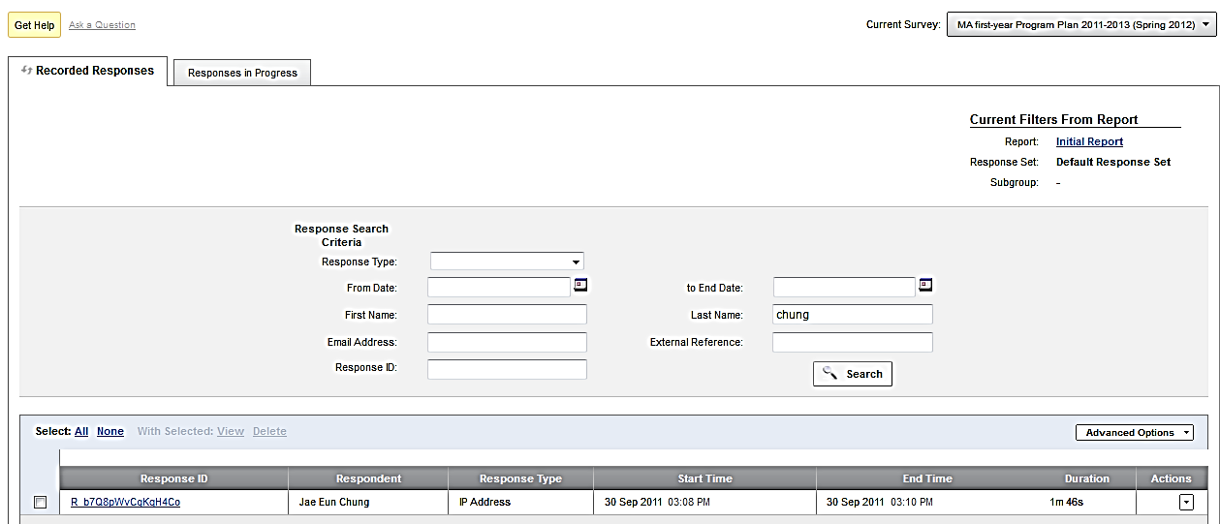

- You will now see two options. Click on “Retake Survey”
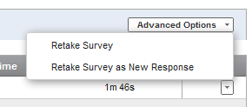

- When you click on “Retake Survey,” a pop-up window with a web address will show up. Copy this web address and send that link to your advisee through your email.
*This way your advisee does not need to fill out all the information again.

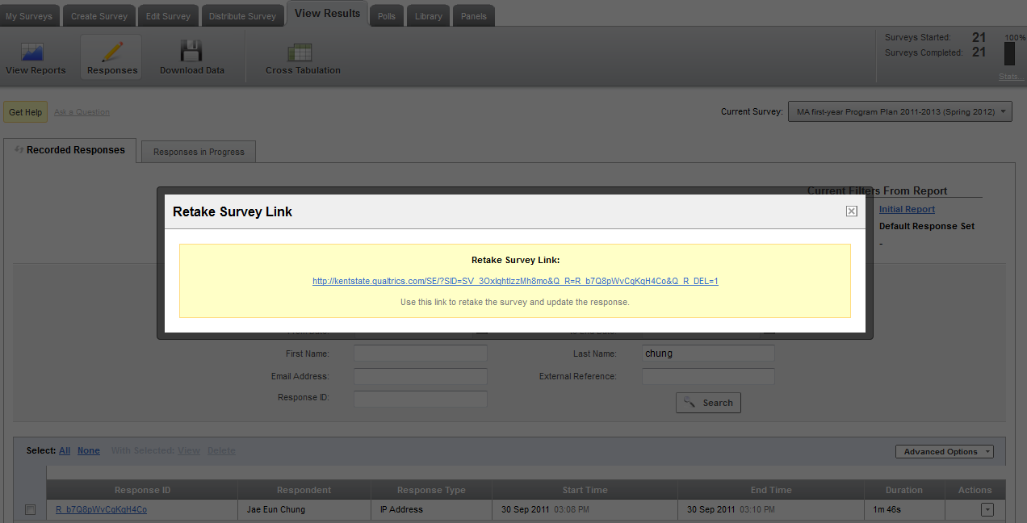

TIMEFRAME .
What is the timeframe for the program plan?
Students will receive an email that contains the link to the Program Plan form at the end of January during their first year of MA program. They will be asked to submit the form by the end of February (the 8th week of spring semester).
Once they submit the form, one month will be given for review (for technical details on “HOW TO REVIEW” please see previous pages) and revisions.
If any revisions are necessary, you need to ask your advisees to revise the program plan (for technical details on “HOW TO ASK FOR REVISIONS” please see pp. 5-6). Any revisions need to be made before the end of March.
At the beginning of April, a copy of each student’s program plan will be printed and placed in their file.
If any changes are made after the formal approval/filing of the program plan, those changes need to be reflected in the annual review document during the second year.

Program Plan

Instruction for Students

M.A. PROGRAM PLAN
Instructions for Students

Who needs to fill out the MA Program Plan?
If you have completed more than 8 credit hours of coursework since your admission to the MA program, then you need to submit the MA Program Plan. In other words, if you took more than two classes last semester, then you need to submit this form.

Until when do I need to turn it in?
This plan needs to be completed no later than the 8th week of spring semester.

What is this about?
The MA Program Plan asks you about your past/future coursework, research and teaching activities, and choice for your advisor and program options (coursework only, internship, project, and thesis options). All the questions that are included in the MA Program Plan are shown in the next pages.

Is there anything that I need to do, before starting to fill out the form?
If you have yet chosen your permanent/official advisor, then it is good time to start thinking. Make appointments with your temporary advisor if you need any assistance in identifying a faculty member who will be a good fit with your study area. Meet with the faculty that you are interested in working with and ask him/her to become your permanent/official advisor.

How do I know which classes I will take in the forthcoming semesters?
For the coursework plan, consult the graduate handbook for detailed guidelines. If anything is unclear and any assistance is needed, consult your advisor for course rotations for the next two years.

Where can I find the form?
You should have received an email that contains the link to the form. This link is unique to each student. Please do not share this link with other students. If you have not received an email about the link by the 1st week of February, you should contact Alice Kopunovitz (akopunov@kent.edu) right away.

Can I partially fill out the form and resume later?
You can come back and resume the survey. When you click on the link in your email, the link will take you straight to the page where you left off. This is regardless of what computer you use to access the survey. However, once you finish all the questions, you cannot come back and change your answers. The final question in the survey is about “Other” activities. Do not hit the “next” button, unless you are absolutely ready to submit the form.

What format do I need to use when I submit information about coursework?
Use the following format for the coursework: Course Number Title (Credit hours, Grade (if available))
e.g. COMM 65652 Theories of Communication (3, A-)

What format do I need to use when I submit information about publication or conference presentation?
Use the APA style (list all the co-authors)
e.g., Kim, J., & Haridakis, P. M. (2009). The role of Internet user characteristics and motives in explaining three dimensions of Internet addiction. Journal of Computer-Mediated Communication, 14, 988-1015.

How do I know whether I completed all the questions?
Once you complete all the questions, you will see a page with the following screenshot. Once you complete the form, you will not be able to go back and make changes.
When you complete the form, you can download a PDF copy of your Program Plan. Make sure you safely keep a copy of your Program Plan on your computer.

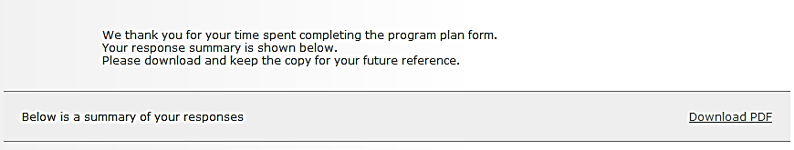

What happens once I submit the form?
Your academic advisor will access your Program Plan and review it.
- Your academic advisor may ask you to revise the plan (during March). If that becomes the case, you will receive an email from your advisor that requests you to revise the Program Plan.
- Once your Program Plan is formally approved by your academic advisor, you need to follow it. A copy of the approved Program Plan will be printed and placed in your file.
- Your Program Plan, as well as the Annual Review document, will be reviewed again by the time you are about to graduate.

What if I need to change any parts in my Program Plan after the plan is formally approved?
In most cases, once the Program Plan is approved, students and their academic advisor must follow the approved program of study. If changes to the Program Plan are necessary, discuss with and obtain approval from your advisor and reflect those changes in the Annual Review document. Any deviation from your Program Plan should be correctly reflected in the Annual Review document. Both Program Plan and Annual Review documents will be reviewed to make a decision of whether you have successfully completed the MA program requirements for graduation.

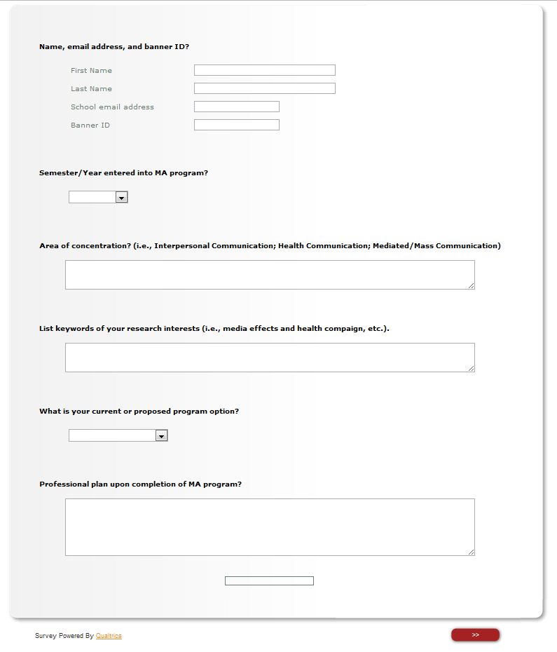
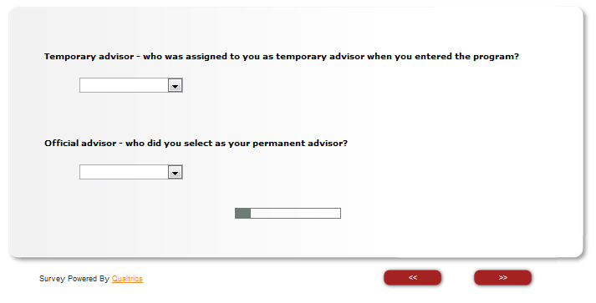
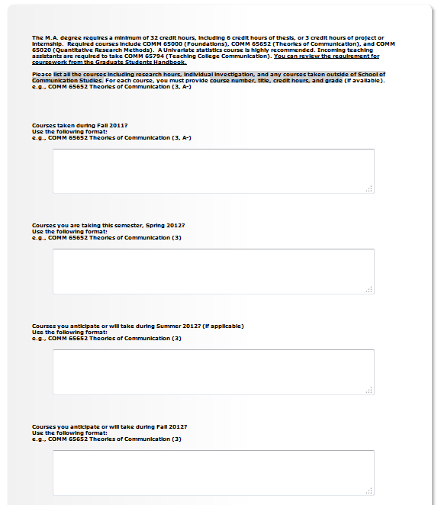
Continued in the next page
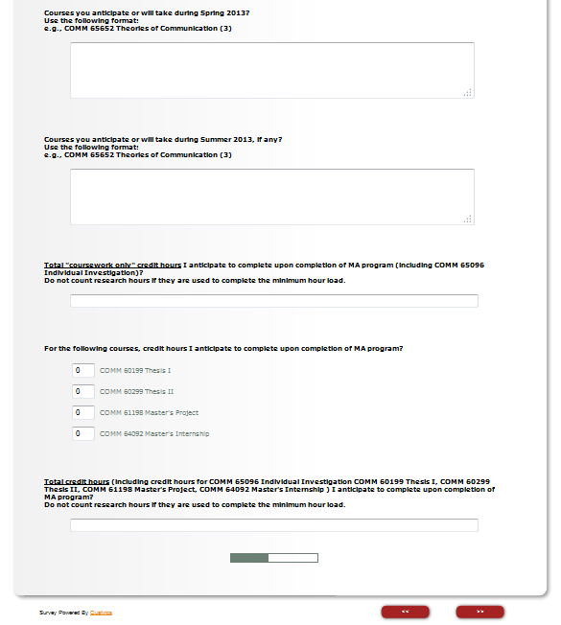

The following two questions are only for internship option students
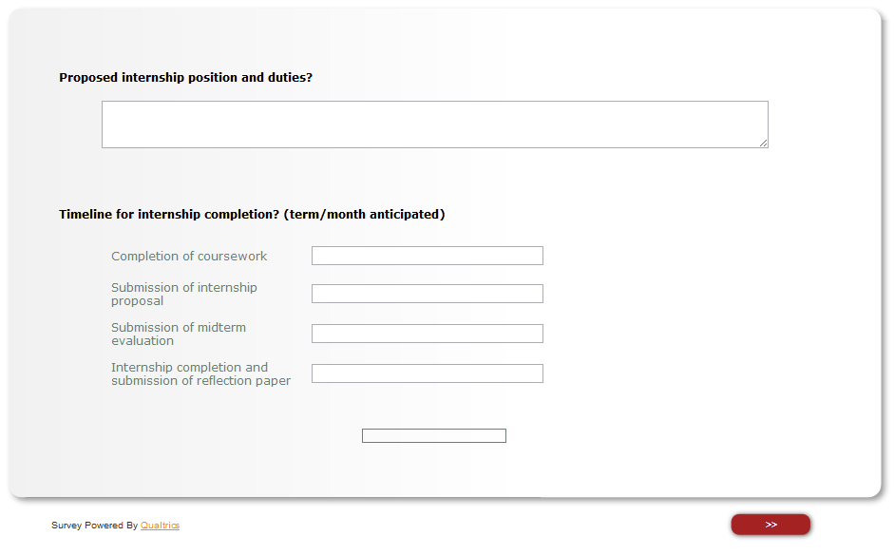

The following two questions are only for project option students
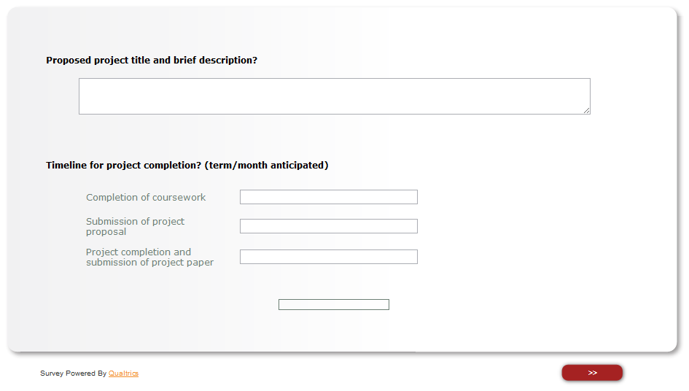

This page is only for thesis option students
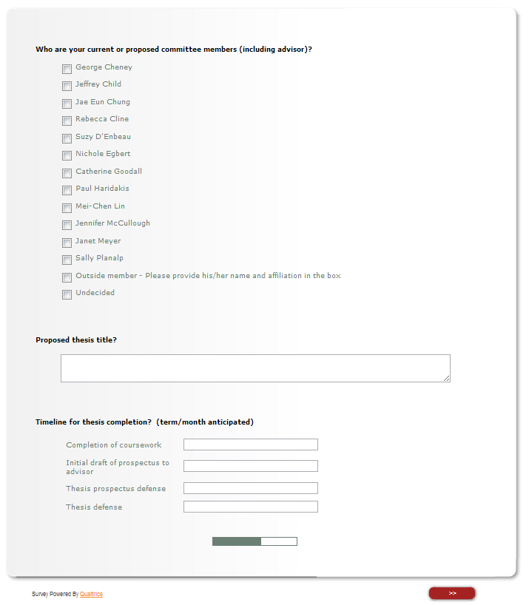

The following two pages are for every student, regardless of program options
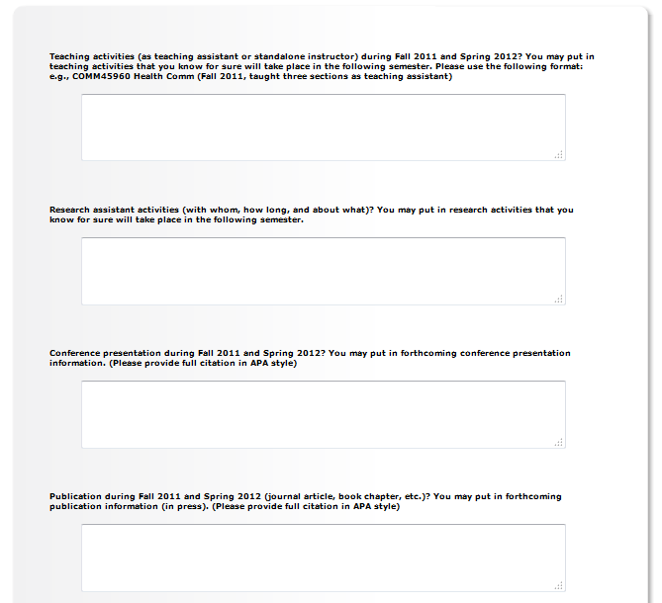

Continued in the next page

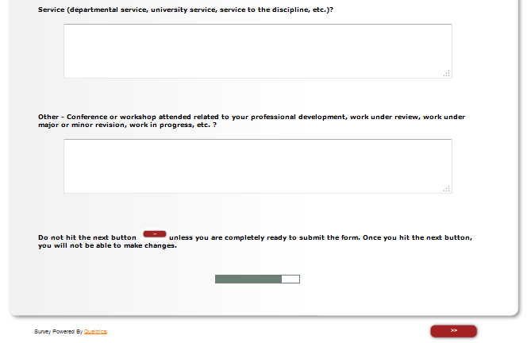

Appendix B

MA Student Annual Review

Advisor Brief Report

To be completed by September 30 of the second year and each subsequent year in the Fall enrollment
Completed copies go to graduate coordinator, student, and advisor

Student Name: ________________________________________ Date: ________________
Name of Faculty Advisor: _____________________________________________________
Current GPA: ________________________ Banner ID: ________________________
Graduation Option: (circle one) Thesis Project Internship Courses Only
Anticipated Graduation Date: _______________
Deadline to Apply for Graduation: ___________________
List any Courses taken with a grade of B- or lower:
___________________________________ ____________________________________
___________________________________ ____________________________________
List any courses with a grade of incomplete (IN) or in progress (IP):
___________________________________ ____________________________________
___________________________________ ____________________________________
Describe what requirements (courses/or GPA) remain for graduation: ___________________________________ ____________________________________
___________________________________ ____________________________________
Describe any notable research/teaching/service accomplishments (publications, presentations, awards, etc.)
_________________________________________________________________________
_________________________________________________________________________
Student Signature/Date: __________________________________________________________
Advisor Signature/Date: __________________________________________________________

Appendix C

Project Option

Examples of Potential Projects
Global: Propose and outline a comprehensive training program for an existing transnational corporation or non-governmental organization, including information known about current practices in that organization's industry or sector but also proposing refinements and innovations. Topics to be reviewed and treated include: cultural and international influences on organizational structures and practices; media choices, richness, and uses in work processes, especially group interaction; plus relevant insights from studies of multicultural training, cross-cultural negotiation, membership heterogeneity and team performance, and diversity management.
Global: Conduct an intercultural sensitivity training to CCI faculty/staff to interact with students, staff and students from a different cultural background. Topics to be covered would be: functions of stereotypes and behaviors that count as prejudice and discrimination historically and at the present time, theories that are used in the literature to explain problematic intergroup interactions, common scenarios where intercultural sensitivity is needed, how to apply intercultural sensitivity in the classroom, and helpful tips for attendees. The training should include presentation, administering intercultural sensitivity test and providing results to attendees before the training, and providing opportunities for attendees to work on case study during the training time. Evaluation of the effectiveness of the training should be included as well.
Health: Develop a training program for health professionals and medical translators to better understand typical language and cultural misunderstandings when dealing with patients from Mexico. The final product would be a PowerPoint presentation for health professionals and handouts of terminology and cultural practices for English-speaking providers and Spanish-speaking (especially Mexican) patients. Alternatively, a video for patients in Mexican Spanish could be used to describe common misunderstandings with regard to terminology, treatment, and institutional practices.
Health: Produce a video for health-care providers illustrating good and bad examples of practices related to: health literacy, patient-focused care, listening, paraphrasing and checking back, breaking bad news, providing appropriate support, managing privacy.
Interpersonal: Produce a video on intimate violence in collaboration with the KSU Women’s Center and KSU people in charge of freshman orientation. Topics to be covered would be: definitions of violence and abuse, background information, recommended precautionary behavior, warning signs, services for victims, and (by contrast) healthy, non-abusive interactions and relationships. Alternatively: Produce a video on intimate violence in collaboration with an organization on aging in the Cleveland area about elder abuse. Topics to be covered would be: definitions of elder abuse, abusers’ characteristics, risk-factors of elder abuse, communication issues that give rise to elder abuse (from both the abuser and the abusee’s communicative behaviors), signs of abuse, and actions that should be taken when one suspects of the occurrence of elder abuse.
Interpersonal: Develop a workshop for the people in the community about communication issues within the family if they are thinking about starting a family-run business (got this idea from the last candidate). The final product will be to offer a workshop to the community (materials included PPT, handouts, or pamphlets, etc.) and gather and analyze the feedback of the usefulness of such workshop at the end of it.
Project Final Paper Evaluation Form for Faculty Advisor
Criteria for Judging MA Project

(Anticipated length 20-25 pages)

Student Name: ___________________________________

Rationale | A=5pt | B=4 | C=3 | D=2 | F=1
- Is the general purpose of the project explained clearly?
- Is there a convincing argument that the project meets the needs of the target audience?
Goals | A=5pt | B=4 | C=3 | D=2 | F=1
- Are the specific goals of the project summarized?
- Are the goals focused and feasible?
- Are the goals justified in light of existing research?
Grounding in Research/Theory | A=5pt | B=4 | C=3 | D=2 | F=1
- Does existing literature and theory guide the development of the project?
- Is the theoretical/conceptual framework explained clearly and accurately?
- Is the literature review thorough and up to date?
Procedure | A=5pt | B=4 | C=3 | D=2 | F=1
- Is the procedure by which the project was developed explained in adequate detail?
- Is there clear identification of and adaptation to the target audience?
Presentation of Project | A=5pt | B=4 | C=3 | D=2 | F=1
- Is the project presented in a clear manner with a focus on the goals?
- Is the level of detail of the report appropriate to the goals of the project?
- Is the project presented in a professional format suitable to the target audience?
- Are the limitations of the project described accurately and appropriately?
Anticipated Outcomes | A=5pt | B=4 | C=3 | D=2 | E=1
- Are the ways that the project was or could be used/ implemented described clearly?
- If the project was used/ implemented, is feedback about its strengths and weaknesses reported and analyzed?
- If the project has not yet been used or implemented, how would it be evaluated?

Total Points | Points Needed to Pass
____ out of 30 | 22 out of 30

Comments:

Name of Faculty Advisor Date Signature
Name of Reader Date Signature

Appendix D

Forms for Internship

KSU School of Communication Studies
MA INTERNSHIP AGREEMENT Form
Intern Name:__________________________________________________________________

Phone: ______________________________ E-mail: __________________________________

Address: _____________________________________________________________________

Name of Faculty Advisor: _________________________________________________________

Position/Title: ____________________________ Phone:_______________________________

Fax: ________________________________ E-mail: __________________________________

Employer/Company Name:_______________________________________________________

Phone: ________________________ Company web site: _______________________________

Address: ______________________________________________________________________

Name of Supervisor:_____________________________________________________________

Position/Title: _____________________________ Phone:______________________________

Fax: ________________________________ E-mail: __________________________________

Duration of Internship: Start: ______________________ End: __________________________

Hours per Week: ______________ (Circle one: Volunteer or Paid)

Please list the experiences you will provide to the intern to expand the intern’s knowledge of the industry, work experience, and/or skill set.
Experience | Benefit to Intern

Please list the main duties that the intern will perform and the approximate percent of time on each duty (you may attach a job description in lieu of this information):
Duty | % Time on Duty

Notes:
- Supervisor agrees to supply a review of the student at the internship mid-point
(Date: ____________) and at the internship conclusion (Date: _____________) Please send a copy of this review to the faculty supervisor within one week of completion.
- The student agrees to comply with the applicable organizational policies and procedures of _________________________________________(company or organization name). Please attach a copy of these to this document.

We agree to abide by the terms of this agreement. Any major modifications will be in writing and agreed to by all parties.

_________________________________________ ___________________________________
Supervisor Signature Date

_________________________________________ ____________________________________
Student Signature Date

_________________________________________ ____________________________________
Faculty Advisor Signature Date

KSU School of Communication Studies
MA INTERNSHIP AGREEMENT Form - Sample
Intern Name:_____Sample Student_________________________________________________

Phone: ___330 672-2659________________ E-mail: _____samplestudent@kent.edu_________

Address: _____105 Main Street Kent, OH 44242______________________________________

Name of Faculty Advisor: ________Dr. A. B. Professor__________________________________

Position/Title: ___Associate Professor________ Phone:____330 672-2121_________________

Fax: ____330 672-3510_________________ E-mail: _____aprofes@kent.edu_______________

Employer/Company Name:____Flash Communications, Inc._____________________________

Phone: ___330 555-2222__________ Company web site: __flashcomm.net_________________

Address: ____75 S. Esplanade Dr. Kent OH 44242_____________________________________

Name of Supervisor:_____Ms. Judy Smith___________________________________________

Position/Title: ___Sales Manager______________ Phone:______330 555-1234_____________

Fax: ____330 555-4321________________ E-mail: ______judysmith@flashcomm.net_______

Duration of Internship: Start: ____9/1/2015___________ End: _____12/15/2015___________

Hours per Week: ___10________ (Circle one: Volunteer or Paid)

Please list the experiences you will provide to the intern to expand the intern’s knowledge of the industry, work experience, and/or skill set.
Experience | Benefit to Intern
Attend annual industrial convention and help solicit new clients | Practice networking skills, gain background of industry, hone sales skills
Attend and participate in weekly sales meetings | Learn to work in a team, help develop new initiatives
Pitch and develop your own product in the area of social networking | Increased Research and Problem-solving skills
Shadow sales team member when visiting clients | Networking, Develop Hands-on understanding, hone sales skills

Please list the main duties that the intern will perform and the approximate percent of time on each duty (you may attach a job description in lieu of this information):

Duty | % Time on Duty
Market Research | 25%
Data Entry | 25%
Product Development | 25%
Website Maintenance | 25%

Notes:

- Supervisor agrees to supply a review of the student at the internship mid-point
(Date: __10/30_______) and at the internship conclusion (Date: _12/15_________) Please send a copy of this review to the faculty supervisor within one week of completion.
- The student agrees to comply with the applicable organizational policies and procedures of ____ Flash Communications, Inc.____________________(company or organization name). Please attach a copy of these to this document.
We agree to abide by the terms of this agreement. Any major modifications will be in writing and agreed to by all parties.

____ Ms. Judy Smith _________ ________________________8/15/2015_________
Supervisor Signature Date
____ Sample Student _______________ _________________8/15/2015__________
Student Signature Date
_____ Dr. A. B. Professor _____________ ________________8/15/2015__________
Faculty Advisor Signature Date

Internship Bi-Weekly Journal Form

Student Name:

Date:

- Write a one-paragraph description of your duties and responsibilities during the last two weeks. (What kind of tasks and projects were you assigned to? What kind of work did you produce or observe being produced? What kind of events, meetings, or training sessions did you attend, if any? etc.)
- How many hours did you spend on your internship during the last two weeks?
Week 1 (Dates: From / / to / / ) : _____ hours/week
Week 2 (Dates: From / / to / / ) : _____ hours/week

- Write a two-paragraph summary applying communication-related concepts and theories from previous coursework and communication literature.
Internship Midterm and Final Evaluation Form for Supervisor

Please mail or fax this completed form to the student’s faculty advisor

Name of Intern: _________________________________________________________

Name of Supervisor: _____________________________________________________

Circle One: Midterm Evaluation Final Evaluation

1. For each of the tasks listed on the internship agreement, please rate the student's level of performance.

Task | Unsatisfactory | Below Average | Average | Good | Excellent

Comments:

2. Please evaluate the intern in the following areas, noting specific suggestions for improvement if needed: (add additional criteria as needed)

a. Professional development

Task | Unsatisfactory | Below Average | Average | Good | Excellent | Not Applicable
Professionalism
Initiative
Dependability
Understands key elements of the organization

Comments:
b. Organizational and time management skills
(add additional criteria as needed)
Task | Unsatisfactory | Below Average | Average | Good | Excellent | Not Applicable
Completes tasks in a timely and efficient manner
Uses resources effectively
Enlists cooperation of others where appropriate
Is effective in time management
Sets and meets realistic goals

Comments:

c. Communication skills
(add additional criteria as needed)
Task | Unsatisfactory | Below Average | Average | Good | Excellent | Not Applicable
Expresses ideas effectively
Accepts and makes constructive use of criticism
Works effectively with supervisor
Works effectively with co-workers
Works effectively with clients/customers/outside stakeholders

Comments:

3. Overall, what are the intern's greatest strengths? What areas need improvement?

If you have additional comments, please feel free to include them here. Thank you.

_________________________________________ ___________________________________
Supervisor Signature Date

_________________________________________ ____________________________________
Student Signature Date

Internship Final Paper Evaluation Form for Faculty Advisor
Criteria for Judging MA Internship Final Paper
(Anticipated length 15 pages)

Student Name: ___________________________________

Goals, Duties, and Outcomes | A=5pt | B=4 | C=3 | D=2 | F=1
- Are the specific learning goals of the internship explained clearly?
- Are the specific duties (including roles served, functions or units involved, experiences gained, projects worked on) and outcomes of the internship explained?
Grounding in Research/Theory | A=5pt | B=4 | C=3 | D=2 | F=1
- Are the goals, duties, and outcomes explained in connection to communication concepts and theories?
- Is the theoretical/conceptual framework explained clearly and accurately?
- Is the literature review thorough and up to date?
Reflection/Learning Outcomes | A=5pt | B=4 | C=3 | D=2 | F=1
- Are the learning outcomes of the internship experience explained?
- Does existing literature and theory guide the reflection of the internship experience?
- Is a convincing argument made about how the internship helps understand the role of communication in work environments?
- Are the ways your internship experience and tasks contribute to the understanding of communication concepts/theories clearly described?
- Are the ways communication-related concepts and theories can be more effectively applied to your internship experience and tasks described clearly?
Presentation | A=5pt | B=4 | C=3 | D=2 | F=1
- Is the paper presented in a clear and professional manner?
- Is the level of detail of the paper appropriate?
- Is the paper presented in an APA style?
Total Points | Points Needed to Pass
____ out of 20 | 15 out of 20

Comments:

Name of Faculty Advisor Date Signature
Name of Reader Date Signature

