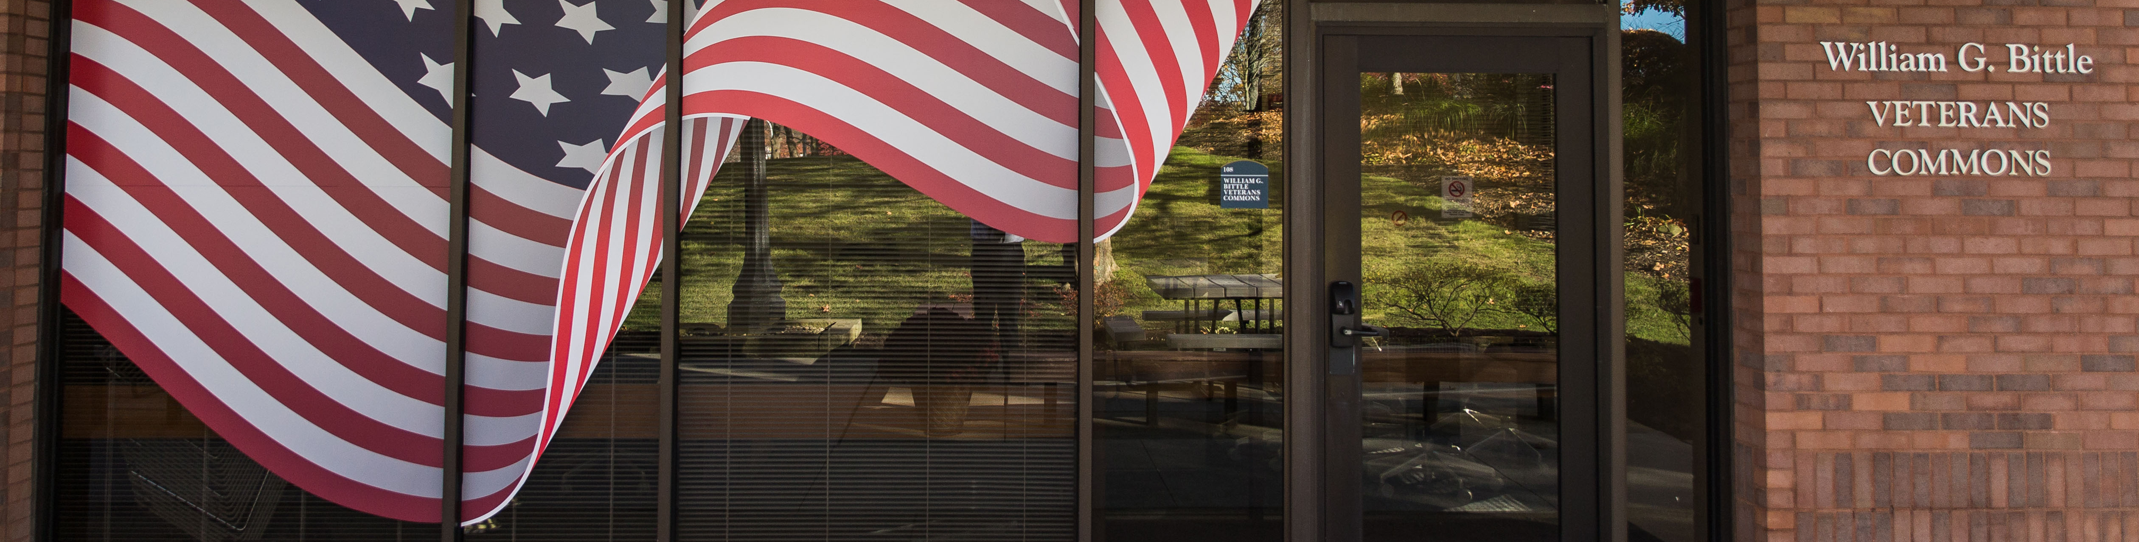

VETERANS GUIDE

STEP 1: ADMISSIONS

General Admission Information: William Casterlow
www.kent.edu/stark/admissions-office Admissions Counselor
330-244-3250
wcasterl@kent.edu

Residency Issues: Stephanie Tarver or Mary Southards
(if you have not lived in the State Admissions Specialist Assistant Dean
of Ohio in the last 12-month 330-244-3258 330-244-3240
calendar year) starver1@kent.edu msouthar@kent.edu

How to Apply for Admission:
- Apply online at www.kent.edu/stark/apply-now
- The $40 admission fee (fee subject to change) will be waived for veterans if they provide a DD Form 214 or a military ID.
- ACT/SAT scores are not required if you have been out of high school for 3 years or if you are 21 years of age or older.
- If you have a GED, bring in the original certificate and scores for Admissions to copy. Send electronic parchment GED transcripts to starkadmissions@kent.edu. Some restrictions apply; see Admissions for details.
- Request official transcripts; they are considered official only if they arrive (by mail or hand-delivered) in a sealed letterhead envelope from a high school, college or university. Transcripts must be received from all schools you have attended (i.e. your high school, Central Texas College, University of Maryland, etc.)
- Provide military transcripts to receive credit for military training:
  - Provide Admissions with copy of DD Form 214 Member 4.
  - For Air Force and Air National Guard transcripts on-line at AFVEC go to https://afvec.langley.af.mil/afvec/Home.aspx and log in. Under Self Service select “CCAF View Progress Report”. In the “Transcripts” drop down, select “Order a Transcript”. Select Kent State University from the list. There is no cost for CCAF transcripts using this method.
  - All enlisted officers and warrant officers, both active and veterans from Army, Coast Guard, Marine Corps, Navy and National Guard request transcripts on-line at https://jst.doded.mil and log in. Select the “Transcript” link at the top of the page. On the “Transcripts Menu” select “Official Transcript Request”. Search for the school and select Kent State University. On the next page, acknowledge the consent statement and select “Yes”. There is no cost for JST transcripts.
  - The Kent State University Credit Transfer Office evaluates the transcripts and issues course credits accordingly. Once the courses have been evaluated, an academic advisor will answer questions regarding these credits.
- Please contact Admissions to see if placement testing is required.

STEP 2: VETERANS EDUCATION BENEFITS & FEDERAL FINANCIAL AID
Primary Veterans Contact: Secondary Veterans Contact:
Anne Fritz Andrea Dale
VA Certifying Official & Financial Aid Representative Financial Aid Coordinator & VA Certifying Official
330-244-3246 | 330-499-0301 (fax) 330-244-3242 | 330-499-0301 (fax)
afritz2@kent.edu adale@kent.edu

Be prepared to answer the following questions:
  - What VA education benefit(s) are you eligible to use and have you applied to use them?
  - Have you attended college previously either at KSU or elsewhere?
  - If you attended college previously, did you use VA education benefits at that time?
  - Are you currently on active duty? Are you currently in Ohio National Guard or in the Reserves?
- The forms/documentation required will depend on your answers to the previous questions. Contact the VA Certifying Official for the forms and documentation that apply to you.
- VA regulations state that only courses required for your degree program may be certified. If you have not declared a major and are in the exploratory category, you must declare a major by your third semester (the VA allows you only two semesters in exploratory).
- To receive federal financial aid (grants and/or student loans) in addition to VA education benefits, complete the FAFSA (Free Application Federal Student Aid) for 2018-19 at www.fafsa.gov. Contact Financial Aid approximately two weeks after completing the FAFSA for further information.
STEP 3: ACADEMIC ADVISING
General Advising Information: Venecia Alexander or Ryan Bucher
Academic Advisor Academic Advisor
330-244-3276 330-244-3260
valexan2@kent.edu rbucher@kent.edu
- Schedule an academic advising appointment after first seeing Admissions and admittance to the university. Schedule an appointment online at www.kent.edu/stark/advising-services or call 330-244-3251 for assistance. Inform your academic advisor that you are using VA education benefits.
STEP 4: ACADEMIC SUCCESS CENTER
If you need any of the following services, please contact these staff members:
Accessibility Services: Counseling Services:
Darcy McBride Emily Ribnik, PCC-S
Academic Services Coordinator Clinical Counselor
330-2445047 330-244-5048
dmcbri10@kent.edu starkcounseling@kent.edu

Testing & Tutoring Services: Interfaith Campus Ministry:
Lisa Hart Rev. Ryan Johanning
Director for Academic Services Director for Interfaith Campus Ministry 330-244-5042 330-244-3282 lhart@kent.edu rjohanning_gst@kent.edu
STEP 5: VETERANS COMMONS
If you would like to tour our veterans and service members-only space on campus, please contact:
Hector McDaniel
Veterans Ambassador
330-244-3336
hmcdanie@kent.edu

(Revised 11/18)

